Composting Technical Guidance – Modernising Biowaste

October 2012

AfOR has collated all comments received from the industry, which included compost producers, consultants, technology providers, local authorities, and added them into the original document in two forms:
- Using so called ‘balloons’ with comments: some of these comments are signed by Justyna but come from members of the Association & others are from AfOr’s technical team members
- Using an horizontal line & blue text underneath the specific paragraph
Different paragraph numbers represent different members of the association only

AfOR has attached an additional document which shows the correlation between the temperature and time during composting process, oxygen concentration in windrows after turning, and an analysis of data representing industrial composting processes by Compost Manager.

AfOR’s general comment
The title refers to ‘Modernising Biowaste’. However, where is the ‘modernising biowaste’ element? This document is merely a collation of information that is already available on composting. As agreed, if you publish this document, please publish it as a resource document, not as guidance on BAT.

There has been a significant interest in this document and concern that if it was to be implemented in its present form, it would compromise the operation of the majority of sites currently operating in the UK.
AfOR hopes that the EA take notice of these concerns and engage with industry prior to implementing any part of this document in the field.

Document Control Sheet BPP 04 F8
Version 13 Feb 2012
Project: | Environment Agency | Project No: | B1802100
Client: | Composting and Aerobic Treatment Technical Guidance – Modernising Biowaste
Document Title: | Composting and Aerobic Treatment Technical Guidance
Ref. No:

 | Originated by |  | Checked by |  | Reviewed by |  | Approved by
ORIGINAL | ^{NAME} |  | ^{NAME} |  | ^{NAME} |  | ^{NAME}
 | Leanne Gourlay  Owen Thomas |  | Adele Graham |  | David Notton |  | Jane Bond
^{DATE} | ^{INITIALS} |  | ^{INITIALS} |  | ^{INITIALS} |  | ^{INITIALS}
July 2012 | Document Status Draft

REVISION | ^{NAME} |  | ^{NAME} |  | ^{NAME} |  | ^{NAME}
 | David Notton |  | Adele Graham |  | Adele Graham |  | Jane Bond
^{DATE} | ^{INITIALS} |  | ^{INITIALS} |  | ^{INITIALS} |  | ^{INITIALS}
August 2012 | Document Status Final

REVISION | ^{NAME} |  | ^{NAME} |  | ^{NAME} |  | ^{NAME}
^{DATE} | ^{INITIALS} |  | ^{INITIALS} |  | ^{INITIALS} |  | ^{INITIALS}
 | Document Status

REVISION | ^{NAME} |  | ^{NAME} |  | ^{NAME} |  | ^{NAME}
^{DATE} | ^{INITIALS} |  | ^{INITIALS} |  | ^{INITIALS} |  | ^{INITIALS}
 | Document Status

REVISION | ^{NAME} |  | ^{NAME} |  | ^{NAME} |  | ^{NAME}
^{DATE} | ^{INITIALS} |  | ^{INITIALS} |  | ^{INITIALS} |  | ^{INITIALS}
 | Document Status

Jacobs Engineering U.K. Limited
This document has been prepared by a division, subsidiary or affiliate of Jacobs Engineering U.K. Limited (“Jacobs”) in its professional capacity as consultants in accordance with the terms and conditions of Jacobs’ contract with the commissioning party (the “Client”). Regard should be had to those terms and conditions when considering and/or placing any reliance on this document. No part of this document may be copied or reproduced by any means without prior written permission from Jacobs. If you have received this document in error, please destroy all copies in your possession or control and notify Jacobs.

Any advice, opinions, or recommendations within this document (a) should be read and relied upon only in the context of the document as a whole; (b) do not, in any way, purport to include any manner of legal advice or opinion; (c) are based upon the information made available to Jacobs at the date of this document and on current UK standards, codes, technology and construction practices as at the date of this document. It should be noted and it is expressly stated that no independent verification of any of the documents or information supplied to Jacobs has been made. No liability is accepted by Jacobs for any use of this document, other than for the purposes for which it was originally prepared and provided. Following final delivery of this document to the Client, Jacobs will have no further obligations or duty to advise the Client on any matters, including development affecting the information or advice provided in this document.

This document has been prepared for the exclusive use of the Client and unless otherwise agreed in writing by Jacobs, no other party may use, make use of or rely on the contents of this document. Should the Client wish to release this document to a third party, Jacobs may, at its discretion, agree to such release provided that (a) Jacobs’ written agreement is obtained prior to such release; and (b) by release of the document to the third party, that third party does not acquire any rights, contractual or otherwise, whatsoever against Jacobs and Jacobs, accordingly, assume no duties, liabilities or obligations to that third party; and (c) Jacobs accepts no responsibility for any loss or damage incurred by the Client or for any conflict of Jacobs’ interests arising out of the Client's release of this document to the third party.

Contents
1 Introduction 1
1.1 Guidance Background 1
1.2 Scope of the Guidance 3
1.3 Approach 5
1.4 Acknowledgements 5
1.5 Guidance Structure 6
2 The Composting Process 10
2.1 General Principles and Definitions 10
2.2 Description of Key Stages 10
2.3 Kinetics and Inhibition 15
2.4 Process Configuration 22
2.5 Process Types 24
2.5.1 No Reactor Composting 27
2.5.2 Reactor Composting 27
2.6 Emission Abatement 27
2.7 Markets and Outputs 28
3 Regulations and Standards 29
3.1 European Regulatory Context 29
3.2 The UK Regulatory Requirements 29
3.3 Planning 30
3.4 Environmental Permitting for Facilities in England and Wales 31
3.4.1 Introduction 31
3.4.2 Exemptions from Requiring an Environmental Permit for Composting Operations 33
3.4.3 Standard Rules Environmental Permits for Composting Operations. 34
3.4.4 Bespoke Environmental Permits for Composting Operations 36
3.4.5 Applying for an Environmental Permit 37
3.4.6 Monitoring Conditions 46
3.4.7 Odour Regulation in the UK 46
3.4.8 Animal By-Products Approval of Composting Facilities 47
3.4.9 Animal By-Products Approval 48
3.4.10 Regulatory Control of Output Materials in the UK 49
3.4.11 BSI PAS 100 Composting Standard 51
4 Technology 52
4.1 Composting Systems 52
4.1.1 Composting in Open Systems 52
4.1.2 Composting in Closed Systems (In-vessel Composting) 71
4.1.3 Emerging Technology - Thermophillic Aerobic Digestion 84
4.2 Comparison of the Composting Processes 84
5 Raw Material and Feedstock 91
5.1 Overview 91
5.2 Suitable Feedstock 91
5.3 Feedstock Characteristics 92
6 Site Design Considerations and Environmental Considerations 95
6.1 Introduction 95
6.2 Overview 95
6.3 Site Suitability 96
6.4 Site Layout 98
6.5 Design capacity and throughput of composting facilities 98
6.6 Operational Areas 100
6.6.1 Feedstock Unloading and Preparation Area 100
6.6.2 Active Composting Area 100
6.7 Compost Maturation 102
6.8 Screening and Refining 102
6.9 Packing and Storing 103
6.10 Site Drainage 103
6.10.1 Permitting requirements for site drainage 105
6.11 Fire 106
6.12 Vehicle Access 107
6.13 Utilities 107
7 Emissions and Abatements 108
7.1 Overview 108
7.2 Emissions 108
7.2.1 Overview of Monitoring 109
7.3 Odour 110
7.3.1 Odour Monitoring 111
7.3.2 Odour Abatement 114
7.4 Bioaerosols 126
7.4.1 Bioaerosol Monitoring 127
7.4.2 Bioaerosol Abatement 129
7.5 Leachate 130
7.5.1 Leachate Monitoring 130
7.5.2 Leachate Management 131
7.6 Dust 131
7.7 Vermin 132
7.7.1 Monitoring and Controlling Vermin 132
7.7.2 Monitoring and Control of Vermin 133
7.8 Noise 133
7.8.1 Noise Monitoring 133
7.8.2 Noise Abatement 134
7.9 Litter 135
8 Operation and Management 136
8.1 Introduction 136
8.2 Process configuration 136
8.2.1 Feedstock supply 136
8.2.2 Inspection and Rejection Process 137
8.2.3 Removal of contraries 138
8.2.4 Removal of Rejected Materials 138
8.3 Optimal Process Controls 138
8.3.1 Process parameters 138
8.3.2 Management and Supervision of Process Parameters 145
8.4 Site Management and Supervision 145
8.4.1 EP Site Management Plan 146
8.4.2 Site Management requirements for Standard Rules Permits 148
8.4.3 Other Specific Site Supervision and Monitoring Requirements 148
9 Outputs – Horticultural and Agricultural Benefits and Markets 153
9.1 Understanding the Benefits of Compost 153
9.1.1 Physical Benefits 153
9.1.2 Chemical and Biological Benefits 153
9.1.3 Ecological and Environmental Benefits 153
9.1.4 Economic Benefits 154
9.2 Potential Markets 154
9.3 Market Limitations 156
9.4 Market Knowledge 157
9.5 Producing a Marketable Product 157
9.6 Product Preparation for Marketing 158
9.7 Development of the Marketing Plan 158
Appendix A Trouble Shooting i
Appendix B Glossary iii
Appendix C References vii

Introduction

Guidance Background
In October 2001, The Environment Agency produced draft Technical Guidance on Composting Operations.

In the decade following this draft, the use of aerobic treatment and composting to recover a range of organic wastes has significantly expanded. This is due to new regulatory requirements and targets for diversion of biodegradable waste, and increased landfill costs which have stimulated the market for the treatment of biowastes. This has resulted in the development of a range of types of aerobic biowaste treatment facilities, including in-vessel operations and the introduction of novel aerobic processing techniques, as well as the more traditional windrow composting process.

There have also been significant and ongoing changes to the legislative regime under which such operations are regulated by the Environment Agency.

The Environment Agency recognises that commercial scale aerobic treatment and composting is not inherently a low risk activity. It has the potential to impact upon amenity, health, and the environment when facilities are poorly planned and operated. The Environment Agency has developed this technical guidance document on aerobic treatment and composting operations for source segregated biowastes. It will provide new best practice guidance to assist in the development, delivery, operation and regulation of aerobic treatment and composting processes and installations, including:

- the fundamental controls and parameters, including windrow height, temperature, moisture and carbon to nitrogen ratio (C:N), for adequate aerobic treatment;
- defining the different types of processes available and identifying the suitability of each process in relation to infrastructure standards, waste types and potential environmental impacts;
- providing evidence to support Best Available Techniques (BAT) and industry good practice, including consideration of IED and BREF standards; and
- acting as a guide for the Environment Agency’s permitting and regulatory staff by providing a structured method to assess the suitability of specific treatment processes against the criteria of composting.

With the imminent implementation of the Industrial Emission Directive (IED), the Environment Agency needs to bridge knowledge gaps so that they can provide clear information to businesses, make effective permitting decisions, and be confident that our regulatory interventions are proportionate and targeted to ensure adequate environmental protection.

This guidance is supported by the Northern Ireland Environment Agency (NIEA) and Scottish Environment Protection Agency (SEPA). The Composting and Aerobic Treatment Technical Guidance is based on established practical and reliable evidence, and is intended to provide advice and guidance to a wide range of stakeholders. The principal audience is operators of existing, and developers of new, aerobic treatment and composting operations and also the Environment Agency’s regulatory staff who will use this guidance as a framework for assessing current and new developments. This guidance will be revised as EU Best Available Techniques (BAT) reference documents (BREF documents) are developed. It is the hope that together with industry we can stimulate and encourage best practice across the UK..

- It fails to address the issues that are covered in BREF documents generally in circulation or similar documents produced by the EA. Therefore, it gives no indication to proactive composters on how to improve and develop key infrastructure changes so that they can be carefully budgeted and in advance of these important regulatory changes. We are unfortunately back to guess work.
The link between scale and permitting is clearly defined, but I also think this should also be reflected in the process management/monitoring aspects.
I know the regulatory framework is complex, I was hoping that this document should provide the compromise position, and not just a set of references to these regulations. This is the regulators expectation based to the complexity.
In order to keep my comments brief, I will stay to comments of a general nature, which highlight the overall inadequacy of the document rather than those of technical nit picking, typos, referencing and other issues with the ordering of the document.

In light of the high profile of bio-waste processing I’m disappointed that the regulator as not taken a more definitive position on these important issues.
It would appear also that much work is still in progress for 2013, would it not be possible to address these concerns with industry prior to the next revision.

- I am not sure the purpose of the guide and how to use it is not immediately clear. I was looking for a simple one paragraph statement at the beginning to tell me, who it is written for, what it is trying to achieve, why it has been written and its limitations. Without something like this I may never get past the first couple of pages. Section 1 is too wordy for me to get a quick understanding of what it’s about. Keep section 1 of course but something short put in front would help people like me.
- I've had a look at SOME of this - limited time for reading such a weighty tome! I find it very good technically - right on the money actually - couldn't fault it. I think it's very comprehensive too - everything's in there.
There's just one thing that lets it down for me - the actual layout is poor I think. Dull as dishwater. I'm sure with not a lot of work it could be improved and be a lot more user friendly.
- Also they need to decide if they are going with American z or English s in sanitisation, stabilisation etc. as they are using a mix of the two. I know the PAS and QP go with z, which is wrong in my opinion.
- A composter:
- The level of detail required to describe the fundamental controls is not present in this document.
- The different types of processes are inaccurately described
- There is insufficient detail and the various remarks are not differentiated by operation sufficiently to provide information on BAT
- This document does not provide a structured method of assessing the suitability of specific treatment processes against the criteria for composting. It repeats information found elsewhere in other EA documents, it is incomplete and misleading in many respects.
- It is ambitious and unrealistic to expect to revise this document adequately for December 2012 publication.
- A composter:
- In summary, we would view this document as a missed opportunity. It has failed to update the previous guidance (2001) which was a very thorough document and pussy foots around current guidance. It fails to acknowledge the existence of industrial sludges that add benefit to a biowaste material. The authors need to exhibit a greater knowledge of the composting process, nowhere in the document is the production of water vapour acknowledged and the age old mantra that every composting operation produces large amounts of leachate is promulgated.
- If this document is used by EA officers to regulate/determine composting operations, there will be no composting of industrial wastes, no matter how suitable because they don’t conform to PAS100.
- Essentially it comes down to a conflict of practical versus academic. Historically, operators have felt comfortable carrying out the composting process through received wisdom and general experience. We often hear the line, “there’s nothing you can’t tell me about compost I don’t already know.” There is no doubting the importance of hands-on experience, but it has to be combined with a recognition of technical and scientific advancements.

On the other hand, EA Officers, by all accounts, lack the practical experience of running a fully-operational site, with all the vagaries thrown up by dealing with machinery, labourers, weather and so on. What they do have is the technical guidance passed down to them by their superiors and a stronger appreciation of science in general.

In our experience, relations between the two sides are not as bad as some try to suggest with very many composters genuinely trying to “do the right thing”. Where operators are dealing with complaints, for example, the majority seem to treat the situation seriously by attempting to get to grips with managing their sites better.

At the same time, they do express a certain irritation with the seemingly arbitrary guidance they sometimes receive from officers. We hear of Officers who can be quick to provide guidance that suggests a lack of understanding of the specific composting or business motivations of the operator. When this happens composters get frustrated.

Officers have their own tales of intransigent operators digging their heels in until the very last minute, not prepared to make any adjustments unless faced by the most severe sanctions. They also have the statistical evidence in front of them (as outlined in the recent Sustainable Business Report) of an industry that is far more likely to get complaints than any other industry the Agency covers. In short, the composting industry takes up a vastly disproportionate amount of the Agency’s time and, in their view certainly, things are getting worse.

You would have thought therefore that a clear set of limits and guidelines would be universally welcomed – everyone knows where they stand. After all, there’s BAT guidance for the nuclear, chemical and landfill sectors. Is composting really so much more complicated that the industry deserves to be exempt from BAT, as suggested by the European Compost Network, among others? Come off it.
The trouble is that those industries have a wealth of science behind them – they have been around longer and financially it has been easier to fund research.

So what’s needed to bridge this gap between one side trying to make a living in difficult times and another merely trying to carry out their statutory obligations?
Without a set of mutually agreed guidelines complaints will continue to grow and the reputation of composting will be further damaged - it should be the great green story of our times. At the same time, gate fees will continue to fall, not least because of the financial squeeze faced by Local Authorities, and composters will be tempted to cut more corners. It is a vicious circle.

So, this debate around BAT could be a final opportunity to examine how the two sides can work together. It is no longer acceptable to bury one’s head in the sand. It’s certainly not appropriate to claim, for example, that “Compost stinks. Too bad.” If nothing else, it just isn’t true. Equally, it is no longer acceptable for bad science to be used to justify EA decision-making. Without good science Officers just cannot make some of the claims they do.

- Comments on optimal management, windrow size etc are worthless when current planning and permitting rules encourage wrong practices (eg faster composting cycles, taller windrows to occupy less ground area etc). Most of the good practice advice in this report, although not new, is pertinent – if this advice is going to be acknowledged and supported by the authorities and regulators then surely it should be taken into account to revise permits and policies accordingly.

It would be useful for any document open for comments to have page numbers.

Scope of the Guidance
This guidance is restricted to aerobic treatment and composting techniques for source segregated wastes. It does not include non-aerobic biowaste treatments such as anaerobic digestion, the treatment of organic waste from mixed waste feedstocks, e.g. MBT processes, or vermicomposting.

This guidance is also only directly applicable to aerobic biowaste treatment operations taking place in England and Wales, although it is considered that the best practice standards provided are applicable throughout the UK.

This guidance document is supported by a technical literature review “Composting and Aerobic Treatment Technical Guidance – Literature Review” (EA/Jacobs, May 2012) which identifies current technical standards for operating and controlling environmental and health impacts from different types of source segregated composting facilities.

This guidance does not aim to be a design guide. However it is punctuated throughout with references and links to information for further consideration by stakeholders.

It is envisaged that this guidance will be revised within 12 months of publication or when further information becomes available, whichever is the sooner .

- General comments:
- One wonders why this guidance was not written by AfOR who are knowledgeable about composting at all levels.
- This report seems biased towards large centralised composting operations, which will only compound an existing problem in current policies and regulations. The choice of a large consultant to carry out this report possibly explains this bias as they are likely to describe what they know best.
- As a small scale operator we would prefer to have our operational range of up to 500t at any one time specifically excluded from the scope of this document as many of the issues discussed and statements made do not apply. In the current draft many statements are untrue/inaccurate when applied to the small scale model. We accept that the majority of tonnage processed in organic systems is in large scale facilities, we also note that issues of concern to the public tend to be associated with large scale facilities, however when the public read these issues they do not differentiate. As an industry therefore we must differentiate clearly and this document fails to do that.
- A lot of the technical advice on good practice, although mostly sound, is of little value if in practice it is not backed up by the permitting and planning system or at least by plans to review those accordingly.
- One of the aims of the document is to provide guidance to EA staff. However problems arise when there is a reliance on that kind of guidance with no or little practical experience about different composting systems. In the past we have found it very useful and had positive feedback from EA staff looking at our on-farm composting operation; they left with a much better understanding of the operations and we gained in our knowledge about regulatory requirements.
- Not sure that this document adds to the body of knowledge currently available, or provides a “one stop shop”. There is “cut and paste” of guidance that is already available from the EA, Animal Health etc and the document constantly makes reference to the fact that the information contained may be out of date and users should refer to the source data.
- Source data such as the PAS 100 scheme rules and the EA Standard Rules Permits and Generic Risk Assessments and guidance docs are essential reading as highlighted in this document which begs the question as to why this document is needed.
- As a training text for coursework it might have a role but I don’t see it as useful for existing operators and it is not specific enough to guide potential operators in developing a composting facility.
- The range of composting techniques feedstock’s and facility sizes in this document leads to a confusing picture for the regulator or non-composting professional especially when definitive statements are used incorrectly or with little or no context.
- Many of the definitive statements are followed by qualification that this may not apply in all cases and that many other practices are valid, yet the danger is if this becomes guidance then EA officers seek to apply a one size fits all solution.
- Many of the errors arise because statements are not qualified as applying only to facilities greater than 500t at any one time. The document has an unstated bias towards large ABPR & green waste sites and many of the statement refer to this type of operation.
- There are several statements that feedstock must/should be processed within 24hrs of receipt – these should be removed as they may be applicable to ABPR waste but not to green waste only feedstock’s which are more tolerant.
- We have not tested all the links but some refer to out of date pages in the Business Link, Environment Agency, CIRA and DEFRA websites.

Approach
The structure and contents of this guidance have been largely informed by the findings of the “Composting and Aerobic Treatment Technical Guidance – Literature Review”, coupled with Jacobs and the Environment Agency’s existing technical and regulatory knowledge and experience of composting processes.

The approach taken has been to develop the guidance so that it presents, in a clear and accessible format, comprehensive details concerning the types and operational principles of aerobic biowaste treatment facilities/processes, and all current relevant information and standards concerning the development, delivery, operation and regulation that apply to such facilities in England and Wales. As such, the guidance is considered to provide best practice principles for the development and operation of aerobic biowaste treatment facilities for source segregated wastes.

Acknowledgements
The development of this guidance has not sought to provide new evidence but instead collate best practice from a range of sources into one guidance document that is approved by the Environment Agency. In doing this we have leant heavily on a number of documents and would like to acknowledge these invaluable sources, these are:

- The Association for Organics Recycling’s - The Industry Guide to Composting
- WRAP - BSI PAS 100
- WRAP - The Compost Quality Protocol
- EA – Getting your Site Right
- EA – How to Comply with your Environmental Permit

In addition we would also like to acknowledge the technical input of Kathy Nicholls and her team at the Environment Agency and the team at ADAS.

- P8/9 of 130 – Section 1.4 – The title of the document does not reflect the information given in this section. Quite clearly this is not a document that is going to provide “Composting Technical Guidance-Modernising Biowaste”. Without reading further it is clear it will be an EA approved document that draws heavily on PAS100 and Quality Protocol materials, rather than wider biowastes that the document title suggests is needed and covered. There is already clear information on how to create quality compost, evidenced by the documents highlighted in this section, what is needed is an unbiased appraisal of what can be done to modernise (i.e. open the mind of the Environment Agency) the treatment and recycling of the wider biowaste market.

Guidance Structure
The guidance is structured into the following Sections:

- Section 2: The Composting Process.

The purpose of Section 2 is to provide a broad range of stakeholders with a good understanding of the mechanism of composting. The general principles and definitions of composting are provided, followed by detailed technical information concerning the key stages in the composting process, the kinetics and inhibition of the process and the configurations of the types of techniques.

- No process flow descriptions. Each stage function needs to be explained and the technology options available.
- The main technology at each stage is not covered. In the case of shredding, the use of high/low speed shredders, vertical shaft shredders. The different mechanisms to power them would be linked to the situation, hydraulics with diesel powered generator, powered from a slave engine or mains power.
- Methods and the theory of screening/sieving would have been nice. Main methods are rotating tromel type or star screen. They have implications for how the process will perform and the output quality.
- Lots of qualitative descriptions of the active composting systems, but no real quantification of the process performance (water use, energy use, aeration rate, heat removal etc.)
- Use of amendments in relationship to operating window of the input materials.
- Permitting requirements are well covered, but this is more to do with the process requirements unless linked to monitoring and control.
- General aspects of health and safety to the workforce.
- Repeated reference to the same subject, therefore unnecessary repetition.
- Some idealised site layout ideas would have been nice.

- Section 3: Regulations and Standards.

The purpose of Section 3 is to provide an overview of the applicable European and UK (England and Wales) regulatory requirements for the operation of aerobic biowaste treatment facilities for source segregated wastes that operators will need to comply with. This is followed by comprehensive information and guidance concerning the application of the Environmental Permitting (England and Wales) Regulations (2010) to such facilities and the regulatory controls that apply to the outputs from the processes. Detailed information is then provided on the regulation of odours from waste treatment facilities in England and Wales. Finally, the section provides information on other regulatory regimes that can apply to aerobic composting operations in England and Wales, including the composting of animal by-products and the forthcoming Industrial Emissions Directive (IED).

- Section 4: Technology.

The purpose of this section is to inform stakeholders about the composting techniques which are currently available and being used within the UK. Emerging technologies are also considered. Clear tables are provided, summarising the advantages and disadvantages associated with each of the technology options and the suitability of each of the processes in terms of feedstock, site suitability and throughput.

- Section 5: Raw Materials and Feedstock

The purpose of this section is to inform stakeholders of the types of source segregated waste feedstocks available in the UK. Details are provided of the properties of these feedstocks, including moisture content, porosity and density and carbon: nitrogen ratios. The section also considers the implications of the feedstocks in terms of Animal By-Products Regulations (ABPR) and its treatment requirements and its classification after treatment as recovered or as still a waste.

- Some example waste specifications would have been good here.
- Seasonality plots of C:N and calculations of correction.
- Methods for checking for gross contamination and recognition of EWC is not an adequate description of these waste streams.
- Methods for biodegradability checking
- Methods for analysis of the polymeric components
- Can we have a clear table of waste characteristics, from each source.
- Only mention wastes we can take, no need to mention thinks we can’t.
- Clear storage expectations.

- Section 6: Site Design Considerations and Environmental Considerations.

This section provides comprehensive details concerning the design, planning and development of aerobic treatment and composting facilities, including capacities, site operational layout requirements, drainage and access. It also provides guidance on assessing the suitability of a site for the development and operation of an aerobic treatment or composting facility, taking into account any environmental sensitivities.

- Section 7: Emissions and Abatements

This section provides details of the potential emissions from aerobic treatment and composting processes and guidance on the types and suitability of the various abatement options available for preventing/abating such emissions. Specific emissions considered include odour, bioaerosols, leachates, dust, vermin, noise and litter.

- A clear view on each of the releases would have been appropriate here, relate to site layout descriptions.
- Summary data of typical ranges of the common constituents in each release.
- A simple comparison of running cost against capital cost would have been nice
- Methods to control flies/vermin.
- General site concerns for litter- fencing.
- Odour from the sources should be described in some detail.
- Environment as a whole concerns energy/water/waste

- Section 8: Operation and Management

Guidance is provided on the operation and management of aerobic composting facilities, including issues concerning optimal process controls and process configuration. Specific consideration is given to small-scale processes. Best practice guidance is included for overall site management and supervision, including monitoring and the development of operational manuals and plans.

- The critical control point at each stage should be stated and it’s window of acceptable variation agreed. For low risk operations, time/temperature and number of turns would be sensible.
- No discussion the monitoring techniques in any detail or the facilities required to do the testing if not in house.
- No other gases mentioned? What about carbon dioxide and carbon monoxide.
- No mention of other GHC gases.
- Very difficult to measure particle size in reality.
- The difference between water holding capacity and moisture content.
- No mention of the physics of oxygen transfer.
- No discussion of forced aeration in terms of simple fan sizing/use characteristics. A fan curve with an explanation of its main features.
- Weather monitoring on site or use of external data sets. What about windsocks as visual indicators of wind direction?
- Practicalities of bio-filter monitoring, moisture when enclosed. Would continuous irrigation be ok.
- Effect of weather conditions on windrows, needs a more technical discussion on rainfall and ambient temperature
- Windrow size calculation by angle.
- Mass balance data.

- Section 9: Outputs – Horticultural and Agricultural Benefits and Markets

This final section provides guidance on the beneficial uses of the outputs from aerobic treatment and composting, detailing the potential physical, chemical, biological, ecological and environmental benefits that the outputs can provide to horticulture. Consideration is also given to the economic benefits of using these outputs in place of other, more traditional materials. Other potential uses of compost are identified, including the associated benefits of such uses. Guidance is provided on the currently available markets for aerobic treatment and composting outputs and the standards and principles that apply to the marketing of these outputs.

- Appendices

Appendix A - Troubleshooting provides a quick look up guide to problems that can occur in composting and aerobic treatment processes, together with potential methods of remediation.

A glossary is provided in Appendix B and references are given in Appendix C.

The Composting Process

General Principles and Definitions
Composting can be defined as “the biological decomposition and stabilisation of organic substrates, under controlled aerobic conditions that allow development of thermophilic temperatures as a result of biologically produced heat, to produce a final product that is stable, has a reduced pathogen load and plant seeds, and can be beneficially applied to land.” (Haug, 1993)

Composting is a natural process in which micro-organisms break down organic matter in the presence of air to form a humus-like product. This product is the compost, which may be suitable for use as a soil conditioner. Good quality compost is a proven organic supplement that can improve yields from poor quality soils through the provision of nutrients and humus. Humus is a complex, stable non-cellular, long lasting naturally occurring organic material that is found within soils. It is beneficial in soil due to its moisture and nutrient retention properties. Composted material will contain nutrients and will continue to break down, with the end point of the process being humus, this is a process that will take several years to complete.

The composting process relies on aerobic micro-organisms, which require oxygen and produce carbon dioxide and water. During the process a large amount of energy is released in the form of heat; this leads to elevated temperatures within the composting material.

Feedstocks for composting have traditionally included manures, garden waste and parks waste, consisting of tree trimmings and grass cuttings. More recently, following the introduction of targets to divert Biodegradable Municipal Waste from landfill, the technique has been extensively applied to the treatment of household food wastes. The Government Waste Strategy (Government Review of Waste Policy in England 2011) has also identified Commercial and Industrial wastes (C&I) for improved recycling (this includes composting). This includes organic material that may contain meat products.

The composting process has also been applied to sewage sludge, industrial sludges and by-products from industrial food preparation.

Description of Key Stages
The composting process uses micro-organisms to degrade organic material. The range of micro-organisms is vast and populations are sensitive to temperature changes. The phases of composting result in a range of temperatures which gives rise to a succession of microbial populations. An increase in temperature affects the microbial population through changes in mesophilic and thermophilic organisms. Microbes of importance include bacteria, actinomycetes and fungi.

The composting process can be broadly split into phases that are typically represented by the temperature profile of the material, namely:

- Mesophilic heating
- Thermophilic heating
- Thermophilic steady state
- Reduction in activity and cooling
Most commercial composting systems will experience both thermophilic and mesophilic phases. These phases describe the temperatures experienced: during the initial increase of mesophilic activity to a thermophilic phase, temperatures between 45°C-70°C can be experienced. This is usually followed by a mesophilic phase with temperatures of typically 20°C-45°C. If these temperature profiles are not managed aggressively, oxygen becomes depleted and the process can quickly become odorous. Substances such as ammonia and hydrogen sulphide can be produced together with odorous intermediate breakdown products.

The temperature of the pile is an indicator of the generation and loss of heat by the composting system, with heat being generated by the micro-organisms as they degrade the waste. Due to the compost mass being an effective insulator, much of the heat is often retained within the waste or system. The combination of this heat generation and retention results in a temperature increase. A suggested typical temperature profile for the composting process and a typical heat release from the various microbial populations is shown in Figure 2.1 below:

In reality, this may reflect the conditions in very small composting systems which can remain aerobic. However, large piles of ‘mature’ compost can retain very high temperatures. It is important to understand that these phases will not occur in an inevitable time line. They can occur out of sequence as a result of a specific management regime.

Figure 2.1 Typical temperature course and heat release during composting (Pöpel , 1971)
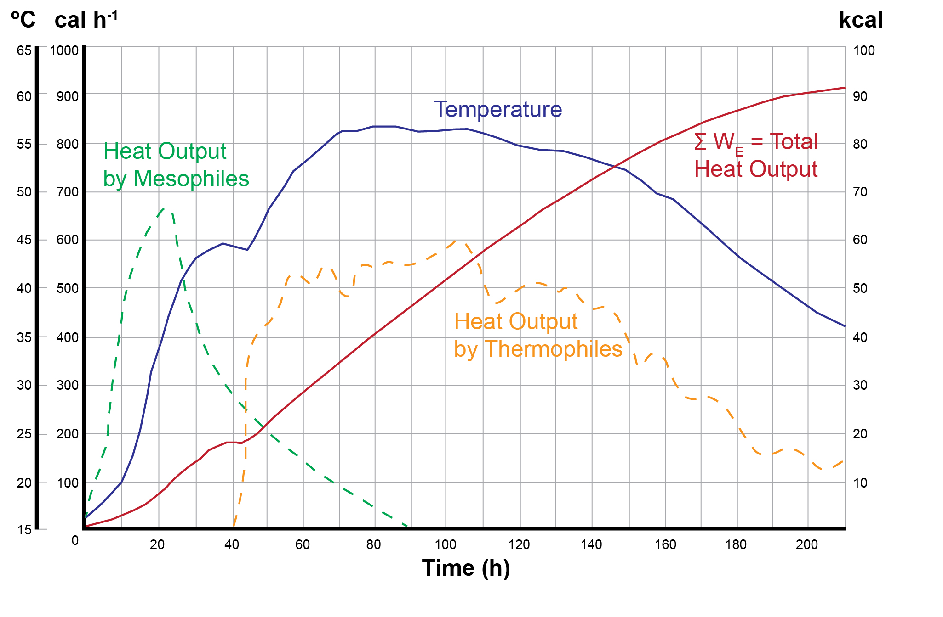

The different anticipated phases of the composting process, as identified within Figure 2.1 are as follows:

Mesophilic Heating

This is the initial stage of the composting process. During this phase, the substrate is degraded by a diverse population of aerobic mesophilic fungi and bacteria. These organisms degrade the readily available organic material within the materials being composted (the substrate), creating new microbial biomass from the substrate. The heat released from this activity raises the temperature of the pile to approximately 45°C and once this temperature is reached the activity from the mesophilic micro-organisms ceases, with many of them dying off leaving only heat resistant spores. In Figure 2.1 this is the period shown up to approximately 40 hours, where the temperature has increased to 45°C. The “heat release from mesophiles” curve shown in Figure 2.1 gives an indication of the relationship between the activity of the mesophiles and temperature. After approximately 20 hours the temperature curve increases to approximately 37ºC. This point corresponds to a peak in the “heat output of the mesophiles” curve of approximately 670 cal/h. As the temperature continues to increase the heat output by mesophiles falls. This reduction in heat output is indicative of a reduction in composting activity by mesophiles.

Thermophilic Heating

Following completion of the initial mesophilic stage, and the reduction of the associated mesophile population, the pile then becomes populated by a thermophilic microbial population of bacteria and fungi, which tolerate and thrive at higher temperatures. There may be a short lag phase whilst this population develops. This population causes another rise in temperature, the activity of this critical population will cease in the temperature range of 70°C - 80°C. Where temperature profiles are allowed to increase to 70-80°C the production of NH₃ will be unavoidable and therefore can produce poor organic stabilisation and objectionable odours. Above this temperature chemical decomposition takes place which can produce undesirable malodorous materials and increase the risk of fire. Figure 2-1 shows the slight lag time by a levelling of the temperature at around 40 hours. Heating of the mass is then re-established and the temperature increases up to 55°C, with the optimal temperature being in the range of 55° - 60°C.

- One thing that stands out is the production of NH₃ and malodours at 70-80º C, (2.1), which is the range many of our composters sanitise. That's not a criticism more an observation.

However, there are variables in this stage of the process that can adversely affect the rate of thermophilic heating. These are generally related to the system used and feedstocks, where waste with readily available sugars, starches and simple proteins will break down more readily causing a rapid rise in bacterial activity and therefore heat output. This is covered in more detail in section 8 (Operations and Management).

Thermophilic Steady State

Following the increase in temperature to a recommended 55°C, the next phase is a relatively static period where the heat released by thermophiles and the pile temperature reaches an equilibrium. The temperature should therefore remain relatively constant. The microbial population at this point continues to be formed of thermophilic bacteria, actinomycetes (which are seen as white filamentous coating on the compost) and fungi. In Figure 2-1 this phase continues up to approximately 130 hours, but will vary according to the processing system used and feedstock.

Reduction in Activity and Cooling

Finally, there is a reduction in activity as the volatile components (the readily available organic part of the substrate) are used. This final phase is often referred to as the maturation phase. The rate of heat output from the degradation of available material is less than the heat loss from the system, resulting in a reduction in temperature.

As the temperature typically drops below 45°C, mesophilic micro-organisms become re-established from spores and bacteria that have survived the thermophilic process. Other methods of pile re-establishment are from new ‘seed’ organisms that are introduced to the composting mass, for example, from external windblown bioaerosols or from mixing in additional active feedstock. Finally, the mesophilic population succeeds the thermophilic population and continues the degradation and maturing process. A summary of the temperature profile is shown in Table 2.1.
Table 2.1 Summary of expected temperature profiles
Summary expected temperature profiles
<24 hours | Ambient – 45 degrees Celsius | Mesophilic activity
24 - 200 hours | 45-65 degrees Celsius | Thermophilic activity
>200 hours | 45-65 degrees Celsius | Thermophilic and gradual re populations, actinomycete increase
4-12 weeks | < 45 degrees Celsius | Increased colonisation of mesophiles

- Table 2.1 states various temperatures and time but does not qualify the turning regime or other operational characteristics.

In order to produce suitably stabilised humic material within the compost it is necessary to consider the yield coefficient - this is the quantity of biomass generated divided by the weight of substrate presented. For a typical yield coefficient of 0.1, the degradation of 1 mole of glucose (Kutzner, 2000) is:

C₆H₁₂0₆ + 0.16 NH₃ + 5.2 O₂→0.16 C₅H₇O₂N + 5.2 O₂ +5.7 H₂0

Where C₅H₇O₂N is a stoichiometric representation of the microbial biomass.

A simplified representation is:

carbon source+nitrogen source+oxygen→microbial biomass+carbon dioxide+water

- Finally on page 8 I am unsure whether the formula is correct as it doesn't match the description just below it (it shows O2 on the right hand side, whereas the description below refers to CO2)

The equations above illustrate the nitrogen source as ammonia, although other sources of nitrogen may be present or produced from the degradation of organic nitrogen, depending on the feedstock. In a well-managed process, with aerobic conditions throughout the waste mass, any excess nitrogen will become released as ammonia and will be ultimately oxidised to nitrate. The pH conditions in the waste mass will retain ammonia in the aqueous phase as ammonium. This demonstrates the importance of feedstock management and effective composting in the prevention of odour arising from ammonia.

When very high temperatures or anaerobic conditions are allowed to develop in the waste mass, through poor design and/or operational management, this may result in poor organic stabilisation and an accumulation of ammonia. This may lead to health and safety issues for operational staff, producing poorly stabilised humic material and releasing odours. End markets and usage issues are covered in Chapter 9.

By considering the representative make up of a feedstock, it is possible to estimate the required oxygen supply and to determine the likely overall heat output. The material properties of feedstocks are provided in Chapter 5. Site design is covered in Chapter 8. These parameters should be considered in the design of infrastructure on the site, such as the use of aeration systems to maintain aerobic conditions throughout the compost pile. Ventilation of air through the compost material helps to control composting temperature, maintain aerobic conditions, and provide a means to direct the exhaust air stream into abatement.

- The description of the key stages outlined in 2.2 is a good outline of the composting process but it should be emphasised that the figures discussed that have been extracted from figure 2.1 are specific only to the conditions used in the Popel reference. Whilst in theory any composting process should follow these phases, the time taken to reach the different points and the temperatures at these different points will vary enormously based on windrow dimensions, feedstock biodegradability, and process efficiency.
This is particularly important for the last line in Table 2.1 which suggests that temperatures should fall to below 45°C for batches of 4-12 weeks in age. Analysis on our dataset strongly suggests that this is extremely rare for the cross-section of sites we have data for in the UK. The distribution curves calculated in section 3.2 (Figure 1 and Figure 2, page 6) indicate that just 2.2% of all readings taken fell below 45°C for 4-5 week-old batches; this figure increased to only 7.3% for 11-12 week-old material.

The authors of the guidance note clearly appreciate the effects of windrow dimensions on temperature, as this is discussed coherently in Table 4.1. SLC understands the importance of the introducing the different phases of composting in this section but does not feel that presenting the figures in the last row of Table 2.1 as expected temperature profiles is a good idea. Although these temperature profiles would be expected for the particular composting process from which the data were taken, our data strongly suggest that temperatures of below 45°C would actually be quite unexpected for 4-12 week-old compost in the vast majority of cases for UK

Kinetics and Inhibition
Microbial activity within a compost pile is influenced by the following factors:

- moisture content;
- pore space;
- oxygen content;
- process temperature;
- nutrients (C:N, micronutrients, availability); and
- pH.

The microbial population within the composting matrix will continue to grow until one or more of the above factors becomes limiting.

Moisture Content

Moisture supports the metabolic processes of the micro-organisms. Water is the medium for chemical reactions, transportation of nutrients and allows transport of micro-organisms. Biological activity reduces or ceases below 15% mass/mass fresh matter moisture content and in theory activity is optimal when materials are saturated. However, the principal source of the oxygen for microbial populations is the air trapped in the voids between the substrate particles. The moisture content depends on the feedstocks (e.g. particle size, degradability), the composting system being used and the stage of composting (Richard et al., 2002).

During normal operations moisture should be monitored as discussed in Section 8. In open systems additional moisture can be added through using a watering system during turning. Wetter wastes are more suitable for in-vessel systems, such systems should incorporate the ability to collect excess moisture.

The optimal moisture content will vary depending on the feedstock and composting system being used. However, a moisture content range of 50% to 60% (on a mass/ mass fresh matter basis) is considered to contain the optimum point for the majority of materials, depending on the particle size, degradability, stage of composting and management regime.

Below the optimum moisture range it is likely that there is an insufficiently aqueous environment for the ideal composting bacteria and fungi. At a moisture content of below 40%, micro-organism activity will continue but at a slower rate, thus limiting the throughput and potentially reducing the end quality of the material in terms of its pathogen content. Drier material will also give rise to high levels of bioaerosols, dust and a potential risk of fire.

At a moisture content above 65% m/m fresh matter water will displace much of the free air space in the pore spaces within the composting matrix which becomes blocked with moisture or compacted material, thereby limiting the mass transport of oxygen. This further reduces microbial activity and can lead to the development of anaerobic conditions.

Further detailed information on the relationship between air space, temperature and moisture will be published in early 2013..

Moisture content should be above 40% m/m fresh matter at the starting point and will generally decrease as composting proceeds. Therefore if the moisture content falls below 40% m/m fresh matter, more should be added to maintain optimum conditions.

Materials should not be allowed to dry out below 40% m/m fresh matter moisture content, as this will increase the chance of damagingly high temperatures or even spontaneous combustion.

Maintaining the correct moisture balance requires proactive management of the material throughout the process.

- p15 of 130– ‘additional moisture can be added using mister during turning’?!?!! Why not just use liquid feedstocks? Although further info regarding moisture, temperature and air space to be released early in 2013, nutrient rich liquids/sludges can be beneficial used within a composting operation. A prime example being raw sewage sludge. The EA accept, in the tables at the end of the document, that the corrective action if a compost heap is too dry is to add water. Why can this liquid not be nutrient rich to not only rectify water content but also nutrient deficiencies, or even nutrients to enhance the composting process ?

Pore Space

Pore space or porosity refers to the void space within the composting material. Pore space is important as the principal source of the oxygen required by the microbial population is the air trapped in the voids between the substrate particles. The majority of aerobic decomposition occurs on the surface of particles. The reaction is at the solid/liquid interface and it is therefore necessary to transport oxygen to that point. Oxygen moves readily as a gas through pore spaces, but moves more slowly through liquid and solid phases. Therefore the movement through the liquid phase has the potential to limit the process.

Insufficient pore space will impede the process through insufficient mass transfer of oxygen, carbon dioxide and off gases. Pore space can also become clogged with moisture, diminishing the effective pore space. However, pore space can be restored within a composting mass through additional bulking agents, turning or agitation.

The relationship between moisture content and available pore space and availability of oxygen can be represented by the term “tolerable moisture content”. This may be affected by physical characteristics of the composting material. Tightly packed particles and feedstock materials, such as layered and wet paper and card, allow pockets of stale off gases to develop and prevent the circulation of air. In these situations anaerobic conditions can develop. The photograph below (Figure 2.2) shows packed and dense material that may give rise to reduced diffusion of oxygen in the mass of materials.

The physical structural properties of the raw materials can therefore affect the composting process. Feedstocks must be adjusted by selection and mixing to provide optimum conditions for composting. Any materials added to adjust these properties are often referred to as bulking agents. The blending of feedstock can aid the distribution of particle size prior to shredding, and so aid aeration and air distribution.

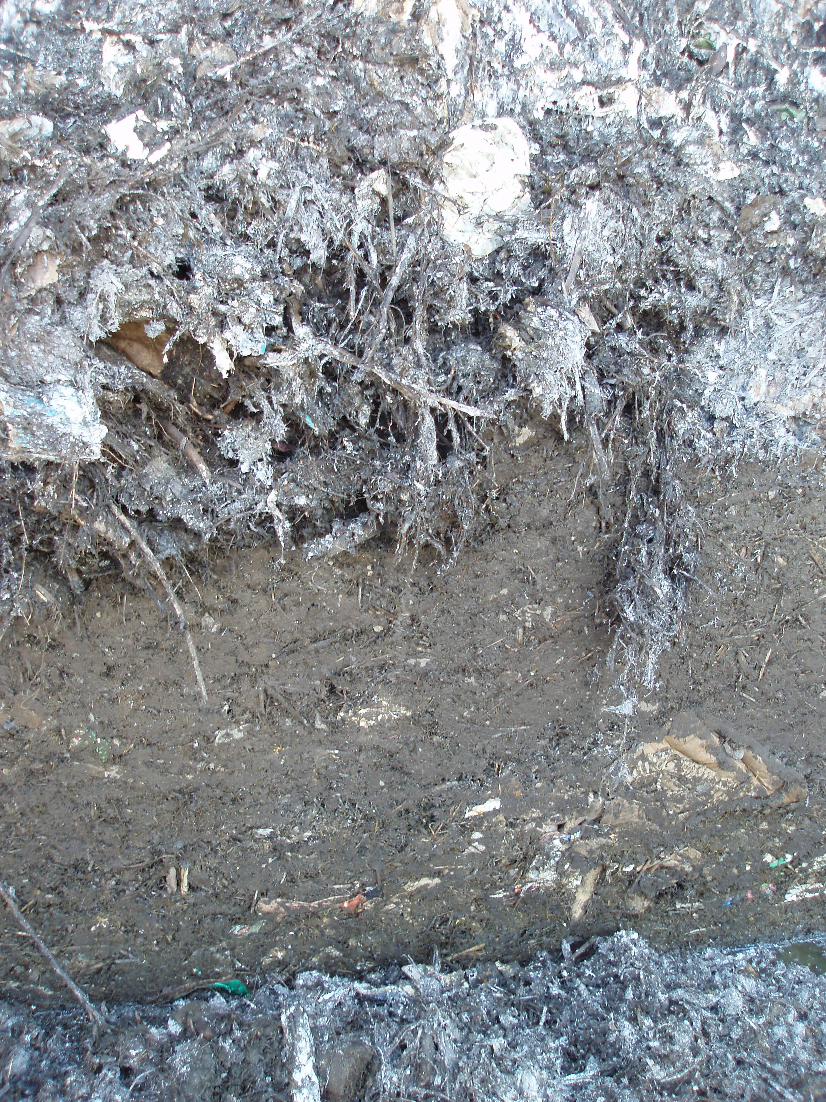
Figure 2.2 Densely packed material and poor diffusion of gases

Oxygen Content

As the process is aerobic it will require a ready supply of oxygen throughout the compost pile. When composting dense materials or materials with small particle sizes it may be necessary to consider methods of supplying appropriate quantities of oxygen throughout the compost mass. Oxygen up take and depletion is caused by microbial activity. The availability of oxygen to the microbes will be influenced by high temperatures and other parameters.

Process Temperature

The optimum temperature range for thermophilic populations is 55°C-60°C, as at about 60°C some beneficial micro-organisms start to be killed. For mesophilic populations the optimum temperature is in the range of 35°C to 45°C. These are typical optimums as there may be combinations of microbial species and feedstocks that have optimums outside of these ranges.

Nutrients

A volatile solids content of at least 40% mass/mass dry basis is needed for the material to be suitable for composting. Volatile solids are that fraction of the total solid which is organic and that can be treated biologically. It is important for the volatile material present to be biodegradable.

- p18 of 130 – Under nutrients, 40% volatile solids/biodegradability is required. Do the EA mean 40% of fresh weight is volatile/degradable or 40% of dry weight (as written) is volatile/degradable? Where does the 40% originate from – no evidence of the science to justify statement.

Nutrients can be grouped into the categories “macronutrients” and “micronutrients”. The macronutrients include carbon (C), nitrogen (N), phosphorus (P), calcium (Ca), and potassium (K). In fact, most become toxic in concentrations above trace. Among the essential trace elements are magnesium (Mg), manganese (Mn), cobalt (Co), iron (Fe), and sulphur (S). Most trace elements have a role in the cellular metabolism.

The most common descriptor of nutrient availability in composting is the carbon to nitrogen ratio (C:N).

Nitrogen is used by micro-organisms for protein manufacture and for reproduction and carbon is used for energy and growth. Generally speaking, biological organisms need about 25 times more carbon than nitrogen. Microorganisms use carbon as an energy source and nitrogen to build proteins and other cell components. However, the carbon and nitrogen in organic materials may not always be readily available to microbes. In general, the combination of feedstock quality and compost management will determine the quality of the finished product. This ideal C:N ratio is not found in any one organic source. However, the majority of organic materials contain ample quantities of nutrients.

Carbon is often present in green waste collections and is much harder for microbes to access than the nitrogen. The complexity of the carbon compounds also affects the rate at which organic wastes are broken down. The ease with which compounds degrade generally follows the order:

carbohydrates > hemicellulose > cellulose > chitin > lignin.

Fruit and vegetable wastes are easily degraded because they contain mostly simple carbohydrates (sugars and starches). In contrast, leaves, stems, nutshells, bark and trees decompose more slowly because they contain cellulose, hemicellulose and lignin.

Cellulose is the structural component of the primary cell wall of green plants , many forms of algae and the oomycetes. Some species of bacteria secrete it to form biofilms. About 33% of all plant matter is cellulose (the cellulose content of cotton is 90% and that of wood is 40–50%).

Lignin aids the transportation of water in plants and adds the strength to the cell wall. Lignin is one of the most slowly decomposing components of dead vegetation, contributing a major fraction of the material that becomes humus as it decomposes.

The rate at which carbon compounds decompose must be considered in planning site operations. If the carbon is in the form that is difficult to decompose, for example large wood particles, the composting rate may be slower (e.g. wood wastes). Since decomposition occurs on particle surfaces, degradability can be improved by reducing the particle size as long as porosity is not compromised.

Raw materials mixed to provide a C:N ratio of 25:1 to 35:1 are generally accepted as ideal for active composting, although ratios from 20:1 up to 40:1 can give good composting results. The carbon should be readily biodegradable, for example lignin is resistant to biological decomposition but contains carbon, this carbon is likely to remain bound up through the typical composting process and residence time.

Low C:N ratios of below 20:1 allow the carbon to be fully utilised without stabilising the nitrogen, which may be lost as ammonia gas or nitrous oxide (especially when the temperature rises and the pH is higher than 7.5) possibly resulting in odour issues. High nitrogen, low carbon feedstocks have a rapid oxygen consumption and these feedstocks require almost constant and vigilant management as the temperature changes and processing are rapid. The feedstocks are also generally more compact and this makes any aeration problematic, which can also cause odour problems.

Ratios of composting materials with a carbon content higher than 40:1 require longer periods for the excess carbon to be used by micro-organisms and for the material to be stabilised. Table 2.2 summarises the C:N ratios for composting.

Table 2.2 Optimal C:N ratios for rapid, aerobic composting (Adapted from Rynk, 1992)
Carbon | Nitrogen | By- Product | Potential risk/problems
<20 | 1 | Excess nitrogen may give rise to ammonia and loss of nitrogen | Off site odour – shock loading in biofilters
> 40 | 1 | Slower rate of composting | Prolonged pad residence and over tonnage at site.  Risk of fires increased

pH

pH level usually drops at the beginning of the compost process. The initial drop reflects the synthesis of organic acids. The acids serve as substrates for following microbial populations. As the pH rises, it reflects the utilisation of the acids by the microbes. Most bacteria will not survive at a pH of 3 or below. Similarly, most bacteria begin to lose activity at pH levels above 10.5, with significant kills above ~pH11.5. Although this range is within the pH criteria for non-hazardous wastes, it is important to note that there will be reduced microbial activity at these extremes.

Composting has some buffering capacity for both alkali and acid wastes. This is due to the production of carbonic acid, a weak acid formed by CO₂ in solution and of ammonia, a weak base. High pH materials will need to be treated or blended to adjust their pH or the process will encounter an extended lag phase before high activity composting occurs. In low nitrogen, low pH materials there may be insufficient ammonia to bring the material to a favourable pH. These situations can occur more frequently where novel wastes are accepted and is not best practise for creating ideal composting conditions.

Therefore it may be necessary to manage this feedstock by blending with additional appropriate material.

Further discussions on the requirements of the composting mass are made in Chapter 5.

Process Configuration
Typically, the phases of composting at a site consist of:

- Pre-processing;
- Sanitisation
- Stabilisation
- Curing/maturation; and
- Post processing.

Pre-processing

Pre-processing usually consists of reception and storage, checking of biowaste quality (at least visually), shredding, blending of materials and/or amendment of moisture balance. To effectively manage odour industry best practice is to manage waste materials before they are received at the site, as there is less likelihood of odorous emissions from fresh waste. This is difficult where contracts take kerb side collected waste which may present waste in an advanced stage of decomposition. The amount of decomposition will depend on factors such as collection frequency and source. .

It would be useful if there was expanded information on the different waste collection methods and managing this at the site (e.g RCV compacted waste that may have been in a bin in the summer for 2 weeks vs. Civic Amenity woody waste etc) as it is only briefly mentioned.

Also and tied into the previous comment it would be useful if there was information as to how collection methods impact the composting process. This would allow local authorities to determine the most appropriate collection methods for their contracts as some collection methods may introduce additional costs that we are unaware of (for example if we compact the green waste).

Particular attention needs to be paid where wastes are bulked up at transfer stations. Where the waste is fresher there is generally less likelihood of odorous emissions when the waste is received and processed on site. Best practice should see waste operators actively auditing upstream feedstock suppliers..

This implies an offsite audit of feedstock suppliers which should not be necessary, the AfOR guidance and compost certification scheme rules suggest inspection of loads at the operator’s site and this should be sufficient to audit feedstock. Operators need to give feedback to suppliers and if necessary not accept waste from poor quality sources. As an example we accept waste from some landscapers regularly, where we are approached by a new client we actively monitor their deliveries to establish a pattern of compliance with quality standards.
Once accepted on site, materials should be processed within 24 hours to avoid uncontrolled decomposition of the waste, See point above

Once accepted on site, materials should be processed within 24 hours to avoid uncontrolled decomposition of the waste. Where this is not possible then the feedstock must be managed to maintain aerobic conditions, for example through the use of aeration. The site must develop contingency to divert wastes when unable to process them quickly. Please refer to Chapter 8 which provides further discussion on the requirements of contingency planning.

- Contingency to divert wastes when unable to process them quickly. Extremely unlikely that an operator will divert wastes to a competitor, who will pay for the diversion? Low gate fees suggest there isn’t the money to pay for this and extremely unlikely that the producer will pay out if the operator can’t cope.

Sanitisation
As previously discussed in Section 2.2, the sanitisation composting phase is characterised by an increase to thermophilic temperatures (55° - 70°C), high oxygen demand and high reductions in volatile solids.

The sanitisation period depends on the material being treated, the process that it is subjected to and the management by the operator. Many of the in-vessel systems were originally developed to more effectively manage the material and improve the process control during the composting process. However, subject to Animal Health & Veterinary Laboratories Agency (AHVLA) approval, these systems are mainly used for the sanitisation phase required for material subject to the Animal By-Products Regulations (ABPR).

Influencing factors such as encapsulation, low gate fees and high capital costs have led to in-vessel residence times being restricted to meet the minimum requirement of ABPR. This will often not be best practice as the waste should be kept in vessel until the sanitisation stage is complete.

Stabilisation

Once the sanitisation stage has been completed to eradicate pathogens and kill weed seeds, the waste will be highly biodegradable. A further period of actively managed composting is required; this stage is known as stabilisation. This is commonly at thermophilic temperature of approximately 55°C. However, lower temperatures have been demonstrated to increase the rate of decomposition.

Stabilisation is the process of biological activities combined with the other conditions within the composting mass, which gives rise to stable compost.

The compost is said to be stable when microbial respiration will not significantly resurge under altered conditions e.g. changes of moisture, oxygen levels or temperature. The rate of carbon dioxide and heat release decreases with increased stability.

The stabilisation period will typically last between 1-12 weeks. The degree of stability needed is related to the intended end use of the compost. i.e. horticultural end uses require a greater degree of stability, as less stable material may contain phytotoxic substances which are problematic for seedlings (if compost is use as or in significant proportion in a growing medium) and may become odorous in storage. Determining the degree of stability is still a developing scientific area and operators should consult with the end markets and users to agree a mutually agreeable test method and acceptance level.

Material that requires further stabilisation for end market will still require active management. Less stable material will have a higher risk of producing odours, leachate, dust and bioaerosol release.

Curing/Maturation

Once the majority of the easily digestible organic material (available carbon and nitrogen) has been used up, the rate of heat release will drop and the material will move into the curing/maturation phase. During this phase the oxygen demand is reduced and temperatures will be approximately 35° - 45°C, and continue to cool. Additionally reactions will take place to reduce the level of nitrate within the compost and this stage will also need to be managed to prevent odours, dust and bioaerosols. There is also a risk of reheating and leachate breakout.

Post Processing

The post processing phase generally involves a combination of screening, blending and bagging to produce a quality, saleable product. The timing and processing applied will depend on the requirements of the finished product markets.

- We feel that the requirement of operators to shred all material within 24 hours suggested in this section and elsewhere in the document (e.g. Table 7.1) severely restricts the ability of operators to create a feedstock blend with the correct C:N ratio (the importance of which is clearly outlined in the preceding ‘Pore Space’ and ‘Nutrient’ sections). Several sites receive different waste streams on different days and as such the ability to be able to blend these correctly prior to shredding is critical.

Whilst we would not advocate stockpiling high-nitrogen wastes due to their inherent instability and odour release potential, several managers of well-run sites achieve a consistently high-quality feedstock by stockpiling high-carbon wastes and oversize when these materials are plentiful and then blending these with high-nitrogen wastes – such as loads with a high proportion of grass clippings – when needed.

In order to allow operators to be able to achieve adequate feedstock blends, we would like to see the requirement to process waste within 24 hours relaxed for high-carbon relatively stable materials (including oversize) with a low odour release potential.

Process Types
There are many different composting processes and classification methods for composting. One classification system is shown below in Figure 2.3. It can been seen that there are many variations in processes. However, the fundamental requirements of the process remain the same irrespective of system applied. The bottom row of the diagram in Figure 2.3 shows increasing technological intervention moving from right to left, with non-encapsulated (open systems, i.e. not housed), non-aerated piles on the right to rotating reactors (in-vessel) on the left. For example an open windrow would be classed as a no reactor semi dynamic non-encapsulated system. The major differentiator is whether or not a reactor is used. Other differences include the approach to aeration and agitation of the material to improve mass transfer. There are numerous approaches to composting and various subtleties between different, similar systems. The descriptions given here provide general outlines, but it is likely to be necessary to consider an individual operator’s process.

Terminology to describe different types in Fig 2 are not the ones commonly used in the industry, this diagram is not clear. For example what the industry calls “Open windrow” is here defined as “Stacked triangular not encapsulated static no reactor composting” not sure it will catch on?

Figure 2.3 Hierarchy of Composting Systems (After Grüneklee, 1998)

Round reactor
Reactor
(In Vessel)
Technical Composting
No Reactor
Static
Static
Semi Dynamic
Semi Dynamic
Dynamic
Encapsulated(housed)

Not Encapsulated

Not Encapsulated

Horizontal
Moved reactor bottom
Vertical
Tunnel
Box
Rotating drum
Bricks
Plain heaps

Bricks
Triangular windrows

Plain heaps
Stacked rectangular heap

Stacked triangular windrow

Stacked rectangular heap

Stacked triangular windrow

Container
Tunnel reactor
Round reactor
Tunnel reactor
Encapsulated(housed)

No Reactor Composting
The most commonly encountered form of composting which does not require a reactor is windrow composting. The physical process is relatively simple with limited engineered infrastructure needed. Source materials are mixed and formed into long piles, known as windrows. The process can be operated in the open or enclosed within a building. Further detailed technical information is provided in Chapter 4.

Reactor Composting
Reactor based or enclosed composting, encloses the composting process. Depending on site design this provides opportunity for a significantly greater degree of control over the process. They require a greater degree of infrastructure than windrow composting. In England and Wales reactor or enclosed composting is commonly used to provided treatment for animal by-products. Most involve a short period of reactor sanitisation followed by treatment in a open windrow.

Enclosed systems can be divided into 6 types, namely;

- Containers;
- Tunnels;
- Rotating drums;
- Silos or Towers;
- Enclosed halls; and
- Agitated bays

One distinction to make is that containers, tunnels, rotating drums and silos or towers are individually contained processes whereas enclosed halls and agitated bays are carried out in individual units within an overall building that contains the emissions.

Fully enclosed systems are typically referred to as in-vessel composting (IVC). These generally require less land space than an open windrow plant. When estimating the required area for the composting of 60,000 tonnes per year, an open windrow plant is approximately three times the size of the in-vessel composting plant. However, most in-vessel systems are primarily used for sanitisation to meet ABPR requirements of waste only. The high temperatures do not allow meaningful stabilisation to take place and waste may emerge with even higher degradation needs and will require aggressive active management.

Some further detail on various in-vessel composting systems configurations, capacity and designs are available in the Composting Association document “A Guide to In-Vessel Composting” (2004). Operators need to be aware of the systems optimal requirements for aerobic operations.

Emission Abatement
The principal output from the composting process is the composted material itself. Additionally there will be leachate, gas, dust and bioaerosol emissions and low grade heat. Further information on emissions is provided in Chapter 7 which also discusses monitoring methodology and abatement techniques. A diagram illustrating the inputs and outputs of a typical composting process is provided in Figure 2.4.

Figure 2.4 Typical inputs and outputs in a composting process
Pre-processing
Sanitisation
Curing/
maturation
Post-processing
Stabilisation

-Rejects and contraries
-Off gas for treatment
-Bioaerosols
-odours

-Bioaerosols
-odours

-Stabilised compost
-Oversize
-Contraries and contaminants
-Off gas for treatment
-Bioaerosols
-odours
-Feedstock materials
-Water
-Air
-Agitation
-Water
-Air

-Blending materials
-Water
-Air
-Agitation

Pre-processing
Sanitisation
Curing/
maturation
Post-processing
Stabilisation

-Rejects and contraries
-Off gas for treatment
-Bioaerosols
-odours

-Bioaerosols
-odours

-Stabilised compost
-Oversize
-Contraries and contaminants
-Off gas for treatment
-Bioaerosols
-odours
-Feedstock materials
-Water
-Air
-Agitation
-Water
-Air

-Blending materials
-Water
-Air
-Agitation

Pre-processing
Sanitisation
Curing/
maturation
Post-processing
Stabilisation

-Rejects and contraries
-Off gas for treatment
-Bioaerosols
-odours

-Bioaerosols
-odours

-Stabilised compost
-Oversize
-Contraries and contaminants
-Off gas for treatment
-Bioaerosols
-odours
-Feedstock materials
-Water
-Air
-Agitation
-Water
-Air

-Blending materials
-Water
-Air
-Agitation

Pre-processing
Sanitisation
Curing/
maturation
Post-processing
Stabilisation

-Rejects and contraries
-Off gas for treatment
-Bioaerosols
-odours

-Bioaerosols
-odours

-Stabilised compost
-Oversize
-Contraries and contaminants
-Off gas for treatment
-Bioaerosols
-odours
-Feedstock materials
-Water
-Air
-Agitation
-Water
-Air

-Blending materials
-Water
-Air
-Agitation

Possible
inputs

Stage

Possible
outputs

- P25 of 130 – Within figure 2.4, and at all other places in document the word “water” should be replaced with more generic term e.g. liquid or moisture. Water is a specific compound and should be avoided. There are a significant number of suitable liquids which are appropriate for inclusion in a composting system, the EA need to move away from their persistent aversion to the use of liquid waste in composting systems. Where is the EA science to suggest otherwise?

Markets and Outputs
Compost is used as a soil conditioner for agricultural and land improvement applications. Used as a soil conditioner, the humic material can increase the water and nutrient retention of soils and provide organic and micronutrients, resulting in increased yields
The potential outlets for the material are discussed further in Chapter 9.

Regulations and Standards

European Regulatory Context
European Directives are transposed into National legislation through Acts of Parliament and associated Statutory Instruments which are enforced accordingly. In England and Wales, the key European Directives that underpin UK legislation with respect to the regulation of the composting of wastes are as follows:

- The Waste Framework Directive (2008/98/EC): Established the waste hierarchy and prioritising recycling over recovery. The 50% target for recycling makes composting an important factor as organics still represent the biggest fraction of MSW in most European countries. A 70% target for recovery of non hazardous construction and demolition waste is also required of member states. This Directive and preceding Waste framework directives require the establishment of a system of permitting and regulation of facilities that manage wastes. The Directive also defines the principles for waste treatment operations to be deemed as “recovery”; all other operations being classified as “disposal”.
- The EU Landfill Directive (2003/33/EC): The landfill directive defines technical standards for the disposal of waste and sets targets for the reduction of biodegradable municipal waste disposal to land. These targets are the primary driver for initiatives on biodegradable municipal waste as they require increasing diversion of biodegradable municipal waste from landfill when measured against a 1995 baseline at specific dates. The upper limit demands 75% diversion of biodegradable municipal waste by 2020. At a national level its implementation generally includes separate collection of organic waste and use of composting or AD facilities.
- The Industrial Emissions Directive (2010/75/EU): Coalesced seven existing directives (including the Integrated Pollution Prevention and Control Directive) into one Directive. Larger scale composting facilities (those with a treatment capacity exceeding 75 tonnes per day) may be regulated (via their Environmental Permit) under the requirements of this Directive.
- The EU Animal By-Product Regulation (EC) No. 1069/2009: The regulations include sanitary requirements for the application and production of compost made from animal waste (including mixed with other food waste). The nature of the sanitary requirements can influence the suitability of feedstock or processes at composting sites.

Regulations EU Context – should be updated with the Soil Directive when published as this will be relevant in terms of objectives for finished composts

The UK Regulatory Requirements
The regulation of composting activities which involve waste materials is undertaken by both Local Authorities, via the planning regime and statutory nuisance, and the Environment Agency through the Environmental Permitting regime.

Further regulatory controls can be applied by AHVLA (should the composting process involve any wastes covered by The Animal By-Products (Enforcement) (England) Regulations 2011) or, in Wales, The Animal By-Products (Enforcement) (Wales) Regulations 2011) and the Health and Safety Executive.

The main purpose of this section of the document is to provide guidance on the regulatory requirements of the Environment Agency in England and Wales, however information is also provided concerning the requirements of other regulatory bodies where there is an overlap or they integrate with the regulatory requirements of the Environment Agency.

This guidance only applies to the composting of materials consisting of or including wastes. The Government has provided guidance on the meaning of waste in the Waste Framework Directive in its Environmental Permitting Guidance “The Waste Framework Directive”, chapter 3, available at:
http://www.defra.gov.uk/publications/files/pb13569-wfd-guidance-091001.pdf.

Whilst all the regulatory information within this document is correct at the time of publication, it is recommended that anyone wishing to develop and operate a composting facility should check whether there have been any applicable new regulatory requirements applied since publication. Information on any such changes should be available from the Environment Agency NetRegs website http://www.environment-agency.gov.uk/netregs/, or reference the Statute Law database http://www.legislation.gov.uk/.

Planning
All facilities must be developed in accordance with local, regional and national authorisations appropriate to the area where the facility is to be developed. This should encompass:

- Planning Permission;
- Exemption, Waste or Installation Environmental Permit, or Installation Environmental Permit;
- Animal By Product consultation and validation;
- Health and Safety consultation, and may include
- Environmental Impact Assessment.(EIA).

In addition the government has recently published a new National Planning Policy Framework (UK Government, 2012) which sets out what developers will need to take into account in any future plans in order to meet the requirements for sustainable development which they will be assessed against. This framework is currently only applicable to England.

Early dialogue and pre-application advice is highly recommended to understand, on any given scheme, the legal requirements, procedural steps that need to be followed, the likely timescales and the extent of engagement with the local community and other stakeholders that may be required.

Appropriate consideration should be given to site selection so that it fits within the existing development plans and is appropriate for development as a composting facility. Site selection should also include likely impacts of the facility on neighbours.

Operators must recognise that the length of time required to achieve planning permission for a compost facility varies from site to site and depends on local circumstance. Small operators in particular are advised to take this into account when preparing their business plans. Where existing authorisations exist for a site, this tends to allow operations to be established more quickly although care must be taken to ensure that existing authorisations are appropriate and entirely up to date.

On receipt of a planning application, the planning authority will determine whether there is a requirement for the facility within the Local Development Plan. For such an application to be successful it must address all relevant planning policies and local factors such as SSSIs, traffic and green belt land. Stakeholders planning to develop and operate a composting facility should contact the local Planning Authority for advice and guidance on applying for the appropriate planning permission.

Operators should consider the best practice approach for twin tracking development of the environmental permit application with the planning application as there are a number of procedural steps where benefit will be achieved by developing them in parallel. However, operators should be aware that Bespoke Permit applications for composting sites require a wide range of supporting documents, as described in 3.4.4 and can be expensive, therefore it may be preferable to get planning permission first.

Environmental Permitting for Facilities in England and Wales

Introduction
The following section provides an overview of Environmental Permitting in England and Wales and how it applies to composting operations. Additional information can be found in the Environmental Permitting section of the Environment Agency website which can be found at:
http://www.environment-agency.gov.uk/business/topics/permitting/default.aspx.

In England and Wales, at the time of writing of this guidance the permitting requirements and standards of the Waste Framework Directive (WFD) and the Industrial Emissions Directive (IED) are applied by the Environmental Permitting (England and Wales) Regulations 2010 (the EPR) and their associated amendments (The Environmental Permitting (England and Wales) (Amendment) Regulations 2011 and The Environmental Permitting (England and Wales) (Amendment) Regulations 2012). Further amendments to the EPR are likely to complete the transposition of the IED into English and Welsh legislation.

As a waste management operation (disposal or recovery), it will be necessary for most commercial scale compost facilities to obtain an Environmental Permit from the Environment Agency before composting operations commence. The application will either be for a waste operation in accordance with the requirements of the Waste Framework Directive (WFD) or as an installation in accordance with the requirements of the Industrial Emissions Directive (IED).

The waste management operations specified by the WFD that are relevant to composting operations are:

- D8: Biological treatment pending disposal
- D15: Storage pending disposal
- R3: Recycling or reclamation of organic substances which are not used as solvents
- R10: Spreading of waste on land resulting in benefit to agriculture or ecological improvement
- R13: Storage pending recovery

The installation activities detailed within Annex 1 to the IED that are relevant to composting are:

Section 5.3(a)(i): Disposal of non-hazardous waste with a capacity exceeding 50 tonnes per day involving biological treatment.
Section 5.3(b)(i): Recovery, or a mix of recovery and disposal, of non-hazardous waste with a capacity exceeding 75 tonnes per day involving biological treatment.

IED will be implemented through amendment of the existing Environmental Permitting Regulations. Defra and Welsh Government are consulting on draft amending Regulations and IED will be implemented over several years commencing from 7 January 2013. The implementation sequence is:
- 12 March 2012 launch of Defra/ Welsh Government consultation (closes 6 June 2012);
- 7 January 2013: amended Environmental Permitting Regulations enter into force;
- 7 January 2013: IED applies to all new installations from this date onwards;
- 7 January 2014: IED applies to existing IPPC installations;
- 7 July 2015: IED applies to existing installations operating newly prescribed IPPC activities (for example, specified waste recovery activities, wood preservation)

Composting facilities currently require planning permission before an Environmental Permit can be issued. However, this may change in the future.

- P29 of 130 - ‘the planning authority will determine whether there is a requirement for the facility within the Local Plan’. Does the Local Plan bother itself with industrial wastes, that will travel, or just domestic composting? If the latter is the case it will be difficult to counter this.

In order for an Environmental Permit to be granted, the Environment Agency must be satisfied that the activity will be operated in a manner so as to prevent pollution of the environment and harm to human health. The permit conditions indicate what needs to be done to prevent different types of pollution, e.g. odour pollution will be assessed differently from groundwater pollution. How to Comply with your Environmental Permit guidance document provided more information. This is available on the Environment Agency website http://www.environment-agency.gov.uk/

For waste operations permitted under the WFD, operators are required to demonstrate that they will take all appropriate measures as laid out within this document to minimise and prevent unacceptable pollution of the environment and harm to human health. This includes offence to senses and loss of amenity. Before a permit can be issued to them, operators must demonstrate ‘Operator Competence’ satisfying each of the following three elements:

- Appropriately technical competent management must be provided and this technical competence must be maintained by compliance with an approved scheme.
- The number and nature of any relevant offences must be disclosed and taken into account.
- The Environment Agency must be satisfied that the operator will be able to provide an appropriate level of financial provision (now only applies to landfills).

For waste installations permitted under the IED, Operators must demonstrate that their activities satisfy the criteria of Best Available Techniques (BAT), providing an assessment and justification of their proposals against relevant Sector Guidance Notes (SGN) and BAT Reference Standards (BREF).

Depending upon the type and scale of the operation, it will require either a bespoke Environmental Permit or a standard rules Environmental Permit. Exemptions from requiring an Environmental Permit are also available. The following sections provide guidance on which type of Environmental Permit will apply.

Exemptions from Requiring an Environmental Permit for Composting Operations
Some small scale and low risk waste operations can be registered as being exempt from requiring an Environmental Permit.

For composting operations in England and Wales, one exemption from requiring an Environmental Permit is available for aerobic composting and associated prior treatment (exemption T23). This exemption allows the composting of small volumes of vegetation, cardboard and food wastes to produce a compost that can be spread on land to provide benefit. This benefit could be nutrient addition or to improve structure of the soil. It also allows the pre-treatment of waste prior to composting by chipping or similar activities. Guidance on this exemption can be found at http://www.environment-agency.gov.uk/business/topics/permitting/116273.aspx. The exemption can be registered with the Environment Agency by following the links within the guidance.

Due to the small scale of the activities allowed by this exemption (maximum of 80 tonnes at any one time), it is unlikely to apply to most commercial composting operations.

Exemptions for land spreading

There are two exemptions which are applicable to spreading waste derived composts to land, these are:

- U10 – Spreading waste on agricultural land to confer benefit
- U11 – Spreading waste on non-agricultural land to confer benefit

For all exempt activity waste must be recovered or disposed of without endangering human health and causing harm to the environment, in particular:

- without risk to water, air, soil, plants and animals;
- without causing nuisance through noise and odours;
- without adversely affecting the countryside or places of special interest.

Additional controls may need to be put in place, over and above the ones specified in the exemptions, to make sure this happens. If the site where the intended operation is to be carried out is undeveloped, operators need to make sure that it will not impact on any protected sites such as European Sites or Sites of Special Scientific Interest (SSSIs).
To check on the current position with regard to available exemptions from requiring an Environmental Permit, please go to the waste exemptions page of the Environment Agency website:
http://www.environment-agency.gov.uk/business/topics/permitting/32322.aspx.

Standard Rules Environmental Permits for Composting Operations.
Standard Rules Environmental Permits (also known as Tier 2 permits) are available where the size/scale, location and types of waste to be composted are such that the Environment Agency has determined that the level of environmental risk from the operation is suitable for control by such an Environmental Permit.

Standard Rules Environmental Permits have a simpler application process than bespoke Environmental Permits applications, and also attract a lower fixed application fee and subsistence charges.

There are a range of criteria that must be satisfied in order for an activity to be able to operate under a Standard Rules Permit.

The current standard rules permit for composting in open systems (non reactor, non encapsulated), SR2008No16, requires the following criteria to be met:
- The quantity of waste that can be accepted onto the site is less than 75,000 tonnes per annum
- The storage, physical treatment and composting of wastes must be at least 250 metres away from the nearest sensitive receptor (typically a dwelling or workplace) The activities shall not be carried out within Groundwater Source Protection Zone 1 or 2 or if a Source Protection Zone has not been defined then within 250m of any well, spring or borehole used for the supply of water for human consumption. This must include Private Water Supplies
- The activities are not within 50 metres of National Nature Reserves (NNR), Local Nature Reserves (LNR), Local Wildlife Site (LWS), Ancient woodland or Scheduled Ancient Monument; or within 50 metres of relevant BAP species/habitats.
- The activities are not carried out within 500 metres of a European site, Ramsar site or a site of Special Scientific Interest (SSSI) or within 250 metres of the presence of Great Crested Newts where it is linked to the breeding ponds of the newts by good habitat. This information can be determined by calling the Environment Agency on 0370 8506506.

The current standard rules permit for composting in closed systems (in vessel composting), SR2008No17, requires the following criteria to be met:
- The quantity of waste that can be accepted onto the site is less than 75,000 tonnes per annum
- The storage, physical treatment and composting of wastes must be at least 250 metres away from the nearest sensitive receptor (typically a dwelling or workplace)
- The permitted activities must also be outside groundwater Source Protection Zones 1 (inner) and 2 (outer). If a Source Protection Zone has not been defined then the activity must also be outside 250m of any other well, spring or borehole used for the supply of water for human consumption
- The only discharges to controlled waters are surface water from the roofs of buildings and from areas of the site not used for the storage or treatment of wastes
- The activities are not carried out within 500 metres of a European Site, Ramsar site or a Site of Special Scientific Interest (SSSI). This information can be determined by calling the Environment Agency on 0370 8506506.

Operators should be aware that the criteria for permits can be changed or new ones added and should consult the EA website at the time an Environmental Permit is required.

Table 3.1 details the standard rules Environmental Permits available for composting operations and the throughput limits that apply. Should the proposed operation meet these basic criteria, it will be necessary to check the actual permit conditions to establish if the location and other criteria that apply to the Permit can be met, and that the waste types permitted are suitable for the proposed operation. If not, a bespoke Environmental Permit will be required.

Table 3.1 Standard Rules Permit throughput limits
Standard Rules Permit | Throughput Limits¹
SR2008No16 Composting in open systems | <75,000 tpa
SR2008No17 Composting in closed systems (in-vessel composting) | <75,000 tpa
SR2010No14 Composting biodegradable waste (in open and contained systems) | <500 tonnes on site at any one time
SR2011No1 Composting biodegradable waste pursuant to T23 (in open and contained systems) | <500 tonnes on site at any one time
¹These are the maximum limits allowed under the Permit – site/operational or other constraints may limit the throughput to a lesser amount.

Details on the specific criteria that apply to each of the above standard rules Environmental Permits can be found at
http://www.environment-agency.gov.uk/business/topics/permitting/118404.aspx. It is important to note that the Environment Agency is continuing to develop its range of standard rules Environmental Permits, so whilst the above table is correct at the time of publication, other relevant standard rules Environmental Permits may have since become available. It is strongly recommend that stakeholders visit the above website to establish the current position.

Applications for a standard rules Environmental Permit must include the following:

- Completed and signed application forms
- Site boundary plan edged in green
- Evidence of appropriate planning permission, or of an application for planning permission
- Evidence of appropriate technical competence
- Details of any relevant convictions
- Application fee

Guidance on all the above can be found in the Environmental Permitting section of the Environment Agency’s website:
http://www.environment-agency.gov.uk/business/topics/permitting/default.aspx

Bespoke Environmental Permits for Composting Operations
Where a composting operation does not meet the criteria for an exemption or a Standard Rules Environmental Permit, then a bespoke Environmental Permit (also known as a Tier 3 permit) will be required. Applications for bespoke Environmental Permits require a significant amount of additional and supporting information to be provided in comparison to a Standard Rules Environmental Permit, and specialist assistance may be required to produce some of the required information. Bespoke permit applications are subject to consultation with the local Planning and Environmental Health Authorities, the Food Standards Agency and the local Primary Care Trust. Applications for installations are also consulted upon with the Health and Safety Executive. This is not an exhaustive list and consultation with other stakeholders may be required dependant on the individual permit application.

One of the key elements of a bespoke Environmental Permit application is the requirement to undertake and submit environmental risk assessments to support the application. Risk assessments should be undertaken in accordance with the H1 process, details of which can be found within the horizontal guidance part of the Environmental Permitting section of the Environment Agency website: http://www.environment-agency.gov.uk/business/topics/permitting/36414.aspx.

Two key issues are often associated with composting operations, these are odour and bioaerosols:

Odour

Composting sites may produce odours as a result of normal operations and odours can become significant if there are local sensitive receptors or the composting process is allowed to become anaerobic.

An odour management plan (OMP) should be developed in accordance with Horizontal Guidance H4. For a bespoke Environmental Permit the OMP will be submitted for approval on application..

An odour management plan should detail the type of material the site will be treating, the type of odours that are likely to arise from various parts of the process and the mitigations that have been put in place to reduce or prevent these odours from impacting on local sensitive receptors.

Bioaerosols

Bioaerosols are complex mixtures of airborne micro-organisms and their by-products. Commercial scale composting activities tend to generate large amounts of bioaerosols that are likely to contain human allergens and pathogens. At the time of publication, the Environment Agency is continuing to undertake and review research into the health effects of bioaerosols and consider how this may be applied to the regulation of bioaerosols from permitted composting sites. The permitting of such sites is currently undertaken in accordance with the Environment Agency Position Statement on composting and potential health effects from bioaerosols 2010, available on the Environment Agency website:
http://www.environment-agency.gov.uk/research/library/position/41211.aspx
This requires that for composting operations that are, or will be, within 250 metres of a ‘sensitive receptor’ (typically a dwelling or workplace), a site specific bioaerosols risk assessment (SSBRA) must be produced and submitted with the Environmental Permit application.

For these sites, the interim position is that, subject to the SSBRA assessment, applicants will be issued permits where:

a) the maximum quantity of waste handled at any one time does not exceed 500 tonnes, or
b) if the quantity of waste handled exceeds 500 tonnes, the operations are carried out in a way, and with the necessary measures (e.g. negative aeration, enclosure), to ensure that they are not likely to result in the uncontrolled release of high levels of bioaerosols.

Operators of proposed new composting operations that are within 250m of sensitive receptors are advised to check with the Environment Agency, as part of their pre-application discussion, what the current position is with regards to bioaerosols.

Application fees
Application fees and subsistence charges are determined by completing an Operational Risk Appraisal (OPRA) spreadsheet that calculates the fees and charges by taking into account the type and scale of the operation, it’s location in relation to sensitive environmental and human health features and operator performance. A more detailed spreadsheet is required for installations. More details on the OPRA methodology can be found at:
http://www.environment-agency.gov.uk/business/regulation/31827.aspx.

The current charges are available from:
http://www.environment-agency.gov.uk/static/documents/Business/EP_charges_scheme_and_guidance_2012.pdf.

Information on the requirements for a bespoke Environmental Permit application are provided in the link below:

http://www.environment-agency.gov.uk/business/topics/permitting/117626.aspx

The Environment Agency has produced a number of horizontal guidance documents, the purpose of which is to provide information relevant to all sectors regulated under the Environmental Permitting Regulations (EPR). For example, noise, odour, energy efficiency, and protection of land. The horizontal guidance documents set out the process for assessing, monitoring and complying with the environmental permit and also details methods of preventing and minimizing, for example noise and odour, where applicable. An understanding of the areas which are controlled under the EPR and the requirements to comply is strongly recommended prior to proceeding with initial site design as it may inform the process. Please refer to Section 6.2 for further information.

Applying for an Environmental Permit
It is strongly recommended that operators contact the Environment Agency to undertake a pre-application discussion with the Area Environment Management Team regarding the location of a proposed composting facility. They will be able to provide advice on the type of permit that should be applied for, the application process and any relevant local environmental issues that may affect the application. Advice can also be sought from our National Permitting Service. It should be noted that there is a maximum 15 hour limit for free advice, following which, charges may apply. Although operators are not obliged to undertake pre-application meetings if these are not carried out it can result in delays to the permitting or even refusal where all the considerations of the proposed site and activity have not been taken into account.

If an Environmental Permit is required, the flowchart in Figure 3.1 will assist in determining how to go about applying for the Environmental Permit. Please note that the flowchart does not include considerations for applying for planning permission.

Figure 3.1 Environmental Permitting Process Chart
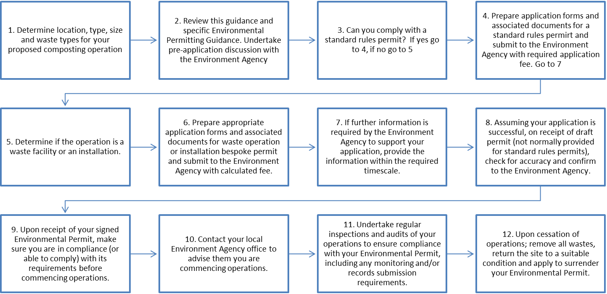

Monitoring Conditions
All Environmental Permits for composting operations are likely to require some form of process monitoring and/or environmental monitoring of emissions. Further information on the types of emissions and monitoring methodologies is discussed in Chapter 7.

The exact monitoring required will depend upon the type, scale and location of the composting operation but will be likely to include:

Process Monitoring

As a minimum, monitoring of temperature and moisture content. Any biofilters will also require routine monitoring for temperature, moisture and thatching/compaction. Good practice may also require monitoring of other factors such as feedstock quantities, windrow dimensions and oxygen levels/aeration.

Environmental Monitoring

The extent of any environmental monitoring required will be process and location specific, depending upon the type and scale of any environmental releases and the sensitivity of the local environment. Representative meteorological monitoring will almost always be needed. Bioaerosol monitoring, in accordance with the latest industry standards, may also be needed. These standards can currently be obtained from AfOR, and are currently being updated.

- As described in section 2.1, carbon dioxide is a product of aerobic respiration and therefore an important indicator of process efficiency. The ratio of oxygen depletion to carbon dioxide release has also been used as an effective indicator of aerobic conditions.
We would consider it good practice to measure carbon dioxide levels as well as oxygen

Odour Regulation in the UK
Composting facilities present a risk of odours, especially if the process is allowed to become anaerobic. The Environmental Permit for the facility will contain conditions requiring the Operator to use all appropriate measures to prevent or, where that is not practicable, minimise odour.

Odour is an issue that is not just regulated under the Environmental Permit. Offensive odours may be considered to be a Statutory Nuisance by the Local Environmental Health Authority, which has powers to serve abatement notices in such cases. Planning permissions for composting facilities may also contain conditions concerning odour.

Whilst the Statutory Nuisance provisions of the Environmental Protection Act 1990 do not apply to permitted sites, Operators should be aware that Civil (or Common) Law actions against them may be possible for nuisance from odours. A 2012 Civil Appeal Court case regarding odours from a permitted landfill (Barr v Biffa Waste Services Ltd [2012] EWCA Civ 312) ruled that the Operators of the landfill were liable for nuisance from odours, even if the operations were being undertaken without negligence and in accordance with a detailed permit. It is therefore very important for the operators of composting facilities to design, operate and manage their facilities in a manner that does not cause nuisance through odours. In the case of civil action the operators defence will be helped if they are shown to be abiding by the terms of their permit.

Animal By-Products Approval of Composting Facilities
Some compostable wastes contain animal based materials that are subject to regulation under the Animal By-Products (Enforcement) (England) Regulations 2011 or, in Wales, the Animal By-Products (Enforcement) (Wales) Regulations 2011. Table 3.2 summarises the different classifications of Animal By-Products:
Table 3.2 Animal By-Products categories
Category | Examples
Category 1 | Category 1 material is the highest risk, and consists principally of material that is considered a TSE risk, such as Specified Risk Material (those parts of an animal considered most likely to harbour a disease such as BSE, e.g. bovine spinal cord).  Pet animals, zoo and circus animals and experimental animals are also classified as category 1 material. The risk from these animals may also be high, for example due to the level of veterinary drugs and residues they may contain; the fact that adequate diagnoses of the exact cause of death of exotic animals can be difficult to achieve and; some species are known to harbour TSEs and may carry other diseases.  Wild animals may be classified as category 1 material when they are suspected of carrying a disease communicable to humans or animals. Catering waste from means of international transport (i.e. which has come from outside the EU) is also category 1 due to the risk from exotic diseases.
Category 2 | Category 2 material is also high risk material and includes fallen stock, manure and digestive content.  Category 2 is also the default status of any animal by-product not defined as either category 1 or category 3 material.
Category 3 | Category 3 materials are low risk materials. Category 3 material includes parts of animals that have been passed fit for human consumption in a slaughterhouse but which are not intended for consumption, either because they are not parts of animals that we normally eat (hides, hair, feathers, bones etc) or for commercial reasons.  Category 3 material also includes former foodstuffs (waste from food factories and retail premises such as butchers and supermarkets).  Catering waste, including domestic kitchen waste is category 3 material.

Animal by-products, other than catering waste and some former food material, must be treated to specific ABP Regulations. These regulations state that category 1 animal by-products (which are considered the highest risk materials) such as Specified Risk Material and catering waste from international transport are not permitted to be treated in composting plants under any circumstances.
Category 2 animal by-products cannot be used as a feedstock in composting plants, except when they have been pre-treated by rendering under a predefined pressure/temperature regime. There are some limited exceptions to this, for example horse and farmyard manure.

For the treatment of the Category 3 wastes within a composting process, the animal by-products must be treated in a closed vessel system and meet certain standard treatment parameters. Different treatment standards apply to facilities that treat only Category 3 catering wastes.

The Environment Agency compost quality protocol also identifies that the composting of green waste or biodegradable packaging (presume to be unsoiled or uncontaminated) that would not usually be affected by these regulations are covered by the regulations if they are mixed with catering waste, or have been soiled by catering waste (unless the catering waste has been classed as ‘meat excluded’ catering waste).

The Animal Health and Veterinary Laboratories Agency (the AHVLA) is the enforcing body for ABPR regulations in England and Wales. Any composting facility that wishes to compost animal by-products wastes must apply for and obtain approval from the AHVLA before they can accept such wastes (exceptions are available for certain home and small site composters).

The AHVLA has produced guidance on the requirements for the composting of animal by-products that describes how these regulations permit the treatment of catering waste and other animal by-products in approved composting and biogas plants, available from
http://animalhealth.defra.gov.uk/about/publications/abp1/abp_full_guidance.pdf.

Animal By-Products Approval
To obtain ABPR approval an operator will be required to develop a Hazard Analysis and Critical Control Points (HACCP) plan that identifies, evaluates and controls hazards which are significant for product safety. The recommended HACCP approach is:

- Conduct a hazard analysis
- Determine the Critical Control Points (CCPs)
- Establish critical limits
- Establish a system to monitor control of each CCP
- Establish the corrective action to be taken when monitoring indicates that a particular CCP is not under control
- Document and record all procedures, corrective actions and verification results
- Establish procedures for verification, audit and review to confirm that HACCP is working effectively

Plant Validation

Once an operator has established a HACCP plan for their system, the system can be validated. Composting validations are based on individual systems, not individual premises. The validation process has two stages, which it is the operator’s responsibility to ensure are fulfilled –

- pre-validation of the system by the manufacturer or operator; and
- validation of the site by the operator, to demonstrate that the system is capable of being operated properly at the specific site.

Pre-validation of the system
This is done by the plant manufacturer or operator. They provide evidence and data to demonstrate that the system can comply with the requirements of the Regulations. Ultimately it may be possible for manufacturers to sell pre-validated systems off-the-shelf to operators. However, in the initial phase of applications, AHVLA expect that each applicant will need to supply data to support their system. AH would expect to receive data on the suitability of the system to treat different feed stocks, achieve the time/temperature parameters, its efficacy in destroying pathogens and the conditions under which it must be operated, including any seasonal variations. The evidence supplied by the manufacturer or operator will be assessed by AHVLA, who will determine whether the system (or the information supplied) is sufficient.

Site validation

Once the operator has obtained the manufacturer’s verification for the system, and it has been accepted by AHVLA, the operator will also need to demonstrate that the system can be operated on their particular site in a way which complies with the requirements of the Regulations. They will need to carry out a validation process to achieve this and, in the light of that experience, submit a HACCP plan listing the system’s critical control points, how they will be measured and monitored to demonstrate compliance, and what corrective action will be taken in the event that a critical control point fails.

New sites at the design and planning stages should submit site plans and details to AHVLA at the earliest opportunity, in order to ensure that plant design is in accordance with the Regulations, and that potential problems may be identified and rectified prior to capital expenditure.

Once AHVLA has received and assessed the HACCP plan and is satisfied that the system is in principle capable of meeting the requirements of the Regulations, they will inspect the site. Further information regarding the approval process can be found on the AHVLA website www.animalhealth.defra.gov.org

Regulatory Control of Output Materials in the UK
For a waste operation to be deemed a recovery process, the principal output must be of sufficient quality to enable its use in place of other materials which would have been used to fulfil a particular function. In the UK, The Environment Agency has defined a series of Quality Protocols or QPs, which define the feedstock, process and output requirements to enable materials to be deemed as being fully recovered and therefore no longer waste. The outputs may be considered as products and any potential specific requirements relating to the ongoing management of these outputs as wastes will no longer apply.

The QP that applies to compost produced from waste is the Environment Agency “Quality protocol for the production and use of quality compost from source-segregated biodegradable waste”. This QP sets out criteria for the production of quality compost from source-segregated biodegradable waste.

Compost managed and produced in accordance with the PAS 100 and QP requirements will normally be regarded as having been fully recovered and to have ceased to be waste (and therefore be no longer subject to waste regulatory controls) when despatched to the customer, provided the following criteria are met:

- the compost is produced using only those source-segregated input materials listed in Appendix B to the QP;
- the compost meets the requirements of an approved standard; and
- the compost is destined for appropriate use in one of the market sectors designated within the QP.

Currently BSI PAS 100 (PAS 100) is the only approved standard. It was sponsored by Waste & Resources Action Programme ( WRAP) and developed in conjunction with the Association for Organics Recycling (AfOR) and the Environment Agency . More details on PAS 100 can be found at http://www.wrap.org.uk/content/bsi-pas-100-producing-quality-compost or by contacting AfOR. The Quality Protocol was first published 2008 but was revised in August 2012.

If the composting process is in compliance with PAS100 and the QP then, in accordance with the scheme, the compost produced will no longer be defined as a waste and it may be used without any further need for compliance with the Environmental Permitting Regulations (unless for any reason it requires disposal, in which case it must be disposed of at a suitably permitted facility).

If the compost does not meet the criteria set out in PAS 100 and the QP and is to be used on land for agricultural benefit or ecological improvement, then the compost is still deemed to be a ‘waste’ material and as such its use continues to be regulated under the Environmental Permitting Regulations. Exemptions and standard rules permits are available for the use of such waste derived composts and further information on this can be obtained from WRAP or from the Environmental Permitting section of the Environment Agency website.

The EU is currently developing End of Waste criteria, which will include a ‘positive list’ of acceptable waste types that will be deemed suitable for recovery by composting. If in the future End of Waste criteria are developed for compost, then this guidance will be updated to reflect the new requirements as these may supersede the Compost Quality Protocol and PAS 100.

- interesting definition of the output material in 3.4.10, i.e. ‘the principal output must be of sufficient quality to enable its use in place of other materials which would have been used to fulfil a particular function.’ Assumption that all composted material will meet PAS100/QP before it is recovered. However, is it not also true that once a material is beneficially used under an exemption or a permitted recycling operation, the material is also recovered and no longer remains a waste?

BSI PAS 100 Composting Standard
The British Standards Institution’s PAS 100 specification for composted materials is sponsored by WRAP and has been developed in conjunction with the Association for Organics Recycling (AFOR), formerly the Composting Association.

The document specifies requirements of the composting process including input materials, minimum compost quality standards, storage, labelling and traceability of composted materials. AfOR has adopted BSI PAS 100 as the specification that composted materials must meet in order to become certified by AfOR’s Compost Certification Scheme and use of its certification mark. Assessment of compliance is carried out by independent certification bodies, under contract to provide a service for AfOR.

More details on this scheme can be found at http://www.wrap.org.uk/content/bsi-pas-100-producing-quality-compost or by contacting AfOR.

Technology

Composting Systems
There are a number of composting technologies which are currently available and being used within the UK. Windrow Composting and In-vessel Composting are the predominant technologies. Other methods which are used are Aerated Static Piles, Continuous Block Composting and Deep Clamp Composting.

The Environment Agency Standard Rules for Environmental Permits categorises composting into two discrete subcategories, namely composting in open systems and composting which includes a closed system element (In-vessel composting). Further information regarding the Environment Agency’s classification of composting systems for standard rules Environmental Permits can be found on the website (www.environment-agency.gov.uk) and is also summarised in section 3 (regulations and standards) and in sections 4.1.1 and 4.1.2 below. In addition, the systems which can be classified under these categories are also discussed. Table 4.3 presents a comparison of the various composting systems presented and lists the advantages and disadvantages of each of the systems.

Composting in Open Systems
The standard rules permit for composting in open systems states that:

- Permitted wastes include green wastes and animal manures but does not include any catering waste and other wastes containing animal by-products.
- Composting can only be carried out under predominantly aerobic conditions in windrows located either indoors or outdoors. The process cannot be carried out under deliberately anaerobic conditions.

- The use of the word deliberately in the second bullet point of section 4.1.1 is inappropriate as it implies that if operators have not deliberately created anaerobic conditions then they are not in contradiction of the guidance.
We would consider that this point should be revised to suggest that operators must take appropriate action to avoid creating anaerobic conditions.
The description of the effects and importance of turning is well-informed, and we welcome its inclusion. There are still a significant number of operators who perceive that the sole purpose of turning is to increase oxygen levels.

Windrow Composting
Windrow Composting is also sometimes referred to as open windrow, open air windrow composting or turned windrows. Windrow Composting is typically carried out externally on an impermeable concrete slab with a sealed drainage system.

While is it qualified as “typically” the inference is that this is the standard for all sites, more needs to be said regarding smaller scale sites that do not require slab and drainage.

Windrow Composting consists of forming the mixture of raw materials into long piles or windrows, which are turned and re-mixed on a regular basis.

Turning releases trapped heat, water vapour, dust and organic particulates and gases. Turning also mixes the materials and may re-structure and redistribute the porosity of the windrow restoring the pore spaces eliminated by decomposition and settling. Turning exchanges the material from the interior with the material at the windrow's surface and homogenises the material. Depending on the age of the compost the oxygen introduced through the turning process may be consumed rapidly. Additionally the agitation may stimulate the process resulting in increased oxygen consumption. Excessive turning may reduce particle size and result in loss of porosity.

Turning allows for the redistribution of material within the composting mass and the exchange of exhaust gasses, assisting in the physical breakdown of the feedstock and may assist in restructuring the pile. Some equipment used for turning is also capable of applying additional moisture to the process. By redistributing the material all of the material should experience the elevated temperatures at the core of the windrow. This will allow for sanitisation of fly larvae, pathogens and weed seeds. Consideration should be given to the frequency of turning and the prevailing weather conditions during turning in order to prevent nuisance.

For many composting mixes the turning process will restructure the pile and result in additional pore space for air flow. However the use of a bespoke windrow turner will result in a reduction of particle size and in some dense unstructured material with a low bulking agent content may reduce the porosity of the material. For this reason it is important to consider the mixture of the compost, the type of turner to be used and the frequency of turning.

During turning the water and gasses within the pore space of the pile are exchanged for fresh air. The agitation may result in additional microbial activity that can quickly deplete the oxygen. However, in appropriately sized windrows the natural aeration should be restored and continuing the supply of oxygen to the composting material.

Windrows should be appropriately sized so that they allow for the sanitisation and stabilisation of material without giving rise to conditions which could cause nuisance.
When determining the appropriate dimensions of a windrow consideration need to be given to the rate of heat generation within the compost, the rate at which heat is lost and the ability of natural ventilation to supply air to the compost. If the windrow in too small then it may not reach appropriate temperatures to allow sanitisation. If the windrow is too large then air will be unable to penetrate sufficiently into the composting mass and may result in anaerobic conditions within the core-resulting in odours when the material is further processed. However “too small” and “too large” are functions of the material being treated.

Some comments on the appropriate sizing of windrows are contained in Table 4.1.
Table 4.1 Windrow sizing comparison
 | Too narrow | Optimal width | Too wide
Too short | Windrow too small to achieve temperatures required for sterilisation of larvae and weed seeds | Heat may be lost from the pile too rapidly | Air may not penetrate to the core of the windrow.  Heat may be lost from the pile  Drying of material may occur
Optimal height | Heat may be lost from the pile too rapidly | Optimal composting conditions achieved | Air may not penetrate to the core of the windrow- resulting in reduced aerobic activity at the core
Too tall | Drying of material may occur  Heat may be lost from the pile too rapidly  Pile sides may be steep resulting in stability issues | Base may be insufficiently aerated  Pile sides may be steep resulting in stability issues | Insufficient oxygen reaching core.  Requires frequent turning to prevent odorous conditions in core.

For dense feedstocks with a small particle size, smaller windrows, possibly as small as 1 metre in height, will be required in order to allow natural ventilation to provide sufficient oxygen to the core of the windrow and prevent anaerobic conditions from developing. It may be more appropriate to combine such materials with a bulkier feedstock and compost within a larger windrow.

For coarser materials taller windrows will be required as the additional porosity would result in a greater heat loss meaning the windrow may not maintain temperatures required for sanitisation. The windrows may be as high as 3-4 metres tall. Care must be taken in the preparation of these windrows as they will be susceptible to settlement, impinging the air flow in the pile potentially leading to anaerobic conditions developing within the pile.

The width of a windrow will be affected by the angle that the feedstock can be stacked at as well as the requirement for natural aeration. Shorter windrows will require lower widths and taller windrows will be wider. There will be some variation for a windrow of a given height based on the angle of the side walls. However, it is up to the operator to use windrows of an appropriate dimension for the feedstock being composted.

There are differing strategies and approaches taken for turning of windrows. These are shown in Table 4.2.
Table 4.2 Windrow turning methods comparison
Turning method | Pros | Cons
Windrow turner-straddling | Thorough mixing of compost  Assist with physical breakdown of feedstock | Specialist equipment-unexpected breakdowns may result in operational problems
Windrow turner-tractor drawn | Thorough mixing of compost  Assist with physical breakdown of feedstock | Specialist equipment-unexpected breakdowns may result in operational problems  Additional space required between windrows for vehicle movements
Front end loader | Lower cost than specialised turning equipment  Simple to substitute in event of failure | Compost will typically need to be moved into a new area during turning -increased land take
Excavator | Simple to substitute in event of failure | Driving on top of the pile will result in settlement and reduce the oxygen supply

Ultimately the dimensions of a windrow pile are feedstock material dependent and are dictated by the aeration requirements of the pile. The rate of aeration depends on the porosity of the windrow and feedstock materials such as manure which are composed of small particles, which tend to be dense and wet have poor porosity. These types of materials must be managed in small windrows, which will minimise compaction and which also have a higher ratio of surface area to waste volume to assist with aerating the pile. Effective and experienced management is required for the process to be properly controlled. Denser materials and/or large windrows will require more regular turning in order to prevent the centre of the windrow becoming anaerobic, which can result in the release of odours once the windrow is turned.

Anaerobic areas can occur in the material near the centre of the windrow if the pile is too large, and these will release odours when the windrow is turned. Alternatively, small windrows can lose heat and may not achieve high enough temperatures to kill pathogens and weed seeds and to evaporate excess moisture in the sanitisation phase.

When the material properties allow for larger windrows to be constructed, operators need to ensure that the materials can still be effectively blended and turned. Operators may favour taller windrows as it allows more material to be handled on site, and may also have some advantages, for example, reduced absorption of water. Please refer to Section 2.0 – The Composting Process for further information on Windrow Composting.

Operators need to be aware that a number of factors need to be considered before selecting a open windrow pile configuration and will need to demonstrate that all parameters are adequately monitored and acted upon as detailed in earlier sections. Site design and layout should be configured to accommodate changes in feedstock conditions to achieve optimum composting.

In addition to windrow dimensions, operators also need to consider the operational areas that surround the windrows These areas need to be sufficient to allow machinery to operate and turn windrows without the risk of vehicles driving over composting materials and causing compaction and also cross contamination, adequate areas also allow surface water and liquor to drain away and prevent cross contamination of batches. Please refer to Section 6 - Site Design for further guidance.

Windrow composting can be subject to forced or negative aeration, preventing or reducing the need for turning and resulting in an increased level of control over the process and a shorter composting period. Negative aeration may reduce the level of bioaerosol emissions and decrease the risk of odour in a well constructed and maintained system. More experimental and monitoring work is being undertaken and this document will be reviewed as new and better techniques are justified.

The other open systems shown within Figure 2.3 may use a different shape of pile to achieve the same biological processes as windrow composting. This may require some physical containment such as a wall, and while many variations that can be applied, the overall aim remains the same. Open composting includes various other techniques such as aerated static pile and deep clamp composting. These are discussed further in Chapter 4.

Open windrow composting is not suitable for treating materials in accordance with the Animal By-Products Regulations (Enforcement) (England) Regulations 2011.

However, it can be used in conjunction with another system, where windrow composting is used as the second barrier. Should this configuration be the process of choice the second barrier must be managed to ensure that this material with very high odour potential is managed effectively and aggressively.

- The paragraph beginning “Ultimately the dimensions of…” below Table 4.2 is quite correct in outlining that windrow dimensions should indeed be determined by the aeration requirements of the pile. However, we would not consider “Effective and experienced management” to be the only means of determining whether or not the aeration requirements of the pile are met. Using these criteria alone, it is not going to be possible for Environment Agency officers to enforce, as they can’t be expected to be able to demonstrate that the management of the producer is ineffective without any firm evidence.
We would consider that, as a bare minimum, oxygen monitoring should be used to prove that the aeration requirements of a windrow are met. In the event that this is not the case, the producer should take corrective action and be able to demonstrate through oxygen data that this action has been effective.

Animal By-Products Regulations requirements for Windrow Composting

If the feedstock contains Category 3 Animal By-Products, then windrowing can be used as the first stage of the two stage barrier treatment process as described in the regulations (Animal Health, 2011). However the process must be housed.
Housed windrows must operate on an ‘all-in, all-out’ basis. This means that all the material in the housed windrow building will be in the same batch, and treated to the same standard. Systems where windrows at different stages of treatment are kept in the same building, and are removed at different times, will not be approved, as the capacity for cross contamination and bypass of the system is considered too great. The only exception would be where the windrows are in completely separate parts of the building i.e. different rooms separated by floor-to-ceiling walls, separate entrances and exits, separate personnel etc.

Animal by-products are tightly regulated to protect human and animal health and the environment. This includes rules for collecting, storing, transporting, handling, processing, using and disposing of animal by-products. Additional information and guidance on the requirements for compliance with the Animal By-Products Regulations (ABPR) can be found online at www.animalhealth.defra.gov.uk.

Sites using waste which is subject to ABPR controls can process material in the open only after a first stage sanitisation is achieved. This is assuming that the time/temperature requirements and other site management practices can and are delivered. Any external processing for second stage needs to be validated by AHVLA . The ABPR regulations are discussed further in Section 4.1.

External windrows can be covered with a membrane which may prevent release of emissions and protect the material form adverse weather and vermin. Commercially available membranes are typically permeable and woven, allowing the pile to breathe whilst at the same time minimising the water ingress. The covers need to be high strength to endure the external conditions.

Aerated Static Pile Composting
Aerated static pile composting involves forced aeration using a blower to supply air, usually from the base of the pile. This type of active aeration can be either negative or positive, i.e. effectively sucking or blowing air through the pile. Active aerated piles give a greater degree of control over the composting process if the system is designed and maintained properly. For open piles a suction (negative aeration) system facilitates the control of emissions to air by collecting emissions to a point source which can then be treated, for example, using a biofilter.

The pile is constructed in a similar manner to a windrow, but is sometimes also formed as an extended pile, where the cross section of the heap is not triangular but in a rectangular bunker configuration where rows are laid up against each other with a retaining wall. The waste is constructed and built upon either a series of perforated pipes or concrete with an air supply system cast in situ. These are connected to a fan which provides either negative or positive aeration.

Preparation of the base is essential. The pipes should be covered with either wood chip or larger woody material to aid dispersion and prevent the pipes becoming blocked. The pipe work will require a schedule of maintenance and cleaning to remain effective -The piles can be covered or enclosed with individual covering structures. This has evolved to the point where individual bunker piles can be compliant with the Animal By-Products regulation, as discussed in Section 4.1.1.

Once the pile is formed, turning or agitation should, with good operational management, not be required provided that the air supply is sufficient and uniformly distributed. To establish this remote thermocouple probes and oxygen monitoring are needed. Where areas or preferential pathways develop remedial action could be required. The correct structure and preparation of feedstock is essential for this system to work adequately.

The reduction in turning or restructuring may reduce the risk of emissions of bioaerosols and odours in a negative aeration configuration as air from the pile can be connected to a biofilter to actively manage bioaerosols and emissions. The active composting period could theoretically be reduced if the aeration were managed effectively.

It should be noted that positive aeration systems in open systems are no longer permitted by the Environment Agency due to the potential to increase bioaerosols and emission release.

Further information on biofilters, including their composition, function and maintenance requirements has been provided in Section 7.2.1.

Aerated Static Piles can be approved as a closed system under the ABPR regulations, if the pile is fully enclosed. The regulations state that the pile must be contained in a walled and roofed building, but compliance can be achieved for systems that use a robust membrane which encapsulates the system. This method is not commonly used and operators would, in any case, need to have the system assessed by AHVLA who are the competent authority. Operators are strongly encouraged to engage in early consultation with AHVLA. Contact details for local offices can be found on the AHVLA website: Animalhealth.defra.gov.org

Aerated static pile dimensions are shown in Figure 4.1 below.

Figure 4.1 Aerated static pile and extended aerated static pile layout and dimensions
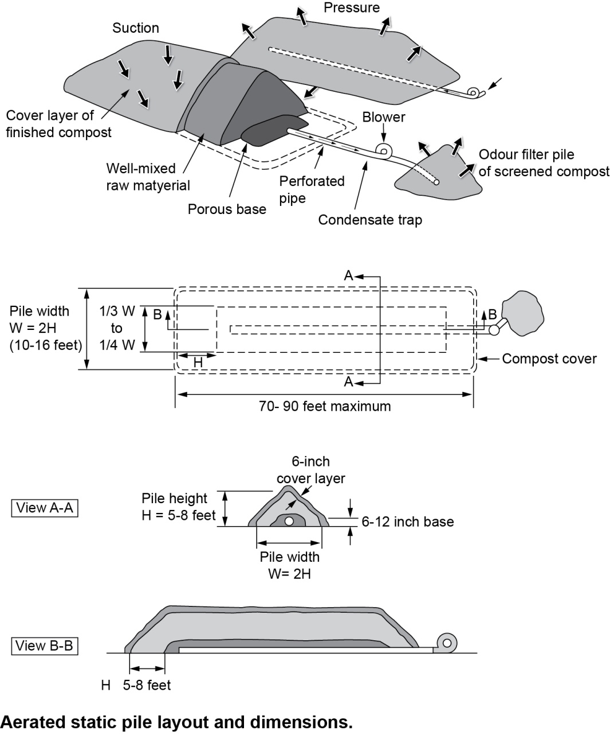
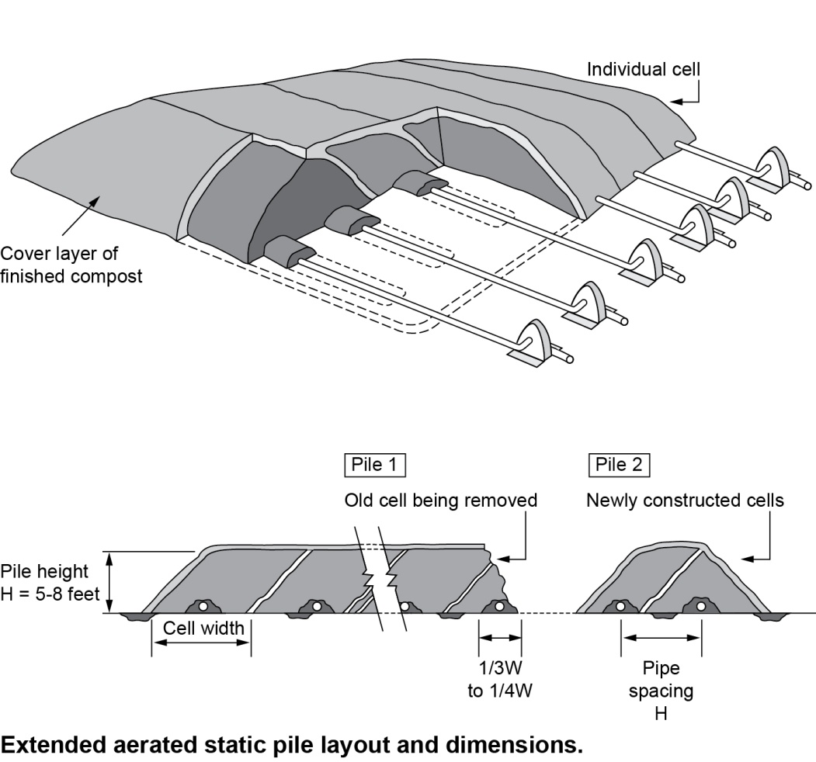
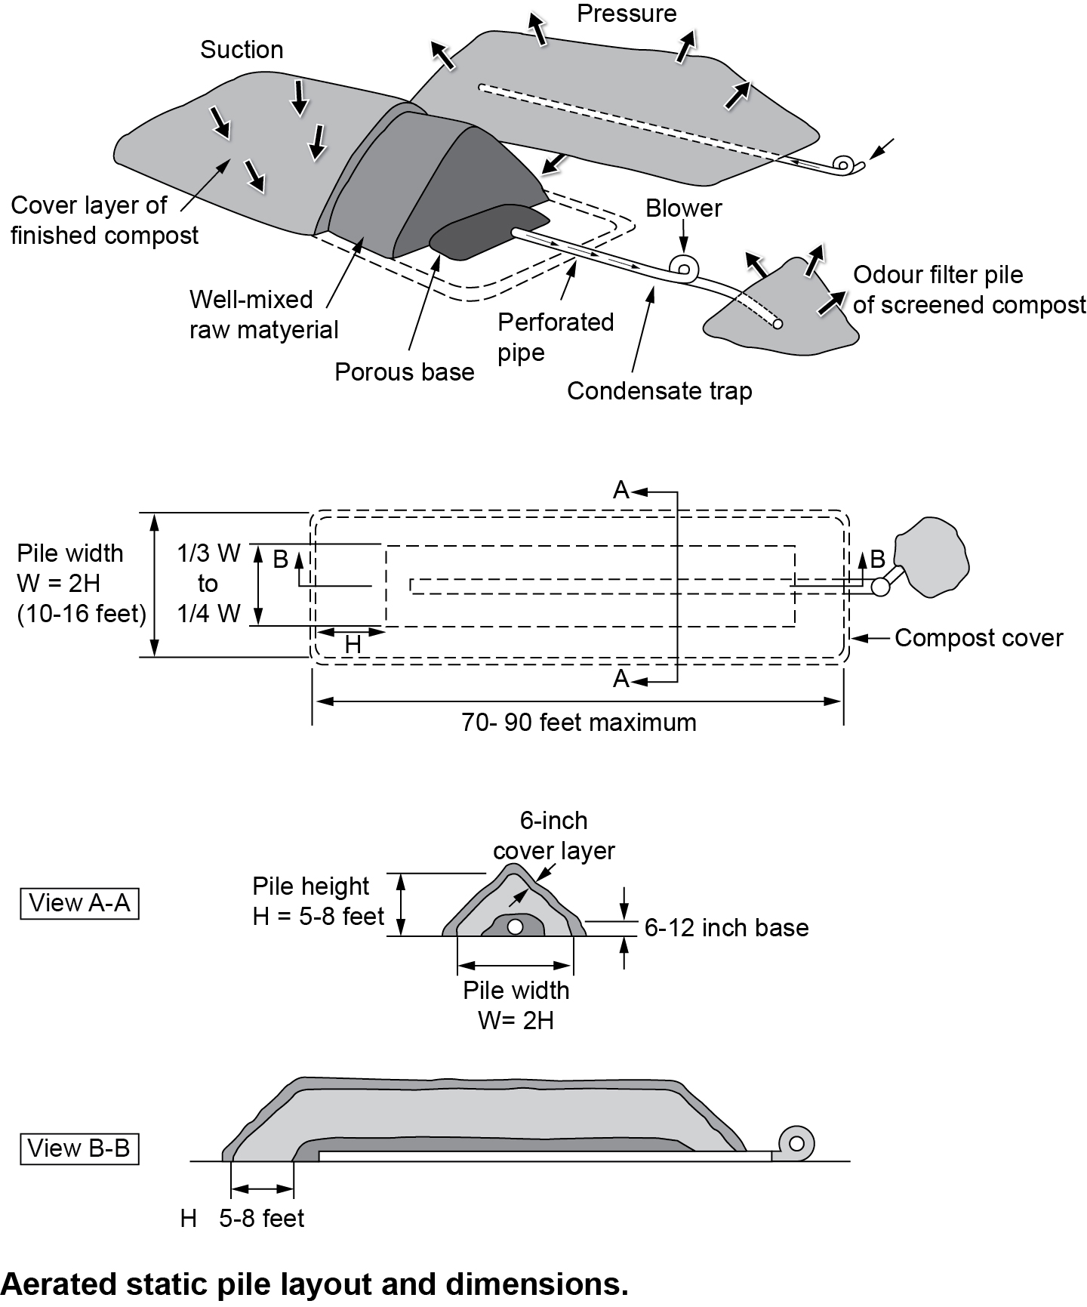
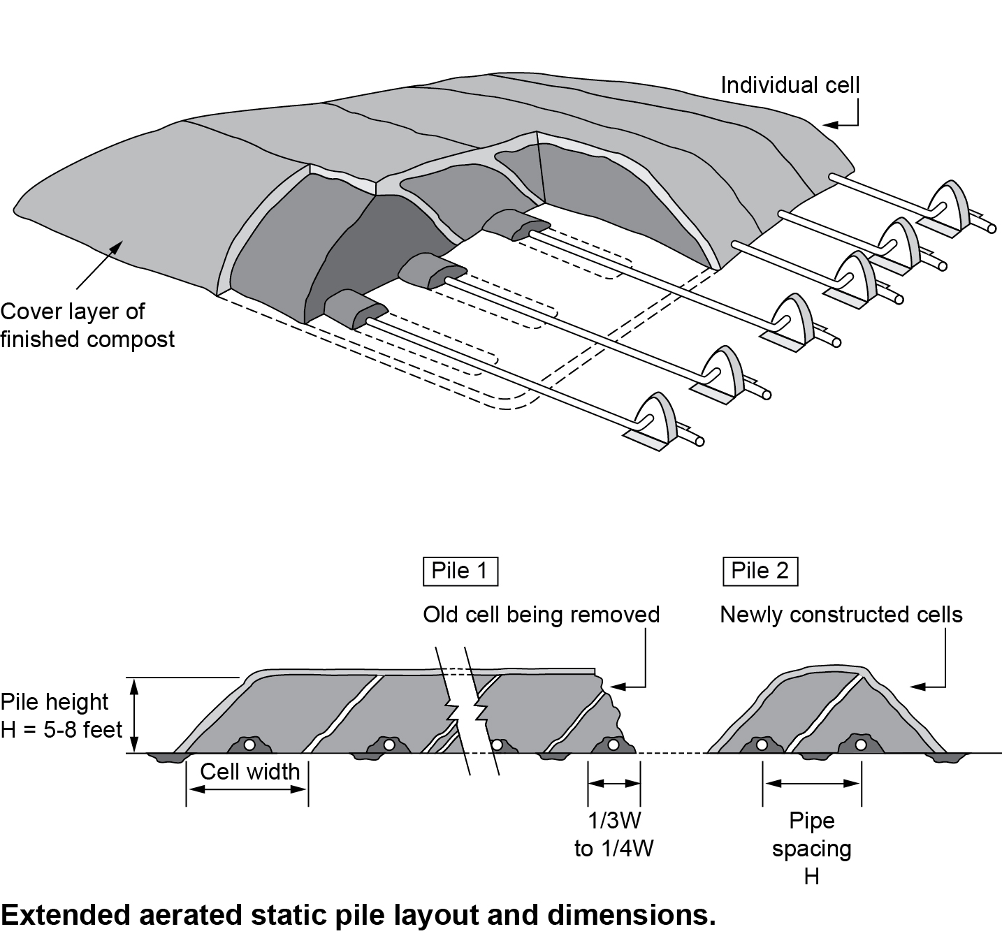
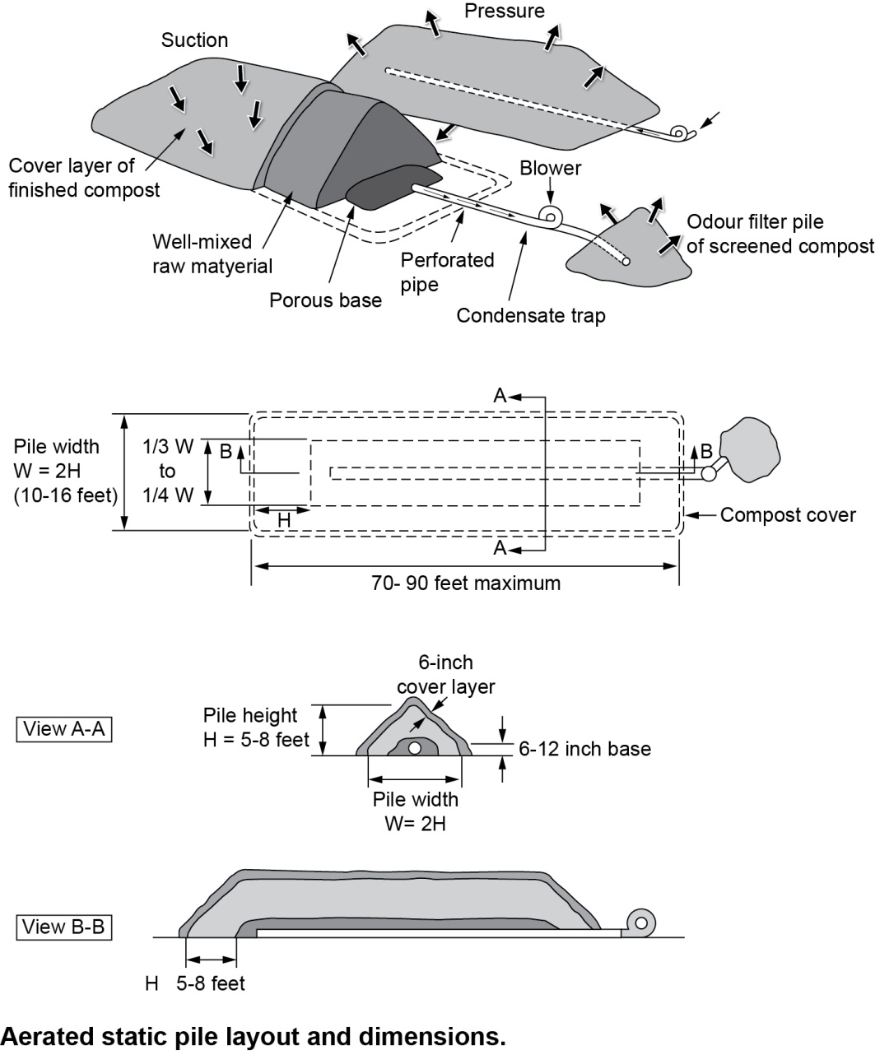
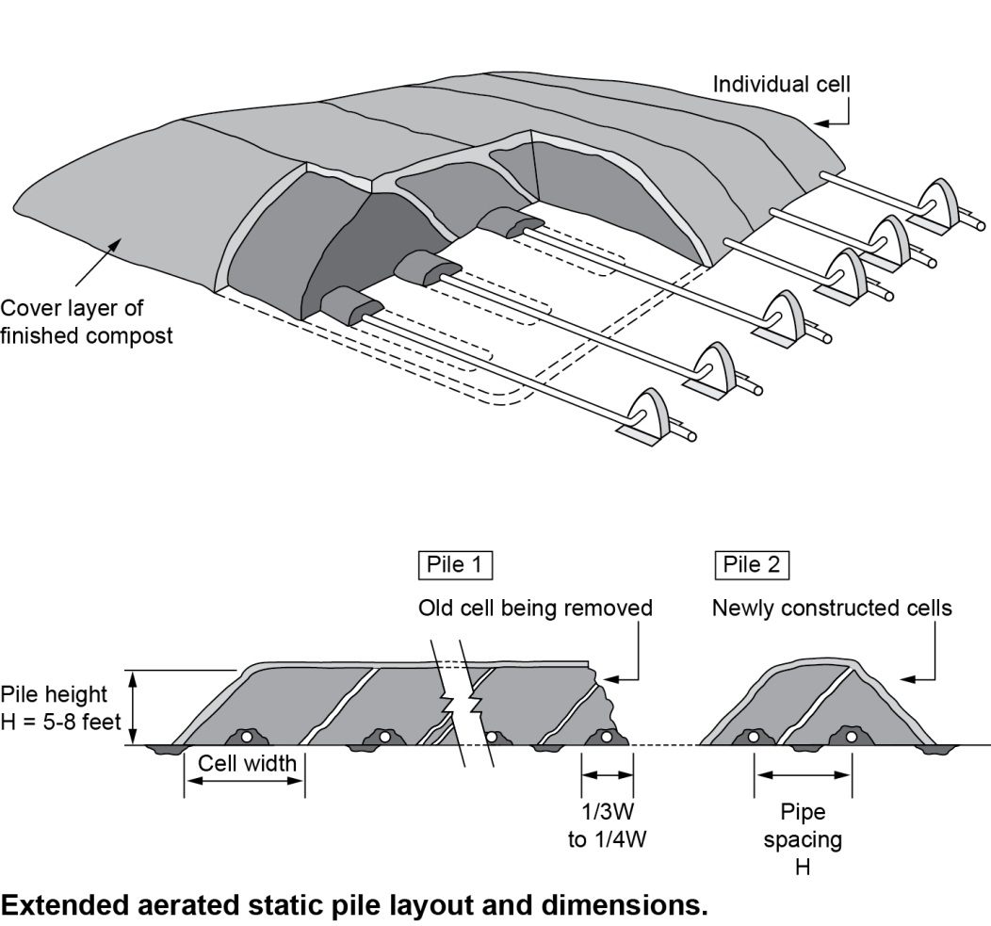
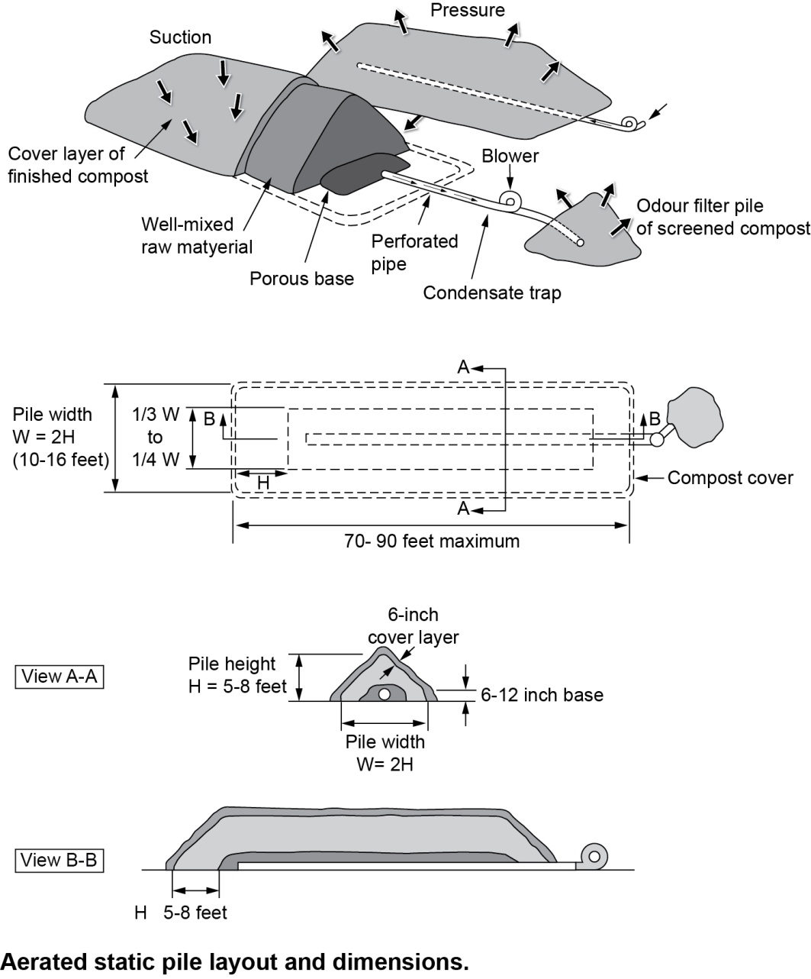
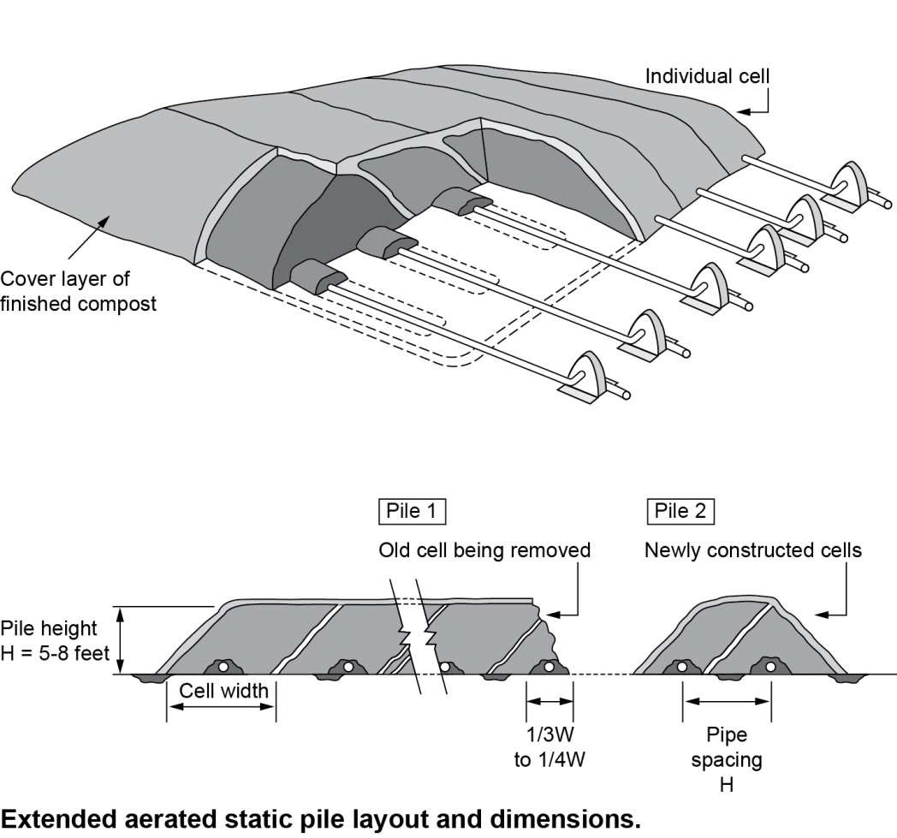

Continuous Aerated Block Composting
Continuous Aerated Block composting is similar to an aerated static pile in so far as it is constructed on a bed of aeration pipes or a bespoke impermeable concrete pad with cast in situ air ducts. The pile is of a rectangular configuration with a flat top; the difference is that a Continuous Aerated Block is turned, which effectively moves the block of material across the pad. Continuous Aerated Block without the inclusion of a forced aeration system is known as a Deep Clamp. The data regarding the effectiveness of Deep Clamp systems suggests that if material is not mixed and prepared well to give adequate structure there is a risk of low rate composting and anaerobic pockets.

With both of these systems it would be expected that air extracted from the negative aeration system would be treated by a biofilter or air scrubbing system.

Composting in Closed Systems (In-vessel Composting)
Permitted wastes for In-Vessel processes include green wastes, animal manures and cooked food waste and animal wastes that are covered by the Animal By-Products Regulations.

Composting can only be carried out under predominantly aerobic conditions and the sanitisation stage can only be carried out in closed systems, such as closed composting reactors or in closed vessels/buildings fitted with bio-filters and /or equivalent abatement systems.

The standard rules permit for composting in in-vessel system states that the process must be:

- Under predominantly aerobic conditions.
- In enclosed vessels/buildings fitted with bio-filters and/or equivalent abatement systems
- In windrows located either indoors or outdoors

Under section 4.1.2 Composting in Closed Systems (In-vessel Composting), I was at first puzzled by the bullet point “In windrows located either indoors or outdoors” – I assume this refers to maturation only.

In-vessel Composting (IVC) is a term that is widely used to define a compost system within a contained and enclosed vessel. These composting systems, range from enclosed halls to covered bunkers or tunnels and containers, which may be vertical or horizontal.

Many of these systems attempt to achieve a higher degree of process control by combining the techniques of enclosed windrowing and aerated piles, in an attempt to utilise the most positive attributes of each method. In-vessel systems can create even and optimum conditions of temperature and oxygen for the micro-organisms, giving improved control and accelerating decomposition. Enclosed composting is a requirement under legislation for composting Category 3 Waste.

In-vessel composting systems can be grouped into two categories, namely encapsulated open systems (in hall) and actual in vessel closed systems. The first is typically a set of container/drums/tunnels/agitated bays which are open at the top but which are situated in an enclosed building with a controlled aeration system. The latter are discrete vessels which are completely enclosed. These can be large high tech purpose built operations with concrete bunkers and computer controlled air flows, or small modular units that can be used for smaller applications e.g. in schools, or even polythene bags or other sealable containers with forced aeration. Please refer to the diagrams below and also to Section 2.0 – The Composting Process which contains further information on in-vessel systems.

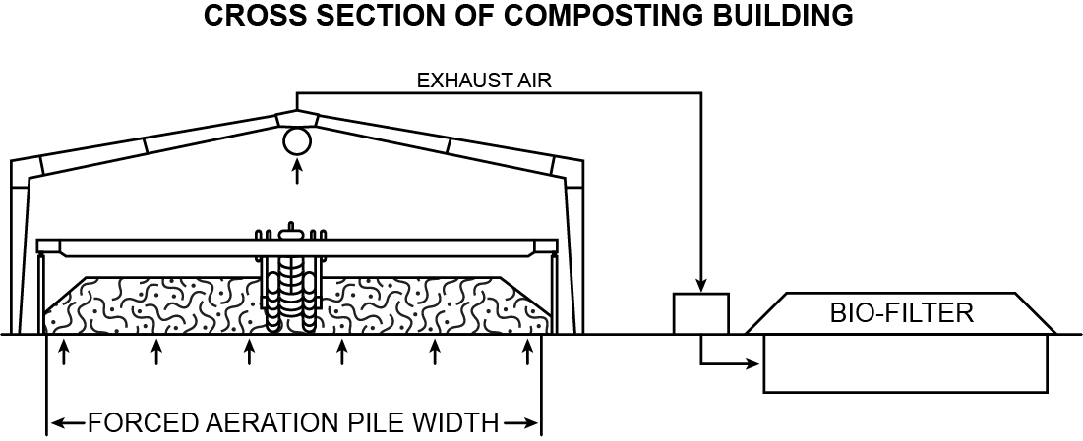

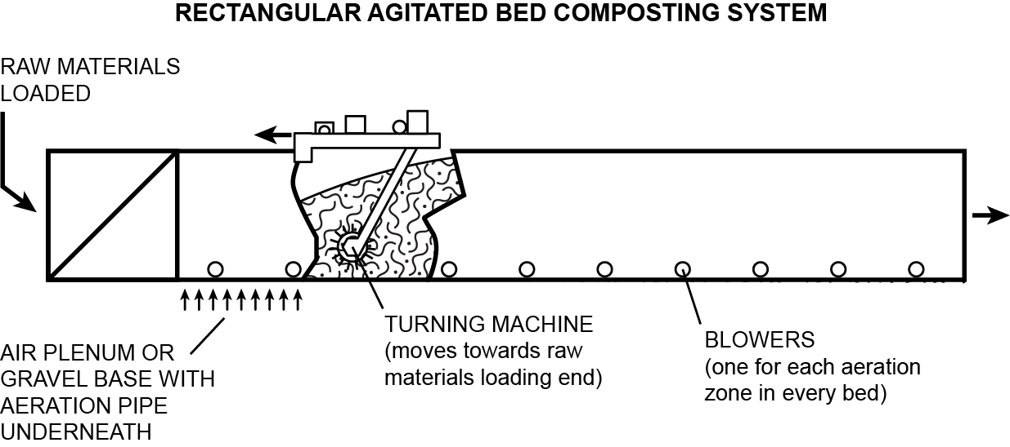

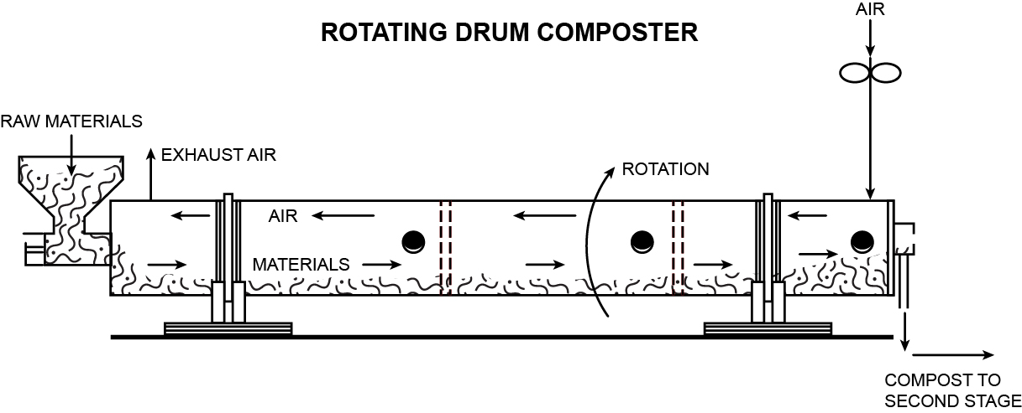

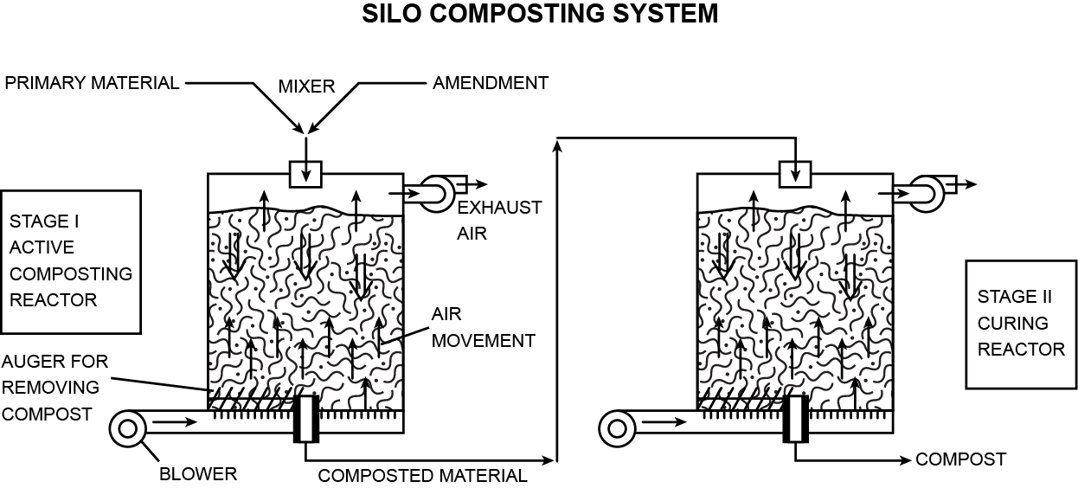

A covered waste reception area is required for compliance with the ABPR regulations. The requirement to enclose the process goes some way to control odour compounds in the feedstock and emission containment conditions as set out in the sites permit. Further stages of these processes can be undertaken in the open, however, an impermeable surface and a sealed drainage system is required and the material needs to be actively and often aggressively managed to prevent emissions. These secondary phases are considered within the Environment Agency’s position statement regarding risk to sensitive receptors.

Operators should note that compliance with the ABPR regulations does not necessarily result in a stabilised product. Waste which has been composted in accordance with the ABPR regulations has been sanitised to remove pathogens. This sanitised waste can become active again and become a source of odour emissions. Waste will still require further treatment to achieve the required levels of stabilisation as set out within the Quality Protocol (EA/WRAP 2012).

Containers

Containers are generally batch type reactors of low volumetric capacity, where air is often forced in through a perforated floor. One of the main advantages of using containers is the relative ease with which the system can be expanded by adding further units. A containerised system is considered superior to an open windrow system due to its uniform aeration and even temperature profiles, combined with more effective emission, moisture and odour controls. Faster composting speeds are also achievable. However, these systems are more engineered and need thorough housekeeping and maintenance to function effectively. They may also require management of emissions.

In order to achieve effective sanitisation of catering wastes, the whole of a container system will need to be approved by AHVLA and be compliant with ABPR, otherwise the vessel will need to be emptied, the material mixed and the vessel cleaned and reloaded, all of which will add further expense to the process.

Tunnels

Tunnels are normally capable of taking more material than a containerised composting system. Air is fed into the system and some systems use mechanical agitation. Bagged tunnel systems have also been available. In these systems the material is loaded into a high tensile polythene skin, using specialist machinery, and an aeration tube is fed in at the time of loading. Control of the system should be undertaken through monitoring of oxygen and temperature levels within the compost.

As with the container type systems the entirety of the material needs to reach the target temperatures in order to meet the Animal By-Products Regulations(Enforcement) (England) Regulations 2011. Some bagged systems have been shown to achieve this through use of an insulating quilt.

Rotating Drums

Rotating drums are large, horizontally mounted drums that rotate as the material is treated. Although these systems do offer very short processing times it is uncertain as to whether or not they are capable of meeting the Animal By-Products Regulations. This is because as the process is continuous there is a risk of by-pass without treatment for material being processed in such a system. It is therefore recommended that this type of system is not used for wastes covered by the Animal By-Products Regulations without other subsequent treatment to meet the requirements of ABPR.

Silos/Towers

Silos or towers are vertical units that normally operate on a continuous or semi continuous basis. Feedstock’s are loaded at the top of the vessel and finished compost removed at the bottom. The loading and unloading of vessels can use some quite complex and heavy machinery. Because of the small footprint and height this type of system can achieve large throughputs i.e. a large volume of material can be effectively sanitised with limited land use. However, there is likely to be an additional area required for maturation or complete stabilisation of the compost post in vessel treatment. Due to the potential to have differing ages of waste within a silo there may be potential for bypass of non sanitised material and this requires appropriate management of the plant to ensure compliance with APBR. These vessels need to be housed in a building with suitable air handling. The stacking of feedstock within the silo/tower can also present compaction, temperature control and air flow challenges. Because materials receive little or no mixing in the vessel, raw materials must be well mixed when loaded into the silo. Care needs to be taken to ensure there is sufficient aeration.

Enclosed Halls

Enclosed halls hold all of the material being processed at once. Materials handling equipment, such as large buckets or even specialist machines are used to move the material through the building as it undergoes composting. Aeration systems are usually required to ensure that the process remains aerobic. One of the key problems with this type of system is that unless the system is designed and managed appropriately there will be material of a variety of different ages within the hall. This could lead to difficulties in complying with the Animal By-Products Regulations. The building should be fitted with air handling systems (see Emissions and Abatement, Section 7.3.2) and extra care needs to be taken in managing of odour and odorous feedstock.

Agitated Bays

Agitated bays are similar to tunnels. Containing walls are constructed either side of the bay thus allowing a turner to straddle the bay and move the material along. Several bays can be constructed next to each other and the turning machine moved between them. Due to the containing walls the floor area can be used more efficiently than with a windrow system. Because they are contained at the sides they cannot benefit from the natural ventilation as in open windrows and therefore require artificial aeration. There is the possibility of by-pass within this type of system due to the material being thrown by an overhead compost turner. This would need to be suitably addressed, by design and/or management of the operations, in order to meet the Animal By-Products Regulations(Enforcement) (England) Regulations 2011.

Emerging Technology - Thermophillic Aerobic Digestion
Thermophillic Aerobic Digestion (TAD) is a treatment technology which is beginning to be used to treat waste food. TAD’s have been used historically for the treatment of sewage sludge. Its use to treat food waste is relatively limited at present, but there are a few permitted sites in England and Wales.

Bacterial digestion is used in this process whereby bacteria consume and degrade the organic matter in the presence of oxygen. The process releases water and carbon dioxide, and producing a final waste product (digestate).

Prior to digestion the waste material is macerated and mixed with water or other liquid waste to form a slurry/sludge. The slurry is transferred to reactor vessels fitted with oxygen distributors and stirring devices. The thermophilic bacteria generate heat up to 75ºC, which is compliant with the ABPR. A retention time of 20 days is typical, however the degradation is typically faster at the start of the process and retention times of 2-6 days may achieve the desired reduction in activity.

The digestate is usually dewatered or dried to produce a bio-fertiliser. This waste may also be useful as a feed stock to Anaerobic Digestion (AD) facilities or for use in a biomass boiler-subject to WID requirements.

Comparison of the Composting Processes
Table 4.3 below summarises the advantages and disadvantages associated with each of the technology options that have been discussed.

Table 4.3 Comparison of Composting Systems

Technology | Advantages | Disadvantages
Windrow Composting | Established process internationally.  Management practises are well established  Specialist equipment is not necessary.  Operations can be largely covered by Standard Rules Permits.  Troubleshooting information is widely available.  Maintenance requirements are largely limited to paving and mobile plant.  Possible to produce high quality material for horticulture and agriculture markets with non-waste status  The quality of the material has nothing to do with waste or non-waste status, which is entirely dependent on a quality protocol that for compost was specifically developed for large centralised sites supplying the horticulture market. Recently the PAS 100 & QP system has been modified to address this imbalance but the underlying standard does not specifically address agricultural requirements. | Requires significant land area to accommodate windrow piles during active composting phase and subsequent maturation. Typically 3x greater than In-vessel.  Weather issues can affect moisture, increase leachate generated and makes moisture porosity and temperature control difficult, any of which can result in product quality issues.  Difficult to control odour and bio-aerosol emissions during turning operations, if windrow is located outside.  Proximity to sensitive receptors is an issue, especially during shredding, turning and screening operations. A distance of 250m from sensitive receptors is required for a standard permit.  May require downtime, i.e. no deliveries of feedstock, whilst critical equipment such as shredders are being maintained.  Contingency needs to be planned.  ABPR waste cannot be processed solely by this method.  When anaerobic condition develops it is difficult to correct and may cause high incidence of odour.  Limited feedstocks.
Aerated Static Pile | Requires minimal turning,  Negative aeration may reduce the potential for bio-aerosol and odour release.  If negative air pressure is adopted then process air can be collected and treated through a managed biofilter.  More control of process as aeration is typically controlled by either a timer or on feedback from a temperature sensor.  Can achieve faster composting than windrow composting.  Requires less physical maintenance of waste once piles are built.  Standard Rules Permit for throughputs up to 75kte IED will apply in sites that take > 25 kte  . | Process is more labour intensive in initial stages when piles are being constructed.  Negative aeration systems can become clogged which can result in uneven composting.  Additional filter/bedding material may need to be provided, i.e. woodchips.  Good housekeeping is essential with regular cleaning regime. Best practice would be to clean pipe work after each dismantling.  Maintenance of equipment required to stop pipe blockages etc.  May require downtime, i.e. no deliveries of feedstock, whilst critical equipment such as shredders and fans are being maintained.  Risk of fires  Risk of anaerobic pockets within composting mass.
Continuous Block | Requires less land area than windrowing.  Standard Permit for throughputs up to 75kte IED will apply in sites that take > 25 kte  Does not require specialist turning equipment.  Maintenance requirements are largely limited to mobile plant, which can be hired if issues arise. | Not a commonly used composting method in the UK.  Little evidence to suggest this is a process that can turn around high levels of waste .  May need more time to treat waste.  System is not compliant with ABPR as no separation of the material for sanitisation  Too large to be housed.  Open to the elements. Potential to generate leachate, odour and bioaerosols  There are likely to be pockets of anaerobic material, however if the majority of the pile turns anaerobic then potentially a large operation to fix.  Difficult to control in the event of fires  May require downtime, i.e. no deliveries of feedstock, whilst critical equipment such as shredders are being maintained.
In-vessel Composting | Faster processing times than windrow composting if aeration and feedstock mix is managed  Enclosed process which reduces potential for odour and bio-aerosol emissions, and allows the process gases to be controlled by an abatement system  Closer process control, which can be automated, i.e. more even temperature and air distribution.  Requires significantly less land area than windrow composting.  Process requires less labour.  Not dependent upon the weather.  Some containerised configurations are modular and can be increased in number as demand increases.  Consistent quality of product, if process managed appropriately.  Standard Rules Permit available for operations with throughputs up to 75kte  IED will apply  Some systems are modular which means maintenance can be undertaken whilst the site continues to accept feedstock deliveries. | Higher capital costs.  Requires greater operator management control.  Maintenance and depreciation of plant is costly  If containment systems fail there can be issues with odour  Operator must ensure contingency measures are in place to divert waste.  May require downtime whilst critical equipment such as shredders are being maintained.  May require back up generator in case of power outage.  ABPR requirement often met and material very unstable. Second barrier if outside needs a high level of skilled management.  May be restriction for land spreading  Pathogen failures control will result in material being held on site and retreated-contingency to cope may be required.
Thermophillic Aerobic Digestion (TAD) | Technology is proven on sewage sludge treatment, albeit not widely adopted for food waste currently.  Benefits will be largely inline with IVC.  Standard Permit for throughputs up to 75kte.  Digestate can be pelletised and used as a fuel in biomass boilers | Technology is used primarily in the UK to treat sewage sludge. Limited application with source segregated organic waste.  Product quality issues are not known  High temperatures in confined spaces can produce harmful off gases. Health and safety considerations will need to be taken into account.  Operational issues are not documented for treating source segregated organic waste.  High water consumption.  May require downtime, i.e. no deliveries of feedstock, whilst critical equipment such as shredders, stirrers, pumps etc are being maintained/repaired.
Deep Clamp | Less area of land required  Less turning required | Less control over process etc  Not in common use, hence operational best practice is not well documented.

Table 4.4 summarises the suitability of each of the processes in terms of ABPR compliant feedstock, site suitability and throughput.
Table 4.4 Process suitability in terms of ABPR compliant feedstock

Technology | Suitability
 | Feedstock ( in terms of ABPR) | Site | Scale
Windrow Composting (open) | Suitable for composting of biodegradable waste, defined by the ABPR regulations as Green Waste.  Not suitable for the 1st stage of composting Category 3 Catering Waste or for the treatment of Meat Excluded Catering Waste.  Can be used as the second stage of a two barrier process being used to treat Category 3 Catering waste. | Sufficient land area to construct piles.  Site must be 250m from sensitive receptors to comply with Standard Permit conditions to minimise noise, odour and bioaerosol risks.  Must have adequate transport links.  Consideration must be given to prevailing wind direction and exposure of piles to weather, especially during turning operations  Topography is an important consideration, e.g., if site is located on high ground to residential areas, there is a potential for cold drainage flows/temperature inversions which may result in drift of odours from site to local community even where distant is >250m.  Adequate suitable paving and lagoons must be developed | Suitable for small to large scale operations. Commonly used for large scale operations, composting green waste materials externally.  Limited by the land area available, proximity to sensitive receptors, transport network access.
Windrow Composting (housed in a building ) | Suitable for composting Green Waste.  Suitable for the 1st stage of composting Category 3 Catering Waste or for the treatment of Meat Excluded Catering Waste.  Can also be used as the second stage of a two barrier process being used to treat Category 3 Catering waste. | Sufficient land area to accommodate buildings.  Site must be 250m from sensitive receptors to comply with Standard Permit conditions to minimise noise, odour and bioaerosol risks.  Air extracted must be treated  Will have additional H&S requirements for working in confined spaces.  Air extraction system must be built to ensure area is kept free of water vapour and off gases and bioaerosols.  May need power supply and consideration of energy resources usage. | Suitable for small to medium scale operations. Limited by the size of the site and its location in terms of proximity to sensitive receptors, transport network access.
In-vessel Composting | Suitable as both 1st and 2nd Stage composting process treating Green waste and Category 3 Catering Waste.  Also suitable for 1st stage of treatment for Meat Excluded Catering Waste. | If any process is under taken in the open then all risks need to be managed  May require access to electrical supply.  All air must be treated by an abatement system that is fit for purpose  Must have adequate transport links.  IVC building must be secure to prevent unauthorised access.  IVC building will need an effective ventilation system and odour abatement | Suited to full range of throughputs. Some in-vessel systems are modular with the ability to add on additional modules as required.  Dictated by the site in terms of location and the transport network.
Aerated Static Pile (external) | Suitable for composting Green Waste.  Suitable as 1st or 2nd stage for Category 3 Catering Waste or a single stage for Meat Excluded Catering Waste. However the pile must be enclosed with a membrane that keeps out vermin and pests and protects the pile from the elements. | Sufficient land area required to construct piles.  May require access to electrical supply or diesel compressor to drive fans for aeration system.  Site must be 250m from sensitive receptors to comply with Standard Permit conditions to minimise noise and odour and bioaerosol risks.  Must have adequate transport links.  Must design appropriate aeration system to cope with anticipated throughput. – if negative aeration used, a suitable biofilter is needed. | Suited to small to large scale operations. Scale will depend on land area available  Dictated by the site in terms of location and the transport network.
Continuous Block | Suitable for composting Green Waste. | Sufficient land area required to construct block.  Site must be 250m from sensitive receptors to comply with Standard Permit conditions to minimise noise and odour and bioaerosol risks.  Must have adequate transport links. | Not a commonly used method in the UK, Potentially suited to all scales, but will be dependent on land area available, requires less land than the windrows, as block is higher and there are no rows.  Dictated by the site in terms of location and the transport network.
Thermophillic Aerobic Digestion (TAD) | Suited to waste types that can be slurried.  A pilot plant is processing shellfish wastes, so capable of achieving ABPR approval for treatment of Cat 3 waste.  Waste must be adequately aerated  Must have an adequate abatement system. | Must have access to adequate water and electrical supply.  Site must be 250m from sensitive receptors to meet the requirements of a Standard Permit for enclosed composting operations.  Must have adequate transport links. | Limited information available based on pilots and trials.  Additional Health and Safety issues with off gases in high temperatures

Raw Material and Feedstock

Overview
Green waste has historically been the main feedstock for aerobic treatment by composting. In the past decade source segregated household food waste has also been increasingly used as a feedstock. As a result green wastes and food wastes are well characterised and the problems associated with composting them are relatively well understood.

However, composting is now increasingly being chosen as a treatment method for other biodegradable wastes, often by industrial and commercial businesses who are seeking alternative methods of waste disposal and who are striving for more sustainable practices. These new wastes are often rich in carbonaceous organic matter, but have varying and often poorly understood aerobic decomposition characteristics that are often very different to those of green and traditional food wastes. This lack of knowledge presents the biowaste plant operator with challenges concerning the suitability of treating waste by this process and the guarantee of getting the resulting material to a suitable market.

What must be considered at the plant design planning stage is whether a quality compost or recovered material can be produced from a feedstock, if the material can be successfully composted aerobically and will it require any pre treatment in order for it to be able to do so. If it is accepted that the process will not be able to fully recover the waste then consideration needs to be given to defining and securing outlets for the processed material.

In addition, the site design also needs to be considered to assess whether it is suitable and has the capacity. Further information has been provided in Chapter 6 - Site Design and Environmental Considerations, Chapter 8 - Operation and Management and Chapter 9 - Outputs. Operators should also refer to the How to Comply with your Environmental Permit guidance document which is available on the Environment Agency website http://www.environment-agency.gov.uk/

Suitable Feedstock
When producing compost, operators should always be mindful of the markets/outlets that are being targeted. Quality standards and protocols have been introduced to provide the market with assurances that products are safe, effective and meet stringently controlled process requirements.

There are many categories of biowastes that are acceptable for composting. The PAS 100 and Quality Protocol (EA/WRAP, 2010) details a number of limitations, some of which are significant, which should be taken into consideration when planning an aerobic process for the recovery and recycling of waste by composting.

If feedstock is not listed within Appendix B (Acceptable biowaste types for the production of quality compost) of the compost Quality Protocol then any compost produced will still be classed as a waste. In these circumstances the operator will need to obtain a permit or exemption to use the waste on land.

Operators should also be aware of the standard rules permits which list the waste types that can be processed. If operators wish to compost waste materials that are not listed in the standard permit, they will be required to apply for a bespoke permit. They will be expected to demonstrate that any bespoke wastes are suitable for the composting process and are biodegradable.

Feedstock Characteristics
The operator must have an understanding of the differing characteristics of the feedstock materials they propose to use. They need to be able to be reactive to managing certain feedstock waste to help to limit odour and bioaerosol releases during composting. An awareness of the methods being used to collect, store and transport feedstock and how it is managed before it is received at the composting facility is critical. The understanding of upstream waste will influence emissions and the quality of compost produced. For example, the age of the waste, how it has been collected or if it has it been compacted in transit. Co-mingled collections may also hinder the composting process, for example, if a high percentage of cardboard and paper is collected with green/food waste this can result in changes in the carbon to nitrogen mix and moisture control is more difficult. Where green waste is collected on the same vehicle with other recyclables there is the potential for cross contamination affecting the potential end use of the compost.

Section 8.3 sets out the steps that operators can implement to manage these risks. The operator should also refer to Section 2 (Composting Process) which sets out in detail the feedstock characteristics which are important to the aerobic composting process and details the role that they play both physically and biologically. In addition Section 8.1 (Optimal Process Controls) details optimal ranges for a number of feedstock characteristics including moisture content, C:N ratio and porosity. That section also provides advice on the steps that can be taken to amend the characteristics by either shredding, blending or mixing of feedstocks.

Table 5.1 provides a quick guide to determine the characteristics of a particular feedstock that operators may be considering. This allows some broad consideration of how waste may need to be processed, added to or booked on to site. It should be noted that these numbers provide a general guide and do not replace the waste acceptance procedures that a potential feedstock should undergo before it can be accepted for treatment.

The table details the moisture content and the carbon to nitrogen ratio that are typically associated with particular waste types. Further information on moisture content and C:N ratio is provided in section 2.0.

Table 5.1 – Feedstock Characteristics
Types of Waste | EWC Code | Typical Moisture Content | Typical C:N ratio
Crop residues and fruit/vegetable processing wastes
Apple filter cake | 02 03 04 | 60 | 13
Apple pomace | 02 03 04 | 88 | 48
Apple processing sludge | 02 03 04 | 59 | 7
Cocoa shells | 02 03 04 | 8 | 22
Coffee grounds | 02 03 04 |  | 20
Corn cobs (Average) | 02 03 04 | 15 | 98
Corn stalks | 02 03 04 | 12 | 60-73
Fruit wastes | 02 03 04 | 62-88 | 20-49
Olive Husks | 02 03 04 | 8-10 | 30-35
Potato processing sludge | 02 03 04 | 75 | 28
Soybean meal | 02 03 04 |  | 4-6
Tomato processing waste | 02 03 04 | 62 | 11
Beet leaves | 02 03 04 |  | 15
Vegetable produce | 02 03 04 | 87 | 19
Vegetable wastes | 02 03 04 |  | 11-13
Fish and meat processing
Blood wastes (slaughterhouse waste and dried blood) | 02 02 02 | 10-78 | 3-3.5
Crab and lobster wastes | 02 02 02 | 35-61 | 4.0-5.4
Fish breading crumbs | 02 02 02 | 10 | 28
Fish processing sludge | 02 02 02 | 94 | 5.2
Fish wastes (gurry, racks) | 02 02 02 | 50-81 | 2.6 -5.0
Mixed slaughterhouse waste | 02 02 02 |  | 2.0 – 4.0
Mussel wastes | 02 02 02 | 63 | 2.2
Poultry carcasses | 02 02 02 | 65 | 5
Manures
Paunch manure (partially digested ruminant feed taken from the rumens of slaughtered cattle) | 02 01 06 | 80-85 | 20-30
Shrimp wastes | 02 01 06 | 78 | 3.4
Broiler litter (poultry litter) | 02 01 06 | 22-46 | 12-15
Cattle manure | 02 01 06 | 11-30 | 67-87
Horse manure general | 02 01 06 | 59-79 | 22-50
Horse – race track manure | 02 01 06 | 52-67 | 3-10
Sheep manure | 02 01 06 | 60-75 | 13-20
Swine manure | 02 01 06 | 65-91 | 9-19
Turkey litter | 02 01 06 | 26 | 16
MSW

Food waste | 20 01 08
Paper from sorted domestic refuse | 20 01 01 | 18-20 | 127-178
Sewage sludge (activated) | 20 03 06 |  | 6
Sewage sludge (digested) | 20 03 06 |  | 16
Straw, hay silage
Corn silage | 02 01 03 | 65-68 | 38-43
Hay – general | 02 01 03 | 8-10 | 15-32
Hay - legume | 02 01 03 |  | 15-19
Hay – non legume | 02 01 03 |  | 32
Straw – general | 02 01 03 | 4-27 | 48-150
Straw – oat | 02 01 03 |  | 48-98
Straw - wheat | 02 01 03 |  | 100-150
Wood and paper
Bark – hardwoods | 03 03 01 |  | 116-436
Bark – softwoods | 03 03 01 |  | 131-1,285
Corrugated cardboard | 15 01 01 | 8 | 563
Sawmill waste | 03 01 05 |  | 170
Newsprint | 20 01 01 | 3-8 | 398-852
Paper fibre sludge | 03 03 01 | 66 | 250
Paper mill sludge | 03 03 01 | 81 | 54
Paper pulp | 03 03 01 | 82 | 90
Sawdust | 03 01 05 | 19-65 | 200-750
Telephone books | 20 01 01 | 6 | 772
Hardwood chips/shavings | 03 03 01 |  | 451-891
Softwood chips/shavings | 03 03 01 |  | 212-1,313
Garden wastes and other vegetation
Grass cuttings | 20 02 01 |  | 9-25
Leaves | 20 02 01 | 38 | 40-80
Seaweed | 20 02 01 | 53 | 5-27
Shrub trimmings | 20 02 01 | 15 | 53
Tree trimmings | 20 02 01 | 70 | 16

Site Design Considerations and Environmental Considerations

Introduction
This section of the guidance focuses on the aspects of site design which should be considered when planning/designing any composting or aerobic treatment facility. The aim of this section of the guidance is to enable operators to construct facilities which can produce products that are of a high standard and/or compliant with quality protocols or other standards, whilst minimising the risk of nuisance (noise, dust, odours etc), pollution (to air and water) and accidents.

- Section 6 is based on larger scale composting facilities greater than 500t at any one time but does not state this, nor does it give the requirements for operations of up to 500t at any one time. We constantly come across EA officers who believe concrete impermeable surfaces are required for every composting facility other than community composting and this document reinforces that incorrect view.

  - Overview
Site design should be considered carefully and ideally takes a phased approach. Table 6.1 summarises the stages and activities that should be considered in the design evolution.

Table 6.1 – Design Stages and Activities to be considered

Design Stage | Types of Activity to Consider | Aspects to Consider
Preliminary Design | - Determine waste types to be treated  - Identify site specific receptors and environmental issues  - Site selection  - Identify site design constraints  - Open discussions with regulators  - Pre-application discussion with relevant authorities  - Pre-application discussion  - Prepare outline design and preliminary risk assessments (including health and safety)  - Undertake outline modelling assessments of impacts  - Develop business case for facility | - Planning  - EIA - is it needed?  - Type of environmental permit (Standard Rule, Bespoke or Exemption)  - Capacity  - Vehicle Access  - Utilities  - Site Drainage  - Site Suitability  - Applicable regulations
Detailed Design | - Establish infrastructure design requirements, including quality of materials, particularly with enclosed systems (compost condensates are very corrosive).  - Consideration of the site management system  - Feedstocks to be managed  - Develop construction Quality Assurance Requirements for facility  - Assess workforce requirements  - Develop Contract specification for equipment supply and construction  - Contingency arrangements for dealing with contaminated feedstock to be included in contracts  - Abatement technology  - Assessment contingency arrangements for facility in the event of failure  - Undertake background environmental monitoring and continue dialogue with Regulators. | - Planning  - Feedstock Unloading area  - Active Composting Area  - Compost Maturation  - Screening and Refining  - Packing and Storing  - Fire  - Size and configuration of abatement

Site selection is important as this will affect planning and permitting. Operators are advised to have pre-application discussions with the Environment Agency. It is advised that planning and permitting should be applied for simultaneously to allow constructive discussion with regulator and planners. Operators should note that at present a waste operation permit cannot be issued without the appropriate planning permission being in place. The planning must reflect entirely the intended operations as this will be checked during the permit determination. Restrictions within the planning permission granted may be reflected within the bespoke permit issued.

In addition the Environment Agency has produced a number of horizontal guidance documents, the purpose of which is to provide information relevant to all sectors regulated under the Environmental Permitting Regulations (EPR). For example, noise, odour, energy efficiency, and protection of land. The horizontal guidance documents set out the process for assessing, monitoring and complying with the environmental permit and also details methods of preventing and minimizing, for example noise and odour where applicable. An understanding of the areas which are controlled under the EPR and of the requirements to comply is strongly recommended prior to proceeding with initial site design as it may inform the process.

The horizontal guidance is listed below and can be downloaded from the Environment Agency the Environment Agency website at http://www.environment-agency.gov.uk/business/topics/permitting/36414.aspx :

- H1 – Environmental Risk Assessment
- H2 – Energy Efficiency
- H3 – Noise
- H4 – Odour Management
- H5 – Site Condition Report
- H6 – Environmental Management Systems

  - Site Suitability
Selecting an appropriate site location is critical to delivery of a successful operating composting facility. Appropriate siting can be the most effective way to deal with potential impacts on the local environment. Developers should take account of:

- topography
- prevailing weather conditions,
- ground conditions; and
- proximity to sensitive receptors.

Topography
Topographical surveys and modelling can help inform design particularly as topography and prevailing weather will affect overall control of airborne emissions, chemical emissions such as ammonia and ground water protection. However, modelling must not be considered in isolation, as it can only deal with more serious pollution events. In the case of odour, where it is difficult to measure one single element responsible, a lower level of odours can give rise to complaints which would not have been predicted by modelling. Specific issues such as location in deep valleys or on hillsides must be carefully assessed as the necessary control measures in these circumstances may mean the project is not viable.

Prevailing weather conditions
Weather conditions must be taken into consideration when planning a composting facility. For example an exposed position with windy conditions may be unsuitable for an open windrow site, where dust and emissions could be exacerbated during feedstock preparation and turning operations.

Ground conditions
Guidance advises the identification of groundwater protection zones in relation to a potential site. (The Composting Association, 2005) as the presence of a protection zone may affect the ability of a site to secure an Environmental Permit. For further details please refer to AfOR document titled The Composting Industry Code of Practice (2005) and horizontal guidance document H1 http://publications.environment-agency.gov.uk/PDF/GEHO0410BSHR-E-E.pdf. I think we have guidance in H1.

Proximity to sensitive receptors
Local engagement can also lead to better relationships with local populations as these aspects will often determine the level of risk that the activity will pose and therefore the outcome of planning and environmental permit applications.

The standard rules permits define various features, such as minimum distances to water courses and sensitive receptors. Bespoke permits are required for sites not meeting the specified distances.

Proximity to residential, commercial and other industrial premises will determine the amount and type of environmental controls that will be needed. In particular, proximity to protected sites and species must also be identified as a proposed compost facility could have a significant effect on such sites and species. Failure to identify and address all the issues may result in additional expense later on or even permit refusal. Consultation with Natural England, English Heritage or Countryside Commission of Wales (CCW) may also be needed at an early stage in these circumstances.

The Environment Agency’s bioaerosols position statement (2010) requires that sites within 250m of a sensitive receptor require a site specific bioaerosol risk assessment and may require on site mitigation. There may be cases where a permit will not be considered.

Transport links and other site specific factors, such as proximity to residential development or other sensitive receptors or flood risk etc may result in planning restrictions. These could impact on the feasibility of the site.

  - Site Layout
There is a large amount of materials handling associated with a composting process. It is possible to address several of the critical control points required in the HACCP plan through appropriate site design. This could include only allowing the composting material to move in one direction through the system, avoiding the crossing over of vehicles, appropriate location of processed material and feedstocks. Therefore the site layout is important in complying with ABPR requirements, such as maintaining separation of batches and avoiding by pass and recontamination of finished product.

The layout design should separate pedestrian areas from the vehicular operational areas. Public access to the site should be limited and should be a safe distance from the operational areas. The unloading areas should also be kept separate from the main routes used for traffic flow on site.

The design of unloading and preparation areas are recommended to be located in close proximity as operations are often linked and may need to take account of spacing to enable the location of preparation equipment (e.g. conveyor belts, grinders, front end loaders, storage for bulking agents (such as woodchip) etc). Process risks such as screening and shredding will also need to be factored into site layout configuration.

Thought must also be given to cross contamination of material when designing unloading, preparation and maturation areas to ensure that treated material does not come into contact with untreated materials either directly or indirectly, for example on workers footwear, vehicle wheels or equipment. This is particularly significant if the facility is processing food wastes and is required to comply with the Animal By-Products Regulations.

If the feedstock does contain animal by-products then the unloading and preparation areas must be fully enclosed, this is to ensure that pests such as birds and vermin cannot gain access to the material and act as potential vectors for pathogen spread. For further requirements and details please refer to the ABPR Regulations guidance which can be downloaded from the AHVLA /Defra website: (http://animalhealth.defra.gov.uk/about/publications/abp1/abp_full_guidance.pdf)

  - Design capacity and throughput of composting facilities
The potential capacity of a facility is ultimately constrained by the size of land holding available, this is a factor that needs consideration when selecting the site, so that overcrowding does not become an issue on site.

Operators should refrain from attempting to increase throughput at the detriment of good site design and operation. The facility design must ensure that there is sufficient space for feedstock unloading, feedstock preparation (e.g. shredding and contaminant removal), active composting, maturation, screening, refining, storing and packaging. Operators also need to recognise the seasonality of green waste. As well as the quantity being higher during the spring and summer period, the waste also tends to be significantly higher in nitrogen. Operators may therefore, depending on the feedstocks being treated, need areas on site to store woody or other high carbon material to rebalance the compost carbon to nitrogen ratio to optimal conditions. Failure to take account of these issues is recognised to lead to operational issues once facilities are developed. Issues may include the requirement for additional handling of the material, incomplete stabilisation or maturation of the compost and cross contamination of feedstocks and finished material. As well as creating nuisance (e.g. odour) these issues may affect the saleability of the finished product if it fails to meet agreed specifications within supply agreements, and may ultimately affect the continuation of the composting operation.

There are many examples of typical footprints that are required for different configurations and throughputs. However many composting sites become overloaded due to the slim economics and reliance on the gate fee to remain viable. These sites often suffer from poor process control and are difficult to manage.

- p67/68 of 130 – reference to the ‘saleability of the finished product’, once again we have the view that the finished stuff can be sold ‘reliance on the gate fee to remain viable’. This is a fundamental misunderstanding that the finished material has a financial value; only in exceptional circumstances is this, the case. The view that often the material is given away/or paid to be removed needs to be considered by the authors of the document.
- 6.5 states “many composting sites become overloaded due to the slim economics and reliance on the gate fee to remain viable. These sites often suffer from poor process control and are difficult to manage” this is a comment on poor regulation as well as poor operation – is it appropriate in this document as worded?
One of the regulatory problems is the lack of a defined minimum composting cycle (where the operator does not require PAS 100) and for smaller sites permits a limit of “500t at any one time” with no maximum annual tonnage. In theory a composter could process 500t a week if the regulator allowed it. This does nothing to create a level playing field or to address the cowboy operators.

In determining realistic site capacity developers should take into consideration:

- existing facility capacities that have been commercially delivered so as to gain an understanding of what can be feasibly delivered on the site and issues which have been encountered at these operational sites.

- the Environment Agency Bioaerosol Position Statement (EA 2010/1) which provides information in terms of site handling capacity and the implications in terms of whether a standard or bespoke permit will be required and in the case of the latter, also a SSBRA.

The standard rules composting permits come in two sizes, namely up to 500 tonnes on site at any one time and up to 75,000tpa. There are currently four standard rule permits to choose from depending upon the waste types needed, site capacity and type of operation (open windrow or in-vessel). The Environment Agency is considering 8 Standard Rules permits in light of the IED. Please refer to the Environment Agency website for the latest details. For further information on the standard permits currently available and the qualifying criteria please refer to section 3.4.3.

- P68 of 130 - Why the reference to the tonnage limits 500/75,000 tpa? If a site can only handle 10,000tpa why is this not restricted in the permit? This will prevent issues from developing as operators are solely reliant on the gate fee to generate income. Planning will also specify throughput limits. Indicates lack of author understanding of composting practicalities.

Developers should note that the tonnage limits within a standard rules permit may be larger that the site is able to handle; for example standard rules permit SR2008No16 has an annual throughput limit of 75,000 tonnes. However a site may be of an appropriate size to handle only 10,000 tpa. If the operator were to attempt to put 75,000 tonnes per annum through that facility it is likely to result in incomplete stabilisation or maturation with the potential to cause nuisance and breach other elements of the permit. It is therefore important that Operators who are intending to operate under a standard rules permit should determine the appropriate throughput for their site based only the constraints imposed by the available space, proposed process and economics of the facility. The outcome of this determination should be detailed in the environmental management system for the site that is required by the standard rules permit.

There should also be consideration at the design stage of ensuring adequate vehicular access, handling and water containment and dispersal to tackle any potential fires that may occur at the facility.

  - Operational Areas
Composting sites can be generally sub-divided into the following functional areas:
- feedstock unloading and preparation,
- active composting,
- maturation and
- finishing/storage.

Each of these functional areas has different technical and organisation requirements and each is discussed in further detail in the sections below.

Feedstock Unloading and Preparation Area
The feedstock unloading and preparation area must be an impermeable paved surface that is designed to withstand the combined weight of the composting mass, the heavy vehicle movements, and the corrosive effects of any leachate. These requirements also apply to the active composting and maturation area operational surfaces. Further details of the design requirements of the impermeable surface can be found in the AfOR document - The Composting Industry Code of Practice.

Active Composting Area
As a typical value, an area of 0.8 square metres per cubic metre of feedstock material will be required for a windrow operation. The area required however will depend on the type of feedstock and the composting process under consideration. The layout must comply with any certification requirements for the separation of batches and the avoidance of cross contamination.
A very broad comparison of the volumetric footprint for two principle types of windrow system derived from research for aerated static pile and turned windrow are presented in Table 6.2.

- P69 of 130 – 6.6.2 refers to 0.8 square metres per cubic metre of feedstock material will be required for a windrow operation? Look at Table 6.2 and please correct accordingly.

Table 6.2 – Active composting area in linear distances (m) and volumes (m³)

Windrow System | Aerated Static Pile | Turned Windrow
Length of pile (m) | 20 – 30 | 46
Height of pile (m) | 1.5 – 2.5 | 1.5 – 3
Width of pile (m) | 3 – 6 | 2.4 – 2.7
Overall Volume (m³) | 90 – 450 | 166 – 373

In addition to the volumetric footprints identified in the table above, operators must also take into consideration the gaps required between windrows, these gaps should be sufficient to provide separation between batches and allow machinery to operate without traversing the edge of piles.

Overall, the dimensions for an aerated static pile need to take into account the ability of the air pipe system to deliver adequate air circulation to the composting pile. In the case of the turned windrow system, the width and height reported relate to mechanical turning and are limited by the dimensions of the turning equipment. The length of a turned windrow can theoretically be as long as required. Practically, the length of the windrow is likely to be constrained by the space available at the selected site under impermeable surfacing.

Deep Clamp composting requires a volume of approximately 1000m³ to establish a batch however this could be modular and more than one clamp established at a single site.

By comparison, In-vessel composting areas are affected by the type of technology under consideration and in particular the spatial arrangement of the In-vessel reactor and the retention time for feedstock materials.

In general, the active vessels within an In-vessel system can be divided into two main types (1) vertical and (2) horizontal. As suggested by the terminology, vertical systems process feedstock in the vertical plane and can range in capacity from a few cubic metres to 1,500m3.

Horizontal systems are more similar to windrow systems in that feedstock is placed in a pile, albeit in enclosed conditions. The volume of horizontal systems can be much larger than vertical and have been reported at up to 10,000m³ for fully enclosed units. Tunnel systems are reported at 4-5m wide, 3-4m high and up to 30m long with an indicative active volume of 450m³. These systems can be modular and therefore larger volumes comprising several tunnel systems are achievable, for example 30 tunnels with a capacity of 2,880m³.

The above data is provided as a guide. It is important that developers engage in early dialogue with technology suppliers to ensure that the preferred technology system can be accommodated on the proposed site and that material can flow through in a manner compliant with ABPR.

  - Compost Maturation
A key requirement for consideration with in-vessel systems is the requirement for a separate stabilisation and curing or maturation area following the active phase of composting.

Maturation areas can be open or under cover however, they must be designed to allow for leachate and odour management requirements to be met.

Site design and operational practices must ensure that contamination of maturing product is avoided. Separation of maturation areas from feedstock unloading and preparation is required by the ABPR and recommended for green waste. Separate front end loading or provision of steam cleaning facilities for front end loaders is advised to minimise the risk of cross contamination.

  - Screening and Refining
Compost is screened to separate compost particles in order to achieve one or more separate size grades of compost. Screening is also performed to remove large physical contaminants including glass, metal, plastics and stones. Oversize material may be blended back into the process as a bulking agent.

Screened compost must be managed appropriately. This is both in terms of ensuring adequate areas to effectively screen and separate contaminants, and to ensure that both the contaminants that are screened out post process and the finished compost are not allowed to come into contact with new feedstock materials. Cross contamination may result in a sanitised batch being contaminated with untreated (thus, not sanitised) biodegradable wastes, and may limit the markets/ disposal points for the operator.

Site design should take account of the space required for screening and refining to ensure cross-contamination is avoided.

Screening presents an increased risk of release of odour, dust and bioaerosols. Permit conditions may require these operations to be carried out in enclosed buildings, and operators should consider the requirements of permit conditions when designing site infrastructure.

Fire outbreaks are more common in feedstock piles and separated physical contaminant piles than in actual composting piles, and is due, historically, to the lack of management and control that these materials receive when compared to compost piles. The Environment Agency has published a set of Pollution and Prevention Guidance Notes to help deal with accidents and emergencies on site. In addition The Environment Agency is currently preparing guidance on the safe storage of combustible materials to prevent and control fires, specifically focussing on large fires at waste recycling facilities.
Please contact pollution.prevention@environment-agency.gov.uk for further information about these new codes and/or the storage of other Combustible Waste Materials.

Developers should seek to ensure that any site design takes this increased risk of fire into account and installs appropriate fire detection and fire fighting equipment. In addition the layout of the site should, where possible allow for the visual inspection of the piles of physical contaminants to be undertaken frequently until the piles are removed from site.

  - Packing and Storing
Site design should take account of the requirement to store finished product ahead of delivery to markets In addition the product must be protected to minimise run off which may require treatment and management, to prevent any access to the product from vermin or other vectors and to prevent dust and bioaerosol emissions. Under cover storage is advised. The area required will depend on the throughput of the plant and the frequency of removal of the product to market.

The operator must also be aware of the risk of fire when stockpiling a product which is perhaps not fully matured and is still producing heat as part of the stabilisation phase. Operators should take appropriate measures to guard against this, such as reducing the size of the pile and monitoring the moisture content.

  - Site Drainage
New sites should be designed and constructed to separate surface water (clean) and foul water (dirty). Surface water drains include land drains and road drains. These should carry only uncontaminated rainwater, as they will be discharged to a local river, stream or soak away. Surface water can be harvested on site and stored for additional water. Foul water drains are designed to carry contaminated waste water safely to a storage lagoon, treatment system or sewage works for treatment.

Simple site improvements such as the construction of a roof over the composting area can allow a reduction in the quantity of water that needs to be disposed of to foul sewer.

Prior agreement from the local sewerage undertaker is required before connecting to the public foul water system. These are known as Trade effluent consents.

Where significant work is being undertaken on an existing site or a new development, the Environment Agency encourage the consideration of a alternative approach for surface drainage, which uses a combination of techniques known collectively as Sustainable Drainage Systems (SuDS). This approach has significant environmental benefits and may also have lower installation costs.

Information on SuDS is provided by the construction industry research and information association (CIRIA) on the link below:
http://www.ciria.com/suds/

In addition The Flood Estimation Handbook (Centre for Ecology and Hydrology, 2009) provides information and methodologies on how to estimate rainfall intensity, storm and flood events and how to calculate the rainfall runoff, specific to a location in the UK. This information can then be used with SuDS best practice to design attenuation and storage features such as lagoons etc.

Developers should also refer to Section H of the Building Regulations 2000 which can be downloaded for free from www.planningportal.gov.uk and outlines the design requirements for drainage and waste disposal, including the drainage of paved areas.

Regardless of the method chosen to deal with site drainage requirements, operators are responsible for complying with environmental regulations and for preventing pollution of air, land and water.

The Environment Agency is responsible for protecting “controlled waters” from pollution, for preventing waste management from polluting the environment, causing harm to human health and detriment to local amenity and for regulating radioactive substances.

The release of the most seriously polluting substances to water, land or air from prescribed processes may be subject to additional regulation under the system of Integrated Pollution Control implemented by the Environmental Permitting Regulations (2010).

“Controlled waters” include all watercourses, lakes, lochs, canals, coastal waters and water contained in underground strata (or “groundwater”), and it is an offence to pollute such waters - deliberately or accidentally. In addition, the formal consent of the Environment Agency is required for many discharges to controlled waters, including direct discharges and discharges to soak away. Such consents are granted subject to conditions, and are not issued automatically.

The Environment Agency has produced a series of Pollution Prevention Guidance (PPG) which provide practical advice that will help operators to avoid causing pollution, minimise waste and comply with the requirements of the law. These are listed below and are readily available on the Environment Agency website at www.environment-agency.gov.uk/ppg

- PPG 1 General guidance to the prevention of pollution
- PPG 2 Above ground oil storage tanks
- PPG 3 Use and design of oil separators in surface water drainage systems
- PPG 4 Treatment and disposal of sewage where no foul sewer is available
- PPG 5 Works and maintenance in or near water
- PPG 6 Working at construction and demolition sites
- PPG 7 Refuelling facilities
- PPG 8 Safe storage and disposal of oils
- PPG 13 Vehicle washing and cleaning
- PPG 18 Managing fire water and major spillages
- PPG 20 Dewatering underground ducts and chambers
- PPG 21 Pollution incident response planning
- PPG 22 Dealing with spills
- PPG 26 Storage and handling of drums and intermediate bulk containers
- PPG 27 Installation, decommissioning and removal of underground storage tanks
- PPG 28 Controlled burn

In addition the Environment Agency has a pack of information which is designed to help industrial and commercial sites put effective pollution prevention measures into practice. The pack is called “Pollution Prevention Pays” and includes a booklet, posters and video. There is also a checklist “Is Your Site Right” which can be used to help quickly check whether your site is operating correctly.

The pack states that effective measures can be put in place once an environmental review, in the form of a site audit is carried out; this covers legal requirements, areas of risk, resource management and waste minimisation and community relations. An environmental review is the first step towards developing an Environmental Management System (EMS), which provides the framework for a company to deal with the immediate and long-term environmental impact of its products, services and processes. The Environment Agency and other independent organisations can help and early dialogue is recommended. Many of the measures and ideas for improvement can be implemented at little or no cost.

Getting your site right is available at:
http://publications.environment-agency.gov.uk/PDF/PMHO0104BHQI-E-E.pdf

In addition the Environment Agency has also published a guide called “How to Comply with you Environmental Permit” which is relevant to waste operations and contains guidance on site drainage.

Permitting requirements for site drainage
If a site is appropriate for a standard rules permit that will define various features, such as distance to water courses and sensitive receptors
With regard to drainage the permits state that the activities shall not be within:

- 10 metres of any watercourse;
- 50 metres from any spring or well, or from any borehole not used to supply water for domestic or food production purposes; and
- 250 metres from any well, spring or borehole used to supply water for domestic or food production purposes.

These standard rules do not allow any point source emission into surface waters or groundwater. However, under the emissions of substances not controlled by emission limits rule:

- Liquids may be discharged into a foul sewer subject to a consent issued by the local water company.
- Liquids may be taken off-site in a tanker for disposal or recovery.
- Clean surface water from roofs, or from areas of the site that are not being used in connection with storing and treating waste, may be discharged directly to surface waters, or to groundwater by seepage through the soil via a soak away.

In addition the introductory note on the Standard Rules Permit for composting biodegradable waste also states that, the storage, physical treatment, composting and maturation of wastes shall take place on an impermeable hardstanding surface with sealed drainage. The note also defines an impermeable hardstanding as, a surface or pavement constructed and maintained to a standard sufficient to prevent the transmission of liquids beyond the pavement surface.

Information on appropriate concrete specification is provided by the construction industry research and information association (CIRIA) on the link below:
www.ciria.org

Developers should carefully consider the requirements of the standard rules permits early in the development process, and engage with the Environment Agency at site selection and design stages to ensure that the permit conditions can be met.

If an operator cannot comply with any of the standard rules permit conditions, or meet any of the specific criteria, then they must apply for a bespoke permit. The application must include additional information about the criteria that cannot be met and how the associated risks will be controlled. An impermeable surface is also required for bespoke operations.

The Environment Agency has published guidance to help operators complete an application and comply with the conditions of their environmental permit. This guidance is called ‘How to comply with your environmental permit’ and it replaces 'Getting the Basics Right'. It contains guidance on permit conditions and describes the basic standards that standard permit holders will need to understand. Applicants for bespoke permits will also find the basic information they need here. (http://www.environment-agency.gov.uk/business/topics/permitting/32320.aspx)

- p73 of 130 – further reiteration of the SR permit requirements, including reference to the permit introductory note, which does not form part of the permit. This adds nothing and only needs a document reference as permit requirements etc may/will change over time.

  - Fire

The potential fire risk in a well run aerobic composting facility is low, provided the system is adequately managed, not allowed to dry out or become anaerobic. However the best way to deal with these risks is to design them out. There will however still be a residual risk and measures should be put in place to limit the size duration and impact of any fire should one break out. .

To ensure that site design has considered the requirement to deal with fires adequately. Developers need to understand:

- Where are fires likely to start on site?
- How are they likely to be generated?
- How the fire will burn and the risk of fire spread
- When are they most likely?
- How can they be prevented?

With the above knowledge the developer should then consider how site design must allow for fires to be managed on site, for example:

- Fire suppression systems, eg sprinklers, water spray (deluge systems) water curtains and fixed monitors
- Fighting strategies e.g. equipment/water supplies/fire ponds/controlled burn,
- Means of applying water to all areas site including within stacks where fire is likely .
- Equipment /Areas to allow burning materials to be separated from the fire so that it can be quenched with hoses or in pools tanks of water.

In addition the site design will need to include for the containment of fire fighting water i.e. means of blocking drains, storage lagoons, tanks and the testing and removal of fire fighting water from site.

Developers should refer to The Regulatory Reform Fire (Fire Safety) order 2005, the Pollution and Prevention Guidance Note PPG 18 – Managing Firewater and Major Spillages, PPG 21 – Incident Response Planning and Getting your Site Right (EA, 2004) pack which recommends the development of a pollution incident response plan to prevent harm to human health and minimise damage to the environment caused by accidents, fires or spillages. Advice should also be sought from the local Fire and Rescue Service (FRS) and it is recommended that the information in the site plan is also included in the FRS own operational incidents plans for the site. often referred to as 7(2)(d) or 9(2)(d) plans, reference 16.

  - Vehicle Access
A proposed site for development should be considered in relation to transport networks . This will influence the ability to receive feedstock at the facility and deliver compost product to outlets. Design should also consider access provision to ensure that a proposed site is capable of accommodating vehicle movements that will be required to deliver feedstock and pick up materials from the site. This may include swept path analysis, and an examination of the types and size of vehicle that will be allowed on site. Operators should also be aware of potential planning restrictions that may result in a facility being required to accept lower tonnages than expected. This may be as a result of restrictions on the number of vehicle movements per day, or on the operational hours of the facility.

A one way system for traffic will provide greater safety, particularly where third parties (sub contractors, public) may be visiting the facility.

  - Utilities
The design of a site should include access to all necessary utilities. This typically includes water, electricity and sewerage as required. Proximity to foul water and surface water should be assessed as this will affect the suitability for development if located remote from the site. Sites will need to have appropriate facilities for the storage of leachate from the composting pad. As such it may be appropriate to house the composting area to allow separation of rain water from leachate.

- P75 of 130 – Section 6.13 – why should proximity from a foul water connection affect site suitability? It is unlikely that in a remote area, at least 250 from a dwelling/workplace, such a connection exists. If it does would the system be able to cope with a sudden influx of contaminated surface water during a heavy downpour?

Emissions and Abatements

Overview
The principal output from the composting process is the composted material itself. Additionally there may be a leachate and there are also gaseous emissions.

The compost should comprise of humic organic matter suitable for land application. Compost produced from novel feedstocks will generally need to be applied to land under the control of an environmental permit.

Subject to appropriate APBR controls, leachate can often be returned to the composting process as a source of moisture. Excess leachate may require treatment or disposal.

The gaseous emissions will contain an elevated level of carbon dioxide and, depending on the feedstock, may also contain ammonia, hydrogen sulphide, other trace gasses or bioaerosols. If the material is within a vessel then it is possible to treat the exhaust air appropriately to reduce concentrations to acceptable levels. If the composting is occurring outside then the management of the process, such as feedstock selection, is an important factor in reducing the concentrations of odorous gasses emitted from the pile.

This chapter examines each potential emission summarised above and provides an overview of the monitoring techniques and abatement measures that are available. The known advantages and disadvantages of the methods and techniques are been discussed, and the applicability of the methods and techniques to a particular composting process have been identified.

Emissions
The composting degradation process does not facilitate the production of complex intermediate by-products. However, due to the mass loss experienced during the composting process, the concentration of dioxins and other materials, such as heavy metals, which are already present within a composting mass can increase.

Gaseous emissions will contain an elevated level of carbon dioxide and, depending on the feedstock, may also contain ammonia, hydrogen sulphide and other trace gasses. If the material is within a vessel then it is possible to gather and manage the exhaust air appropriately to reduce concentrations Emissions will contain bioaerosols and the configuration of abatement systems will need to be considered carefully to reduce both odours and bioaerosols. Guidance on best practice of design and maintenance of biofilters will be produced in 2013.

If the composting is occurring outside then the management of the process, through feedstock selection and processing, is an important factor in reducing the concentrations of odorous gasses emitted from the pile. The other parameters as above are critical in the control of odours and bioaerosols. Negative aeration or static pile are currently considered to be best practice with treatment of emissions and air.

Composting presents a number of key emissions and nuisances that must be monitored and controlled throughout the process, namely;

- Odour;
- VOCs;
- Bioaerosols;
- Leachate/effluent;
- Dust;
- Vermin;
- Noise; and
- Litter.

- P76 of 130. Section 7.2 Why are dioxins in compost mentioned? Especially in a document so heavily weighted towards PAS100/QP outputs. Why doesn’t the EA go the whole way and require testing of all organic materials, recycled to land, for organic compounds of potential concern? This would of course include mixed waste materials like sewage sludge and anaerobic digestate (N.B. PAS110/QP digestate is produced from mixed waste e.g. glass and plastics are allowed at the front end provided screened out prior to plant exit) permitted on agricultural land for food production. Of course, dioxins, and other organic compounds of concern are at such low levels, in all of these materials, so as to not cause concern. Thus we return to original point why mention dioxins?

Overview of Monitoring
Site staff must be trained to monitor for fugitive emissions such as dust, fibres, particulates, vapour releases and odours using their visual and olfactory senses. Where applicable the relevant British Standards should be used for monitoring e.g. British Standard 7445:1991 Description and measurement of environmental noise. In addition, dedicated monitoring equipment, strategically located, may be used to quantify emissions from the site. Different equipment is available dependent upon the type of monitoring or sampling required e.g. grab samples or continuous sampling.

The frequency of monitoring may be determined on the basis of results, seasonal considerations or specific activities being carried out. It may also be specified by the monitoring requirements of the site’s environmental permit.

All monitoring results need to be recorded to aid in the investigation of complaints and improving operational management. The results may have to be submitted to the regulatory authority, which is normally a requirement of the environmental permit.

In developing a monitoring strategy, early dialogue with the regulatory authorities is recommended such that the monitoring locations, sampling and analysis techniques and procedures can be agreed prior to embarking on a strategy that may not meet requirements. Trigger levels above which specified action is needed can also be agreed.

The emissions are discussed in the following sections and where applicable relevant limits and standards are presented. In addition techniques and methodologies for the monitoring and abatement are discussed in terms of the advantages and disadvantages.

Further information on emissions monitoring is provided in the Environment Agency the Environment Agency Horizontal Guidance documents:
http://www.environment-agency.gov.uk/business/topics/permitting/36414.aspx

Odour
Odour is the perception of certain chemicals within the olfactory area of the sinuses.

In order to be perceived in this way a chemical must meet all of the following criteria:

- The chemical must be released into the air and transported in air to the receptor;
- The chemical must dissolve in the olfactory mucus (mostly water); and
- There must be a receptor nerve cell available that can detect the chemical.

Biowaste materials have the potential to generate odour as they biodegrade. Three main sources of odorous compounds from composting activities are identified in specific odour guidance (The Composting Association, 2007):

- Most feedstock materials naturally contain odorous compounds such as limonene from citrus fruits or pinene from woody materials. Individually these chemicals are not considered particularly offensive however in mixture particularly with the smell of putrefaction the results can be a “rotting food” smell.

- Odours are produced during the natural breakdown process occurring in aerobic composting. This can begin during storage. In particular large molecules (fats, proteins) break down into smaller molecules and some of these breakdown products are intrinsically highly odorous for example amines and fatty acids.

- Odours are produced when anaerobic conditions prevail in the composting material. When oxygen becomes depleted, some micro organisms adapt their metabolism (facultative anaerobes) whilst other, true anaerobic micro-organisms will become active. The result of this process is that the micro-organisms metabolise compounds other than oxygen, for example sulphates, which regularly result in recognisable offensive smells such as hydrogen sulphide.

- We don’t think we need long winded definition’s of what odour is. What should be included is guidance on how to control it.
- The odour section deals with many techniques for monitoring but fails to recognise that odours are typically associated with large composting sites and are typically not a problem with small scale (well run) composting sites. We submit planning for 500t at any one time on-farm compost sites for the composting of previously shredded green waste and constantly have odour issues from large scale facilities raised by objectors. This document does not differentiate between large and small scale facilities.

Poor management of unprocessed waste/substrate storage and of the composting process (through for example creation of anaerobic conditions) can lead to the generation of offensive odours, which can become a persistent nuisance to local residents and may result in enforcement action being taken by the Environment Agency against the site operator. Odours can also create negative perception of composting facilities by local residents and communities, which may impact on the long term viability of facilities and therefore needs to be planned for and managed carefully with each new facility.
The current form of odour condition used in the environmental permits is shown below and usually consists of two elements:

- the odour boundary condition, which specifies the outcome which the operator must achieve (i.e. no pollution beyond the site boundary); and
- a condition requiring compliance with an approved Odour Management Plan (OMP) (where activities are considered likely to give rise to odour)

A composting activity that requires a bespoke permit, particularly if in close proximity to sensitive receptors, would be expected to submit an OMP with the permit application. The frequency of odour monitoring, if required, would be set in the permit based upon the assessment and agreement of the OMP. Should odour prove to be a problem then the permit can require the OMP to be revised. In exceptional cases there may also be specific operational conditions relating to odour control which require certain techniques or specify emission limits.

- p78 of 130 – enforcement action need not only be taken by the EA, the Local Authority also has a role to play. Have the LAs had input in to this document?
- P79 of 130 – further lazy copying of permit conditions without any specific reasoning/guidance.

The Odour Boundary Condition
Emissions from the activities shall be free from odour at levels likely to cause pollution outside the site, as perceived by an authorised officer of the Environment Agency, unless the operator has used appropriate measures, including, but not limited to, those specified in an approved odour management plan, to prevent or where that is not practicable to minimise the odour.

Further information on odour management is provided in the Environment Agency the Environment Agency H4 Odour Horizontal Guidance on the link below.

http://publications.environment-agency.gov.uk/PDF/GEHO0411BTQM-E-E.pdf

Odour Monitoring
Monitoring can take several different forms depending on site, scale and type, location and location of sensitive receptors. These should be considered as part of the OMP:

- sniff testing (to check ambient air on or off site);
- meteorological monitoring - very simple, low risk, sites may monitor solely by indirect (e.g. local airfield met data) or observation methods, most, though, will require appropriately configured on-site data-logging instruments;
- complaints (direct complaints, as well as those made to the Environment Agency or a third party such as a local authority);
- odour diaries;
- surrogate chemicals or process parameters (e.g. H₂S, ammonia in emissions, and pH and liquor recirculation flow in a scrubber);
- emissions monitoring if there is a point of discharge to foul sewer;
- grab samples of source emissions that are subsequently diluted to the odour threshold in a laboratory setting (i.e. BSEN 13725 Dynamic Dilution Olfactometry);

Sniff testing is a common form of odour monitoring. While the factors mentioned in this section need to be taken into account in order to minimise inconsistencies, it can provide good evidence of an odour problem. Monitoring results will be improved if observers have been trained and understand their own sensitivities.
Example forms and advice for sniff testing and other useful forms are provided in the Environment Agency H4 Odour Horizontal Guidance.

Self-monitoring by operators involved in process activities using this method may not be ideal because staff working at the site adapt to odours from the site and this adaptation means that they may not be able to assess the level of odour objectively. Office or management personnel who are not routinely involved in the process environment may be able to provide more objective assessments. Where there are particular odour issues it may be helpful to engage the help, where possible, of ‘neutral” people in the local community (not associated with the operation) to assist when complaints are received.

- P79 of 130 - Suggests that ‘neutral’ people in the local community (not associated with the operation) assist when odour complaints are received?!? No suggestion is made how this will be managed or how these people will be chosen? Unworkable suggestion.

A field dilution olfactometer is another method that may be used to monitor odour. However, although this may prove to be useful evidence when assessing how much pollution there is, the technology needs to be fully evaluated before it is used in regulatory context.

Such instruments will be subject to some of the same limitations as sniff testing:

- olfactory sensitivity of the user;
- short term adaptation;
- the need for the tester to be physically present during peak exposures;
- requires good operational technique;
- rapidly fluctuating odours may change in the time it takes to carry out the assessment;
- users distracted by what is happening around them can sometimes not detect even a strong smell.

Some UK experience suggests that there may be a tendency for this type of equipment to underestimate the actual exposure. This tendency to underestimate suggests that observed results may be interpreted as a minimum odour concentration levels.

Dynamic Dilution Olfactometry:

The standard method for measuring odour in Europe is Dynamic Dilution Olfactometry (BS EN 13725:2003). This involves diluting a grab sample in a dedicated laboratory to a concentration at which half of an odour panel (of human sniffers with known sensitivity) can just detect the odour. So a dilution detection level of 10,000:1 would be a concentration of 10,000 odour units per m³ (ou_{E}/m³) (1ou_{E}/m³ = the level of detection under laboratory conditions). This method is only suitable for more concentrated odour samples collected at source, which are relatively stable, as they need to be able to be detected by the human nose. If testing is carried out on highly variable emission sources, then the sampler will need to ensure that representative samples are taken. The BS standard provides information on the level of accuracy for the method which should be considered in these investigations. The use of accredited laboratories and sampling services is strongly recommended. A minimum of three odour samples are typically required to assess the variability of results.

Hedonic Tone Analysis is a sensory odour analysis technique that enables the relative offensiveness or pleasantness of odours to be determined. This technique can provide useful data for assessing the overall offensiveness of the odour produced by your facility and thereby assist in deciding the appropriate standard to use in modelling. A standard method (VDI 3882:1997, Part 2 Determination of Hedonic Tone) has been published by VDI Germany. See also Appendix 2 and Appendix 3 of the H4 Horizontal Guidance.

Chemical monitoring techniques

A range of chemical monitoring techniques can be used under some circumstances. For example:

- Non-specific instruments (flame ionisation [FID], electrochemical detectors). Instruments that use a flame ionisation detector will respond to all volatile hydrocarbons, whether odorous or not. Therefore, the instrument may only give an indication of potential odour issues.
- Long path-length monitoring (e.g. LIDAR) also just measures Volatile Organic Compounds (VOCs). It can, though, be useful for detecting odour sources because it allows you to take measurements across an emissions plume. Concentrations that are highly variable over a short period of time (i.e. seconds) probably come from nearby. More stable concentrations may suggest an emissions point which is further away. For ground level emissions it should be possible to move the monitor upwind of the suspected source to assess background levels. Some instruments allow for the quantitative assessment of dispersed emissions, as well as an assessment of relative emissions across a large area.
- Gold foil instruments are intended to measure extremely low levels of H2S (ppb range). But they are susceptible to interference from other gases and/or may also seriously underestimate the overall odour exposure if organosulphide chemicals (mercaptans) or other odorous chemicals .are present. Hydrogen sulphide instruments based on metal-oxide semiconductors will typically have sensitivities in the ppm range and so are limited to the assessment of relatively concentrated odour sources.
- A gas chromatograph mass spectrometer (GCMS) can, theoretically, be used to give speciation or a finger print of a particular chemical combination. However, the chemicals causing the odour are usually minor components (presenting very low concentrations) so that the results may not be representative of the odour.
- Electrochemical detectors (electronic noses) used in arrays may have applications in detecting a change of state in operating conditions as process controls. They are unlikely to be of value in measuring exposure in ambient air because they are not as “sensitive” as the human nose to a wide range of odours.

Chemical monitoring techniques such as continuous emissions monitoring, analysis of emissions grab samples and, sometimes, assessments of ambient air, may be useful as process controls. Where known, the investigator will need to consider the odour threshold of chemicals being investigated compared with the detection threshold of the analytical method being used. This a particular concern in the “chemical analysis” of highly odorous chemicals in ambient air where the human nose may be more sensitive than any analytical instruments.

Measuring Odour Surrogates and Process Controls
In a few cases, it is possible to monitor for odour surrogates. For example: odorous chemicals found as part of the mix (e.g. hydrogen sulphide or ammonia);
non-odorous chemicals associated with odours (e.g. methane from landfills).

Process measurements, such as pH in a scrubber or the presence of anaerobic conditions in a composting windrow (refer to Section 8.3.1), can be good indications of whether odour is under control.
With surrogate measurements, the key is that the ratio of surrogate concentration to odour units must be relatively constant and known. Most of the chemical instrumentation techniques listed above can be used to measure odour surrogates – that is they may be used to measure a single substance which is not actually the odorous chemical but is present in a constant relationship to it.

The information presented in this section should be read in conjunction with the Environment Agency H4 Odour Management Horizontal Guidance. The guidance provides further details and requirements regarding odour management that the developer will need to take into account when preparing an odour management plan.

Odour Abatement
Prevention or minimisation of odour emissions through an active odour management plan (OMP) is a requirement for permitted sites in the UK as set out in the Standard Rules Permit for Composting in Open Windrows. As well as being a regulatory requirement there are several additional benefits to the operator in producing an OMP, including;

- reduction in impact from identified risks;
- establishment a trust based relationship with stakeholders;
- minimisation of odour management costs; and
- optimisation of odour abatement equipment.

An OMP requires the operator to assess the potential level of odour pollution at the site or facility and to implement appropriate monitoring and control measures in accordance with the Environment Agency’s Horizontal Guidance.

Developers must employ the appropriate measures necessary to prevent potential odour pollution or minimise it when prevention is not practicable. The measures that are appropriate will depend on your process, and your site-specific circumstances and will take costs and benefits into account.

The boundary condition ensures that operators will not be in breach of that condition provided they are using appropriate measures. However, even if the operator is using all appropriate measures, if the Environment Agency consider the residual odour is at such a level that it is unreasonable, then it will be necessary for the operator to take further measures to reduce odour pollution or risk having to reduce or cease operations. Where the residual odour pollution is, or is likely to be, unacceptable the Environment Agency will work closely with operators to help them find solutions that will avoid this eventuality.

- So the EA can issue a permit, the operator can abide by it, yet the EA may still consider an odour to be ‘unreasonable’. This then leads to the fact that the EA will find it easier to tackle an operator than to respond to the community by saying that “the operator is compliant with the permit and, therefore legal”.

Ultimately developers and operators risk the closure of their facility if they cannot adequately mitigate odours. It is therefore important to fully understand the mechanisms and events which cause odours to arise.
A systematic approach should be taken, considering all measures under each of the following headings, and giving priority to controls that can be used at the earliest possible stage in the process:

- Managing waste inventories. Material should be processed promptly within 24 hrs or stored to prevent anaerobic degradation or decays which can then result in avoidable emissions throughout composting or processing activity. Further information on feedstock preparation are provided in Section 5- Raw materials and Feedstock and Section 8 - Operation and Management.
- Process Improvements such as amending the composting mixture, or the avoidance of unfavourable meteorological conditions during odour forming activities, such as turning, screening and shredding.
- Controlling evaporation to minimise surface emissions off wastes
- Effective containment and abatement. Containing odour material and extracting air for odour “filtration”.)

Table 7.1 lists some of the potential sources of odour arising from a compost facility and some of the mitigation measures that should be applied by site operators to minimise odour issues arising on site.
Table 7.1 – Prevention through active odour management procedures

Potential Source of Odour | Mitigation Method
Malodorous feedstock receipt at facility | Suggested BAT would be to reject excessively malodorous loads at the weighbridge unless there are robust systems in place to control and contain odours.  Robust management procedures - rapid processing or enclosure.  Blending of feedstocks with materials that adsorb odour such as finished compost product.  Covering with ‘biofilter ‘  Ensuring collection of loose waste, either between windrows or in open drainage and collection systems, where they may become anaerobic.  Booking in waste to allow for prompt processing as waste arrives, and planning contingency or down time and shredder time.
Stockpiled unprocessed feedstock becoming odorous | Minimising storage of feedstocks. BAT - all feedstocks should be processed within 24 hrs  Enclosed stockpiling and management of feedstock with air management system for all catering waste.  Aeration of stockpiles during prolonged storage in both open and enclosed systems.
Shredding and turning of composting materials | Enclosed area for shredding with air handling  Moisture control in processing  Minimising shredding and turning of compost materials during windy conditions or when wind is blowing towards sensitive receptors
Processing of biowastes | Controlled environment systems to maintain aeration of materials, and contain and treat emissions  Porosity and structure in loading vessels or building open windrows  Installation of biofilters (or other effective abatement systems) for enclosed/ in-vessel system or open static piles  Minimising agitation and turning of open windrow composts when prevailing wind could carry odour towards sensitive receptors. BAT: Installing static pile aeration  Windrow turners  Appropriate windrow height.
Emissions from odour treatment systems | Appropriate design, monitoring, management and maintenance of systems to contain and abate odour and bioaerosols
Effluent handling and storage system | Robust water management system to minimise run off from organics/composting materials  Maintenance of handling and storage system to limit standing effluent.  Clean water management, and resource planning - separate clean from dirty water and foul run off  Aeration of leachate lagoons  Venting underground systems
Facility maintenance/equipment cleaning. | Risk assess prior to undertaking maintenance  Avoid periods when odour arising from maintenance could impact on sensitive receptors due to windy conditions.  Contingency for downtime and breakdowns so that waste is not stock piled  Deep cleaning of vessels in between loading to ensure air delivery/leachate systems are clear  Design biofilters on a modular basis so that some parts of abatement can be kept in operation during staged refurbishment

- P83 of 130 - Table 7.1 – refers to BAT, why do we need this guidance then? Let’s develop the BAT document. This table is a waste of ink, it soon runs out of ‘mitigation methods’, as such needs expanding and avoidance of the words, ‘appropriate’, ‘robust’, minimise’ etc
- We would agree that minimising the turning of windrows is an effective means of mitigating odour release, particularly during windy conditions but think that this could be expanded to encourage operators to think more carefully about windrow turning.
We would like to see the following points added to this mitigation method:
- Only turn windrows when this is likely to be beneficial to the process; and
- Avoid turning batches that have not returned to an aerobic state

Whilst prevention of odour formation through good operational management will always be the priority for composting facilities, treatment of odour emissions will be a requirement for most contained facilities. The exact type of odour control systems will depend on the scale and type of odours that are anticipated. They can include biofilters, chemical scrubbers, ozone treatment, neutralising agents and localised barriers e.g. atomiser.

The following information refers to the ability of the equipment to mitigate against odours, where it is considered that the mitigation measure may also mitigate against bioaerosols this is indicated.

Biofilters
Biofilters are filtration substrates, comprised of a substrate and micro-organisms, that filter odorous air. They are used in the waste and composting industry as a primary mechanism for converting odorous compounds into less odorous or odour free compounds. As the odorous process air passes through the biofilter substrate, odorous chemicals dissolve or attach to a water layer on the substrate and micro-organisms within the substrate mass metabolise the odour molecules before the air is discharged to atmosphere. That is, the micro-organisms population within the biofilter feeds off the odorous compounds passing through the biofilter.

Biofilters are designed based on the nominal volume of process air that they are required to filter. However biofilters will require active management to keep them operating optimally. If a biofilter is accustomed to coping with moderate loadings on a continuous basis, it may struggle to cope with the occurrence of a sudden load, potentially resulting in a release of odorous gas. The ability of the biofilter to cope with this type of event will depend on its design characteristics, filter media and microbial populations. Operators should consider the potential loadings prior to site development in order to optimise operation of the biofilter.
Biofilters are the most common method of odour scrubbing at compost sites and with careful design and sizing are an efficient method of treating air with relatively low levels of pollution loading. Biofilter costs are relatively low in comparison to other physical or chemical treatment methods, but they can have a high space or footprint requirement.

Biofilters may be of closed or open design, both of which work on the same principle:

- Closed biofilters, where the filtration medium is housed within a structure. This will typically have an inlet port for the untreated, odorous air, and an exhaust port for the treated air that has been through the filter.
- Open biofilters, where the medium is exposed to atmosphere, sometimes at the sides as well as the top. This will have an inlet port but filtered emissions will escape freely from the media mass on all exposed surfaces.

Biofilter design:

The basic design of biofilter consists of biologically active media bed supported over an enclosed chamber that allows odorous gas to be fed into the filter media (fixed bed biofilter). Biofilters vary from relatively simple, open designs, to highly engineered closed systems. Enhancements to the basic biofilter design include bio trickling filters and bio scrubbers.

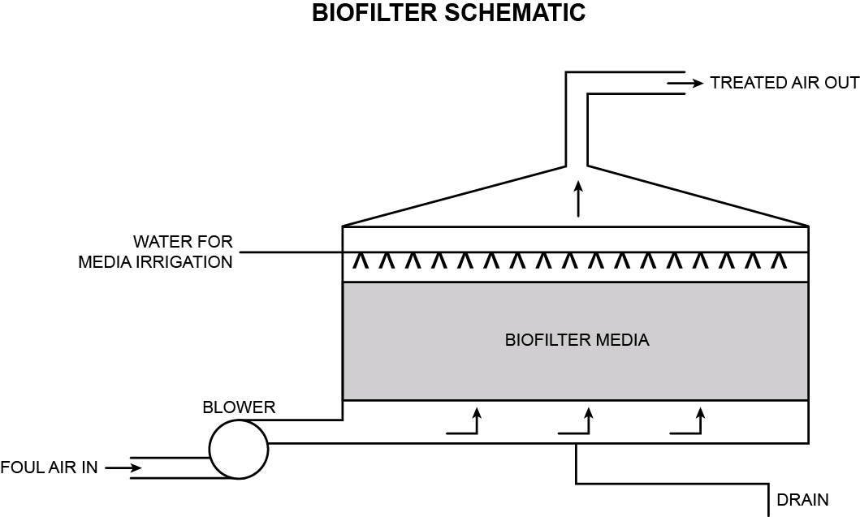
Figure 7.1 Bio trickling filter schematic diagram

Biotrickling Filter:

A bio trickling filter is a modification to the trickling filter design used in waste water treatment. The process gas and liquid (commonly sewage) flow through a fixed bed either counter-currently or co-currently. The fixed bed material provides a surface for an aqueous biofilm to form in which biodegradation can occur. The bed is generally packed with an inert material such as structured plastics, resins, ceramics, celite, polyurethane foam, or lava rocks. The use of a synthetic media within the biofilter can provide benefits in that the system can be easily cleaned, result in a faster start-up, allow the system to handle high contaminant concentrations and give greater process control than basic biofilters.

A diagram of a simple bio trickling filter is provided in Figure 7.1.

Bioscrubber:
The bioscrubber is an enhancement to the biotrickling filter. The bioscrubber attempts to improve the absorption of pollutants into the liquid phase, and lengthen the time the microbes have to consume the pollutants. These are accomplished in two ways: the tower packing is flooded with a liquid phase and the discharge effluent from the bioscrubber is collected in a storage tank (sump) before being recycled back to the bioscrubber. The bioscrubber may also offer improved process control over a conventional biofilter.The relative advantages and disadvantages of each biofilter treatment method are set out in Table 7.2.
Table 7.2 – Biofilter Design Advantages and Disadvantages (Sources: US EPA 2003, Cabrera et al., 2011)

Design | Advantages | Disadvantages
Fixed Bed Biofilter | Generally low operation, capital and maintenance costs.  Maintenance can be reduced through the usage of lava or pumice media.  Easy operation and start-up.  High gas/liquid surface area | Large space requirement for traditional design  No continuous internal liquid flow in which to adjust bed pH or to add nutrients  In an open design it is more difficult to obtain samples to prove effectiveness.  Natural (biodegradable bed media such as wood chip must typically be replaced every 2 to 5 years depending on rate of flow and loading of gases - may need to be replaced more frequently. These can be expensive when the system relies solely on biofiltration
Biotrickling Filter | Good for high flow rates | Media may require regular replacement.  Higher comparative capital costs.
Bioscrubber | Humidification of process gas is not required  Smaller footprint than traditional biofilters  pH and nutrient feed can be automated | Considerably more expensive to install and operate than other biofilter designs  Overfeeding can lead to plugging  Disappointing abatement results in UK applications on sewage odour

Biofilter Operational Requirements:

Maintaining optimal operational conditions is vital to ensure that a biofilter remains effective in treating fugitive odorous emissions. Operational considerations include;

Filter Media:

The filter media to be used in a biofilter is an important consideration and must be selected to provide; adequate residence times, sufficient surface area (sorption capacity) for contaminants and microbial attachment, living space and reserve nutrients for microorganisms, water content, and structural support to maintain internal structure.

Materials that can be used as filter media include organic materials and wastes from a variety of sources, and inert materials for structural support and to aid adsorption capacity. Additives may be used to maintain optimum conditions such as limestone or crushed shells for pH maintenance.

Biodegradable filter media, such as woodchip would need to be replaced at intervals of approximately 2 to 5 years. Inert beds, such as pumice stone or lava would last significantly longer; approximately 20 years.

Temperature:

Temperatures in the range of 15–40 ºC are recommended for biofilter operation, but they can also provide effective abatement at slightly higher temperatures too. Rapidly fluctuation temperatures may adversely affect performance. In some situations it may be necessary to consider controlling the inlet air temperature and pre-cooling or heating may be required to maintain the optimal bed temperature for microbial activity.

Moisture:

Low water contents or difficulties in controlling its level are the most common causes of poor biofilter operation. A moisture content that is too low can lead to bed desiccation and the development of fissures that cause short circuiting, which reduces effective capacity, residence time and process performance. Too much water inhibits the transfer of oxygen and hydrophobic pollutants to the biofilm, thereby promoting the development of anaerobic zones within the bed and limiting the reaction rate. Anaerobic zones can result in foul-smelling emissions. Excessive moisture can also cause unacceptably high pressure drops across the biofilter by limiting porosity.

Acidity:

Most biofilters are designed to operate near to pH 7, although a large number of microorganisms are abundant and active in many natural ecosystems where the pH is lower or higher, and the pH of the medium must be adjusted to the optimum value in each case. Regulation of pH can be achieved by the addition of solid buffers (e.g., lime, calcium carbonate, and phosphate salts) to the packing material at the beginning of the operation, or by irrigating the bed with a nutrient solution that contains pH buffers (calcium and sodium hydroxide, and urea), or by additional irrigation. When addition of a buffer to the medium does not solve the problem or the capacity of the buffer is exhausted, the filter media may have to be removed and replaced with fresh material.

Nutrients:

The filter media must contain all of the nutrients required to support microbial activity, such as carbon and Nitrogen, as well as micro nutrients such as potassium and phosphorus. Due to the high concentration of ammonia and organic chemicals in gasses from compost operations, the addition of nutrients to biofilter media is not normally required. However provision should be made for addition of nutrients if required.

Recommended Operational Conditions for Biofilters are detailed in Table 7.3.
Table 7.3– Recommended Operational Conditions for Biofilters (source: EC, 2006)

Characteristic | Description
Filter media | Typically Biologically active, but reasonably stable
 | Organic matter content >60 %, however mineral media have been successfully used.
 | Porous and friable with 75 – 90 % void volume
 | Resistant to water logging and compaction
 | Relatively low fines content to reduce air pressure drop
 | Relatively free of residual odour
 | Specifically designed mixtures of materials may be desirable to achieve the above characteristics
Moisture content | 50 – 80 % by weight
 | Provisions must be made to add water and remove bed drainage
Nutrients | Must be adequate to avoid limitations
 | Usually not a problem with aerobic digestion gases because of the high NH₃ content
pH | 7 to 8.5
Temperature | Near ambient, 15 – 35 or 40 °C
Gas pre-treatment | Humidification could prove to be useful in order to achieve near 100 % inlet gas humidity. Pre-scrubbing with water or acid to remove high concentrations of ammonia may help control media pH.
 | Dust and aerosols may be removed to avoid media plugging, but for most biofilters this is not a problem (unless they have a tissue/material filter layer in the bottom of the biofilter which could become blocked with dust particles)
Gas loading rate | <100 m³/h-m³, unless testing supports higher loadings
Gas residence time | Minimum of 45 seconds, unless testing supports shorter residence time
Media depth | >1m, <2 m to minimise pressure drops and operating costs
Elimination capacity | Depends on media and compound (typically in the range 10 – 160 g.m-3.h-1). Odour abatement in excess of 95% is possible with good designs and on-going management
Gas distribution | The manifold must be properly designed to present a uniform gas flow to the media

Chemical scrubbers
There may be circumstances where wet chemical scrubbing is a suitable supplement or replacement for biofiltration in the removal of composting odours, for example when it is necessary to replace large volumes of air within a building due to elevated levels of ammonia. Chemical scrubbers may provide a better treatment option in the case where odour streams are highly variable, although this can lead to dosing instability. Additionally a chemical scrubber may not be as effective in the removal of volatile organic compounds as a biofilter. Typically the area required for a chemical scrubber will be smaller than that for a biofilter, but due to the chemicals involved in the process there will be special handling and storage requirements on site.

The Industry Guide for prevention and control of odours (AFOR, 2007), states that wet chemical scrubbers provide intimate and prolonged contact between the treated air stream and an aqueous absorbing solution. A wide range of variations are possible including:

- Re-circulating and single-pass scrubbing solutions
- Acidic or alkaline scrubbing solutions
- Oxidising scrubbing solutions
- Packed column, plate or spray towers

Common chemicals used in wet scrubbing include oxidizing agents (sodium hypochlorite, hydrogen peroxide), bases (lime, hydrated lime, caustic), acids (sulphuric, hydrochloric), reducing agents and absorption enhancing agents.

Due to the complex nature of compost gases that include ammonia, organic sulphur compounds, and other organic compounds such as terpenes, different absorption conditions are necessary to remove all these compounds. Therefore single stage scrubbing may not be particularly effective and a multi-stage process is usually required. Examples of multi-stage scrubbing systems include misting towers (rarely very effective) and packed bed scrubbers.

Capital costs for these systems can be relatively high, particularly when equipped with systems to re-circulate and chemically dose the scrubbing solutions. However, their compact size, high potential removal efficiency and ability to handle highly variable air streams and loading rates can make them cost effective in some cases, particularly where high volumes of air require treatment (e.g. building ventilation) such as on a large scale In-vessel composting facility (AfOR, 2007).

It is thought that misting may provide some level of mitigation against bioaerosol, however further research is required.

Ozone treatment
Ozone gas has been promoted as a means of treating malodorous air at composting sites; however there is little supporting evidence of either the use of this technology by composting facilities or its efficacy in reducing odours from composting.

The ozone molecule (O₃) is a form of elemental oxygen which is widely used as a non selective oxidising agent. Through oxidation it may change the malodorous compounds into a less odorous form and is itself reduced to O₂.

As with all odour control systems, operators should only install proprietary ozone systems on the basis of objective odour abatement performance guarantees (for example, measured using olfactometry), and in the light of successful objective odour abatement performance measured on similar plants.

Effective microbe addition
An alternative strategy to reducing the production of odorous compounds is through the addition of effective microbes (EM) within the composting mass. This theory behind this method is to treat odours at point of generation rather than through additional treatment post formation. This is achieved through increasing the number of beneficial micro-organisms within the composting mass. There is limited peer reviewed data showing the efficacy of EM addition and their survival rates. Although a potentially inexpensive system users should seek objective data to demonstrate the effectiveness of any such products before placing any reliance on them as an odour mitigation technique.

Effective micro-organisms are typically a mixture of different natural microbes and mainly made up of lactic acid bacteria, yeast, actinomycetes and some phototrophic microbes. These will support the activities of other microbes that are already working within the compost. A reduction in the mechanical turning of compost with this regime ensures less ‘spiking’ of temperatures, lower temperatures throughput the composting process and a more consistent level of temperature and degradation within the feedstock.

The EM additive typically comes in a liquid state. It is most usually applied during shredding, additional applications may be made during turning. A storage tank will normally be located on the shredder with spray nozzles located on the output conveyor of the machine.

Masking/Neutralising agents
Deodorisers may be used to reduce odour detection off site. These agents come in a variety of aromas including peppermint, strawberry and eucalyptus. Although the mechanism is poorly understood, it is claimed that odour compounds adhere to the neutralising compounds prevalent in the agent. The neutralising agent then dissolves the volatile organic compounds and combines with them to form a non-odorous compound (AfOR, 2007). To be effective the neutralising compost needs be form an aerosol, consideration should also be given to maintenance and the potential for legionella.

Deodorisers are applied by misting systems, which typically use compressed air. Due to the significant air volume to be treated in proximity to the odour emissions and the diversity of dispersion routes that the air can take on leaving the site, the efficacy of this technology may vary according to the prevailing weather conditions and whether the facility is enclosed or open. The use of deodorisers should therefore only be used as part of a more comprehensive odour abatement treatment plan. The good practice objective of preventing the formation of odorous chemicals must override the principle of treating them once they have arisen.

The use of deodorisers can also, in themselves, be considered offensive to some people if used over an extended period. This is reinforced by the Environment Agency’s H4 guidance that states that masking agents that inhibit the recipients’ sense of smell should not be used, and that perfumes are often perceived to be as offensive as the original odour and are simply adding another pollutant to the air.

- p90 of 130 – why is half a page given to deodorisers when EA guidance states that they shouldn’t be used?
- We would very much agree with this section: masking / neutralising agents should not be used as an alternative to odour potential minimisation through thorough process management.

Topical (localised) barriers
As volatile odorous chemicals migrate to the surface of a pile they can be dissolved in, or released from, available water in the form of surface moisture. Odours may be therefore be managed by the localised application of water. In order to take full advantage of this phenomenon, several conditions must be met:

- There must be sufficient water available to dissolve the chemicals;
- The solubility of chemicals should be optimised for the odours present. Volatile fatty acids will dissolve more freely in alkaline solutions while ammonia will dissolve more freely under acidic conditions.; and
- An active aerobic biological community (e.g. bacteria, fungi, etc) can help to break down odorous chemicals once they are dissolved

Careful observation and application of water, potentially with the addition of an inexpensive neutral phosphate buffer, can help to optimise all of the above conditions. Too much water will reduce the availability of oxygen in the surface layer for aerobic microbes, while too little will not trap the odorous chemicals. Side-by-side testing of a number of proprietary topical treatments has demonstrated a wide range of effectiveness (AFOR, 2007).

Containment
Containment of waste/substrate reception and treatment processes allows odorous emissions to be controlled and may also improve process control, product quality and compliance with other legislative requirements. Additionally it is a legislative requirement for APBR waste materials to be contained. The costs associated with providing containment will vary significantly depending on the composting process and scale of operation. Health and safety considerations regarding working in a contained environment also need to be considered, and this is one the reasons why containment is often accompanied by air extraction and odour abatement to treat extracted air. Considerations may include providing adequate ventilation for workers i.e. supplying fresh air to replace that which has been extracted.

The option of covering windrows using a fabric or membrane cover is a possible solution to assist in the containment of fugitive and organic emissions from open windrow facilities. Such materials may allow fugitive emissions to be contained within a textile membrane cover that encapsulates the compost windrow. However the operator would be required to provide evidence of the efficacy of such a system. Such membranes may require specialised handling equipment and protection from rodent damage. Using these systems requires attention for increased temperature and conditions where malodourous areas may develop.

The efficacy of containment systems will depend on the completeness of the encapsulation and the air handling systems employed. Operators should pay careful attention to the design of systems and their effectiveness at the design stage in order to minimise the effectiveness of the system and minimise the potential for nuisance and pollution. This is a specialist area where poor design can easily lead to operational problems.

This approach may also be effective for bioaerosol control, however further research is required.

Bioaerosols
Bioaerosols refer to micro-organisms, including fungi and bacteria suspended in the air. Bioaerosols are generally <10 µm in size and are not typically intercepted by hairs and specialised cells that line the nose.

Exposure to bioaerosols has been associated with human health effects and symptoms usually manifest as inflammation of the respiratory system, coughs and fever. Inhalation of bioaerosols may cause or exacerbate respiratory diseases, for example Farmers Lung. Farmers Lung is a form of extrinsic allergic alveolitis, which is a lung disease that can develop after exposure to certain substances. It is the outcome of an allergic response to a group of microbes, which form mould on vegetable matter. Bioaerosols have been also known to causecase gastrointestinal illness, eye irritation and dermatitis.

The Environment Agency released a position statement in November 2010 stating that in terms of composting, the release of potentially harmful bioaerosols must be controlled. This will be taken into account before authorising any new composting facility located where the composting operations would be within 250 metres of sensitive receptors.

If operations are within 250 metres of workplaces or dwellings the developer must carry out a Site Specific Bioaerosol Risk Assessment (SSBRA) in support of their application. Before granting a permit the Environment Agency must be satisfied that the SSBRA shows that bioaerosols can, and will, be maintained no higher than acceptable levels at the sensitive receptors. For further details regarding the acceptable levels of bioaerosols at sensitive receptors please refer to the Environment Agency Bioaerosol Position Statement, which is available on the Environment Agency website at:
http://www.environment-agency.gov.uk/static/documents/Research/Composting__bioaerosols.pdf.

Standard methods of determining bioaerosol levels are available. However based on the present scientific understanding of bioaerosols, the way they behave and their health impacts, it is now considered that there is currently no suitable methodologies for carrying out adequate quantitative SSBRAs for new composting facilities. Accordingly, the Environment Agency will need to take a precautionary approach, and not normally permit those facilities where a quantitative SSBRA would have been expected, until such time as a suitable methodology becomes available, unless additional measures for control are put in place by the operator.

The types of new facilities affected by this approach are those that would have handled more than 500 tonnes of waste at any one time, and would have carried out any “composting operations in the open that are likely to result in the uncontrolled release of high levels of bioaerosols”, as defined above. In practice, this would not include situations where the entire composting operation is carried out inside a building, or where composting takes place outside, but using negative aeration and without turning. However it would include compost maturation in conventional outdoor turned windrows, carried out following other treatment operations such as in-vessel composting, treatment in a dry AD (anaerobic digestion) plant and treatment in an MBT (mechanical biological treatment) plant.

Guidance on the evaluation of bioaerosol risk assessments for composting facilities is available on the Environment Agency website. (http://publications.environment-agency.gov.uk/PDF/GEHO0809BQUO-E-E.pdf)

- p92 of 130 - This guidance is to update a document that is almost 12 years old and there is still no reliable evidence regarding the issues surrounding bioaerosols!

Bioaerosol Monitoring
There are currently three common methods used to collect bioaerosols. These are direct impaction, filtration and liquid impingers. The direct impaction and filtration techniques are approved methods listed in the Environment Agency/AfOR Standardised Protocol for the Monitoring of Bioaerosols at Open Composting Facilities (AfOR 2009), available AfOR:
http://www.organics-recycling.org.uk/page.php?article=1750&name=Standardised+Protocol+for+Monitoring+Bioaerosols
Each of these methods requires specialised equipment to both collect and analyse the samples. Environment Agency staff must ensure that this standardised protocol is followed by those undertaking bioaerosol monitoring. The protocol has been specifically developed for composting facilities that operate open-air turned-windrow systems composting green waste, but is equally applicable to in-vessel systems where they may still emit bioaerosols. Where the waste source potentially presents a different hazard to green waste e.g. those wastes regulated by the Animal By-product Regulations, 2005, additional monitoring of micro-organisms to those listed in the standard protocol, specifically Gram-negative bacteria, may be required.

Meteorological data (wind speed, wind direction, temperature and relative humidity) should also be recorded during sampling, as well as taking note of on-site activities.

Standard Protocol Methods
The current protocol for monitoring bioaerosols specifies Andersen Samplers and Filters as these are considered to be the best characterised and most well used of the current options to sample bioaerosols.

Andersen samplers are direct impaction samplers, where the sample is collected directly onto an agar plate. The advantages of this method are that it requires minimal post-collection sample handling; it pumps at a high rate and is capable of collection of bioaerosols at low concentrations. There are also a number of disadvantages with this method. For example, it cannot be used for non-culturable micro-organisms, and the plates become easily over-loaded in areas where there are high emissions. In addition, prolonged exposure may harden the agar in the plates, resulting in particles bouncing off the agar, thereby reducing overall concentrations. The samplers are also expensive and labour intensive to operate.

The filtration method uses personal aerosol filter samplers. The advantage of this system is that it is simple and relatively inexpensive, which allows for easy replication of samples. This method can be used for both culturable and non-culturable micro-organisms. Although the field work associated with this method is straight-forward, the post-sampling laboratory analysis requires more work than for the direct impaction samplers. In addition, sampling for markedly longer time periods will cause micro-organisms to dry out and lose viability. A further disadvantage is that the limits of detection with this method are not as low as for the Andersen sampler.

For further details on these methods, please refer directly to the protocol, which is available from AfOR.

Other Methods
The Environment Agency/ AfOR protocol for sampling bioaerosols is recommended as a minimum for bioaerosol monitoring. However, other methods can be used. Liquid impingers capture bioaerosols in a glass vessel containing a liquid, normally a Dreschel bottle. Examples of this equipment include the AGI-30 and the BioSampler (SKC). The main advantage of this method is that it reduces the possibility of micro-organisms drying out, as they are captured in a liquid. However, prolonged sampling periods can result in the liquid evaporating. This method can be used for both culture and non-culture methods.

Sampling Frequency
The frequency of sampling for bioaerosols should be determined by the level of risk from a particular site. With new sites, the level of bioaerosol emissions will initially be unknown, so more frequent sampling should be undertaken, until the emissions and controls are well understood.

Bioaerosol Abatement
At open windrow compost facilities, the primary abatement measures for bioaerosol release are;

- reducing releases;
- containing emissions; and
- enhancing dispersion.

Altering or reducing composting turning activity, particularly during strong winds, is recommended particularly if wind direction is towards sensitive receptors. In addition, slower speed shredders and dedicated turners, i.e. a front end loader can generate fewer bioaerosols. The use of baffles over turning equipment can help reduce bioaerosols created during the turning process.

The use of moisture control to limit dust generation can in turn restrict the release of bioaerosols associated with the dusts.

Site position in relation to prevailing wind conditions to limit passive bioaerosol release can play an important role. Windrows should be orientated to take into account the direction of the prevailing wind, where site design allows this. The smallest possible area of composting mass should be exposed to the prevailing winds and preferably at low elevations within the overall site context. There is evidence on the usage of bunds, trees and banking to increase turbulence at the site, resulting in improved dispersion and reductions in downwind concentrations of bioaerosols. This use of landscaping to improve dispersion requires further detailed investigation.

In terms of containment of emissions, in-vessel systems and closed windrows present additional mitigation in the form of exhaust air and biofilter treatment systems, provided that appropriate effective extraction systems are incorporated into the site design. There may be a release of bioaerosols during deliveries and other activities that may require the doors to be opened. Operators should consider the activities and potential releases during these times to minimise uncontrolled releases. When operated correctly, biofilters have been demonstrated to reduce the presence of spores and bacteria. This is not their primary function and developers should not assume that the installation of a biofilter will adequately remove bioaerosols.

- 7.4.2 ought to include a note that smaller sites (less than 500t at any one time) are typically not a cause of concern for odour or bioaerosols.

Leachate
Leachate is generated where excessive moisture penetrates a composting mass, for example through rainfall, or from the composting process itself which generates water as a by-product. This moisture can percolate through the composting mass and chemicals within the compost dissolve into the water to form a leachate (the chemicals leach out of the compost). The leachate may have a high odour potential and should be managed appropriately.

- p94 of 130 – ‘the composting process itself which generates water as a by-product’ Microbes might produce water as a by-product of respiration but this does not lead to a net production of water from an active composting system. A greater amount of moisture is lost as evaporation than is added. Thus, in the UK, we see a drying of the material as time progresses. Evidence that the authors and reviewers of this document do not understand the science and practicalities of composting.
- 7.5 ought to include a note that leachate is typically not a concern for small scale sites less than 500t at any one time.

Likewise, many of the compost feedstock materials have high inherent water content and as they breakdown a solution of chemical components from the breakdown will arise and can collect at the base of the compost pile. These leachates may present potentially harmful characteristics such as soluble chemicals, nutrients, organic matter and potentially pathogens.

Leachate is usually collected and can, on occasion, be returned to the composting process as a source of moisture. To avoid contamination, leachate from unsanitised waste should not be applied to sanitised wastes. The collection and recirculation of leachate should be considered at the site design stage.

Excess leachate may require disposal and depending upon the site location and available disposal routes may require on site treatment. Some leachates may be suitable for ‘’fertigation’ (fertilisation and irrigation) for agriculture and are applied under a permit for landspreading. Only leachate derived from sanitised compost is suitable for landspreading.

Leachate Monitoring
Leachate can be a significant source of nutrients and can be valuable in a number of applications. However the content of leachate is dependent on the composition of the feedstocks being processed there. Therefore if leachate is to be discharged to the ground, i.e. spread on land, then the developer should refer to the Environment Agency groundwater environmental permitting guidance which sets out the requirements that must be met, which may include monitoring.

If leachate produced on site is to be discharged to a surface water course (following treatment) or sewer then the developer will be required, as part of the environmental permit, to complete modelling which will be used to assess the discharge, the developer should refer to EA Horizontal Guidance H1 Annex D. Further discussion on leachate disposal is contained within Section 9.

    - 7.5.1 para 1, leachate disposal to the ground, I am not aware that this is a permissible activity and there is little detail here to explain it, this section needs expanding and references cited. The reference to ???

Leachate Management
The key considerations and priorities to deliver abatement of leachate include:

- Prevention of leachate as a priority through design to separate rainfall from stored feedstock, active composting and product maturation areas;
- Reuse of leachate to maintain optimum moisture content in the active composting mix, taking account of any compliance requirements with the Animal By-Products Regulations; and
- Treatment of excess leachate to the necessary standard to enable it to be exported or discharged safely from site.
- Application of leachate to land may be permissible under an appropriate Environmental Permit, it may also be necessary to inform the Environment Agency prior to deployment.

- P95 of 130 - It may also be necessary to inform the EA prior to deployment. It is a bit more than ‘may be necessary’ and also as this is the first time deployment has been mentioned. Deployment of what?
- 7.5.2 states that “impermeable surface is required on all areas” which is incorrect as it does not qualify this to specific Permit types it applies to.

Impermeable pavement should be constructed in all operational areas of the facilities, particularly in the case of composting pads or composting vessels but also including all storage, shredding and maturation areas. Leachate should be managed via a sealed drainage system that collects the leachate and separately contains them from non-contaminated surface water at the facility.
Leachate and other potentially polluting liquids should be directed to impermeable storage tanks or lagoons made either of concrete or man made materials which are chemically compatible with the liquid they will contain, such as HDPE (high density polyethylene) of the same quality as used to line some landfill sites. Leachate levels within storage vessels should be monitored and arrangements for collection and treatment should be made in advance to reduce the likelihood of pollution. As well as ensuring leachate is removed regularly the operator should ensure that the storage facility, and any drainage and sumps associated with it, are de-sludged regularly to prevent both odours and a reduction in the capacity of the system.

Dust
On a similar basis to bioaerosols, dust emissions may arise from composting activity or vehicle movements associated with the process. Dust formation from the compost generally occurs in material with a moisture content lower that 30%. This level is below the ranges discussed in Section 5. Regular monitoring of moisture content within the compost will assist with reducing dust emissions. Further possible mitigation measures include:

- Maintaining and cleaning of plant and machinery to avoid dust generation;
- Paving of all operating, storage, loading and unloading areas;
- Sealing of roads particularly if traffic volumes or meteorological conditions that would encourage dust formation are likely to be high;
- Reducing shredding, turning and screening of compost materials particularly on windy days;
- Use of water based dust suppressants(damping down) and windbreaks;
- Use of negative aeration and air treatment within enclosed reception and processing areas;
- Regular suction sweeping of roads.

Vermin
Compost facilities, particularly open windrow operations, can attract vermin and in particular flies, rodents and birds. These vermin, if not managed, can affect operations and create a negative perception of a composting facility. They pose an environmental and health hazard as a potential vector for pathogens, and can result in cross contamination between clean and dirty areas of a composting site, which could result in noncompliance with the ABPR Regulations.

Consideration of control measures such as fencing, screens and/or covers should be undertaken at the facility design stage to mitigate against potential vermin.

Feedstock reception areas should be closed, except for when receiving deliveries, and this can limit the entry of vermin into compost feedstock material.

- 7.7 states “Compost facilities, particularly open windrow operations, can attract vermin and in particular flies, rodents and birds.” This is not our experience of small scale green waste only sites and should be qualified. An unqualified statement such as this is detrimental to the public’s perception of our operations. The paragraph then goes on to require that all feedstock reception facilities should be enclosed, clearly a reference to ABPR facilities but is not qualified. The comments and advice on vermin are not true of green composting only which does not attract vermin and does not need to be processed indoors.

Monitoring and Controlling Vermin
Developers need to have written procedures for the inspection and control of vermin. Inspections should be carried out weekly by a nominated person and the results recorded. All operatives should report any sightings to the nominated person immediately.

The site should be actively managed in order to reduce the presence of vermin, this includes measures such as:

- The incorporation and maintenance of adequate drainage to avoid pooling water;
- Using composted material or mulch to cover raw waste, making it more difficult for vermin to get to raw feedstock; and
- Using enclosed delivery areas.

If vermin is detected then immediate action needs to be taken to control the situation. This may be by instigating better housekeeping, clearing spillages etc. Where an infestation is likely, or occurs, it is recommended that professional pest control contractors are brought in to eradicate the problem immediately. Appropriate control measures need to be implemented to prevent a reoccurrence. All action taken must be recorded.

Monitoring and Control of Vermin
Operators should have written procedures for the inspection and control of scavengers. Inspection must be carried out weekly by a nominated person and the results recorded. All operatives must report any sightings to the nominated person immediately.

Upon detection immediate action must be taken to remove the scavengers from the site. The materials, or wastes, that are attracting the scavengers should be isolated and secured to deter further scavengers. Appropriate control measures need to be instigated to prevent a reoccurrence. All action taken must be recorded.

Noise
Excessive noise levels have the potential to cause nuisance to nearby residents due to loss of amenity or loss of sleep. Aerobic compost operations present potential emissions from noise in respect of mechanical handling equipment such as shredders, turning equipment and front end loaders. In the case of certain In-vessel forced air blowers/driers and forced air compost systems, and, in the case of enclosed composting systems, active air extraction systems and loading and unloading of compost feedstock and product can all cause excessive noise. In the case of increased capacity or new facilities there may also be additional noise from traffic.

The Environment Agency has produced horizontal guidance on noise pollution (H3 Noise Assessment and Control). This guidance describes the principles of noise measurement and prediction and the control of noise by design, by operational and management techniques and abatement technologies. The guidance assists in determining if proposals are BAT for a given installation.

Noise Monitoring
Developers should monitor the noise from site regularly, when it is fully working and also when it is shut down in order to provide a baseline for comparison. This will give an idea of the impact of work on the noise levels in the surrounding community. Monitoring will also help to identify any sensitive areas, changes in noise levels or specific spikes in noise levels. Additionally the routine monitoring of site noise will assist with demonstrating improvement if complaints are received, or to demonstrate compliance with specific limits.
If in doubt, seek advice from a noise expert.

Where to measure

In the case of compliance monitoring, measurement positions should be as close as possible to the positions specified in the conditions attached to the Permit.

For new proposals, extensions or alterations, Part 1 (Permitting and regulation) of the horizontal guidance offers advice on the choice of the location at which to specify Permit conditions; one of the key aspects that may influence this choice is the ability to carry out meaningful monitoring. Since the concern is impact upon the sensitive receptor, the preferred technique has to be to assess and measure at that receptor. This would then enable a receptor level to be set, or a suitable level calculated for a boundary or other appropriate measurement location.

The choice of measurement position will depend very much upon local circumstances, including the sensitive receptor to be protected.
For further information on selecting measurement points developers should refer to the horizontal guidance document from http://www.environment-agency.gov.uk/business/topics/permitting/36414.aspx.
Noise Measurement Procedures
Standard measurement methodologies for noise measurement are contained in BS 7445:1991 and in BS 4142:1997. The relevant conditions can be summarised as follows:
- measurements should be taken 1.2 – 1.5m above the ground
- precautions should be taken to minimise the influence of wind (use a windshield), and of heavy rain falling on the microphone windshield and nearby surfaces (generally do not take measurements in the rain and when roads etc. are wet)
- minimise the effect of electrical interference due to power cables, radio transmitters and the like (use equipment that is CE compliant) but be alert for inconsistent or unusual results
- If measurements have to be made above ground level, the microphone should be positioned 1m from the façade of the building
- measurements should not be made if the average wind speed exceeds 5 m/s
- measurements should either be taken under free-field conditions (more than 3.5m from any reflecting surface) or at 1m from the facade of a building and results treated accordingly (when a noise source is incident on a façade, the effect of reflected noise from the façade is generally to increase the “façade level” measured at 1m by 3 dB)

All measurement conditions should be recorded and any deviations from the relevant British Standards justified, for example, shortening a measurement period due to rain or an extraneous noise source.

The horizontal guidance provides an example of a report form that can be used for recording noise complaints and measurements. This also serves as an aide mémoire for best practice. The aim should always be to ensure that measurements could be repeated at a later date at the same location.

Noise Abatement
Design considerations and best management practice for minimising the emission of noise includes:

- Incorporation of noise screening and cladding around particularly noisy site equipment;
- Attenuation provided by trees and hedges around boundary;
- Undertaking processing operations such as shredding only during normal working hours
- Using mobile noise screens
- Consideration of noise rating as part of equipment selection policy
- Robust site management procedures to eliminate and reduce noise including routine operational noise assessment
- Minimise use of noisy site equipment on windy days, where the prevailing wind direction is towards sensitive receptors.
- Provision of personal protective equipment to employees where exposure to noise is potentially above 85 dB(A) average over eight hour working period

Litter
Litter can cause a significant impact the on health of local wildlife and loss of amenity for nearby residents. For source segregated aerobic composting operations, litter should not be a comparable nuisance to other waste management operations handling mixed wastes. However, it can become a problem where feedstocks, particularly from local collection authorities, have become contaminated with general wastes. This should be tackled by rejecting heavily contaminated wastes: Inspection and Rejection Processes are covered in Section 8.2.2.

The potential for litter to arise through contaminants in feedstocks however remains a possible source of pollution from a composting operation and the following mitigation measures should be considered:

- Minimising exposure of operational areas to prevailing winds
- Use of wind breaks, tree and shrub lines
- Use of mobile screens to intercept incidental litter
- Removal of litter from feedstock material
- Programme of litter picking on and around site by the end of each working day
- Robust management of sites to ensure prompt disposal of any residual wastes or reject material arising through the course of operation to an appropriate facility
- Potentially windblown materials or waste should not be unloaded or turned during windy conditions

Operation and Management

Introduction
There are generally three different types of activities associated with managing a composting facility. These activities are:

- Monitoring and managing the receipt and handling of feedstock materials, including the removal of contraries;

- Monitoring and managing the optimal process parameters of the composting process; and

- General site management, operation and maintenance of the facility

These are discussed in further detail in Sections 8.2, 8.3 and 8.4.

Process configuration

Feedstock supply
Composting processes are sensitive to the feedstock materials used in the process. Operators should develop procedures to deal with the removal and management of any impurities. The removal of these impurities is imperative for the production of a compost material if it is to meet the PAS100 specification and/or the Compost Quality Protocol.

Many biodegradable organic materials can be composted. However, some pure streams e.g oils, dairy and fatty products, can hinder the process and need to be carefully blended. Further information on suitable feedstocks for composting is provided in Section 5.

Operators of composting sites should also be trained to identify poisonous weeds or invasive species, (such as Japanese knotweed and ragwort) which may be found within deliveries to site. The Environment Agency has guidance on invasive non-native species which can be downloaded from http://publications.environment-agency.gov.uk/PDF/GEHO0410BSBR-E-E.pdf.

Operators should take the opportunity to work with Local Authorities to ensure that waste arrives with minimal contamination, for example by ensuring delivery vehicles are regularly cleaned. Rigorous waste acceptance procedures and inspection of feedstocks is needed to ensure wastes are not malodourous when accepted. Best practise contractual arrangements should allow for waste diversion where waste is malodorous, and allow for rejection at the weighbridge.

Operators should, where possible, develop supply contracts that specify the materials which are acceptable to their process and set limits on impurities. Good working relationships with suppliers are also encouraged. Many process and quality issues can be resolved at the point of waste arising/ collection, for example, the impact of the raw feedstock odours will depend on their volume and their previous history and handling. Education can play a large part in developing the relationship and inviting potential suppliers to the composting facility can provide them insight into why limits and restrictions are important. A system of booking in waste should be considered to accommodate waste mixes and volume limits.

Within contracts operators should also consider the contingency action that needs to be taken to manage events such as oversupply of material, breakdown of machinery or insufficient bulking agents. It may be necessary to have arrangements with other facilities to allow wastes to be accepted and processed, rather than to accumulate and present an odour risk.

Suggested contractual considerations for the supply of organic waste for composting are included in the Compost Quality Protocol/ PAS 100. These should be considered as a minimum requirement and include the following:

- Regular supplies of different waste types and materials
- Quality of source segregation, time limits, no odorous material, verification by nominated person (including the exclusion of specified weeds and other contaminants), the acceptance criteria should be included in the contract.
- Quantity issues in relation to the delivery vehicle type vehicles, or containers.
- Return of loads where they are found to be odorous, contaminated, outside agreed limits to include financial penalty clauses. These should be rejected immediately from the weighbridge.
- Delivery times specified such that the load is not too early or too late, within operational times imposed by the permit. A booking in system to allow for effective site operation and avoid late processing is considered BAT.

The Contract should clearly define the wastes types that are accepted and be in accordance with those listed within the permit. A further refinement is that these must be in accordance with the Compost Quality Protocol, otherwise they may not be considered to be fully recovered.

- One composter
- p101 of 130 – A further refinement is that these must be in accordance with the Compost Quality Protocol, otherwise they may not be considered to be fully recovered. Sadly, it appears that although the document refers to ‘biowastes’ there is no shift to acknowledge anything other than materials acceptable under the QP/PAS100 can be considered as either ‘compost’ or ‘recovered’.
- p101 of 130 - Regurgitation of AfoR guidance. This need only be referenced it does not need to be copied in full.

Inspection and Rejection Process
It is important that the operator develops robust inspection and rejection procedures at the facility. The Association for Organics Recycling (AfOR, 2011) identifies the rejection procedures for the delivery of organics materials on site. The process steps described in the document are summarised below:

- On arrival details of the waste carrier, waste type, code, source, quantity and delivery date should be recorded on a waste transfer note or a weighbridge ticket.

- A visual inspection of the load should be made by the site supervisor to identify any obvious contamination in the load. This means that loads which are clearly contaminated can be rejected and re-directed to another facility prior to tipping.

- The driver should be instructed to tip the waste at a suitable location and then the site supervisor will instruct an operative to spread and inspect the load. The result of the inspection should also be recorded and provided to each waste supplier.

- The load will either be accepted, accepted but with contraries removed or rejected. Specifically the inspection should involve checking the load is what is expected, that it conforms to its consignment or transfer notes and meets the criteria specified in the relevant permit.

Where previous problem materials or waste streams/ sources of waste have occurred with particular suppliers, then these should be given additional attention to check that controls have been implemented.

Removal of contraries
Care must be exercised to ensure the removal of large objects or inert materials such as metal or masonry. Inadequate removal of contraries can lead to problems with the presence of visual contraries (e.g. glass, plastic), as well as large and inconsistent particles, which devalue the end product. Good management of this process is desirable since once reduced in size contrary items become more difficult to remove.

Removal of Rejected Materials
Care must be taken to ensure rejected materials are kept separate from those materials either awaiting inspection or being accepted on site, to prevent any cross contamination.

The material should be kept in a designated quarantine container or area on site. Any odour or dust controls detailed in the on-site contingency plan must be adhered to.

If the material is rejected and can be traced to a source then this material should ideally be returned to the supplier, or directed to an alternative suitable licensed facility. The regulatory authority should be notified of the action that was taken. Records should be kept of loads rejected and where the rejected material is redirected to.

Unacceptable materials should only be removed from site and delivered to an alternative location when all relevant legislative requirements and paperwork are in place, and the site manager is satisfied the material is going to a suitably licensed facility.

Optimal Process Controls

Process parameters
As discussed in Section 2, there are a number of factors that affect the composting process. Some of these parameters need to be controlled as they have an impact principally on the end quality of the product and on the generation of emissions, these parameters are:

- Oxygen within the waste mass
- Particle size, porosity, structure and texture
- Nutrients and Carbon Nitrogen ratio
- pH
- Moisture
- Temp
- Time

The PAS 100:2011 standard provides a documented guide and system for the control of the process parameters. It introduces hazard analysis critical control (HACCP) as a system to ensure that production parameters are met. This HACCP approach is also required by AHVLA for compliance with ABPR. Further information on HACCP is provided in Section 8.4.2 b (iii).

Table 8.1 below lists the parameters and values that are typically associated with successful composting. Many of these factors are interdependent, as discussed in Section 2. Sections 8.3.1 (a) to (g) provides further insight into these parameters. It should be noted that if ABPR material is being treated then the temperature and particle sizes will need to comply with the legislation.
Table 8.1 Parameters and values that are typically associated with successful active composting

Process parameter | Typical successful range
Oxygen | 5%-15%
Porosity | Minimum porosity of 20%v/v
Particle size | 10mm- 30mm for forced aeration  25mm 40mm for open windrow  >50mm for passive
C:N ratio | 25:1-30:1
pH | 5.5 – 8.0 typically
Moisture content | 50% - 60% typically
Temp | 45ºC – 55ºC

- p103 of 130 - Table 8.1 – So therefore provided the composting mass can reach these basic fundamental parameters the EA are happy that the material will compost? It will be interesting to see this in practice, as suspect the EA will revert back to only materials that are on PAS100 list as suitable.
- As discussed previously, we would consider carbon dioxide to be a key process parameter.
The abbreviation ‘Temp’ is not defined, which may confuse certain readers.

Whilst we would generally agree with the values in this table, the figures for porosity, particle size, and C:N ratio are all fairly difficult to measure reliably on site and as such are of limited use in a practical environment.

The oxygen figure of 5-15% is perfectly acceptable but it must be stressed that this is under steady-state conditions. The report previously outlines the effect of turning on oxygen consumption rates (Section 4.1.1). Because of this, we know that oxygen levels drop following a turn before slowly recovering as consumption declines. Typical data from this process is shown in Figure 3 and Figure 4 (page 7). These data clearly show that a minimum oxygen level of 5% at all times is impossible. Provided the aeration mechanism (whether passive or active) is sufficient, these low levels will recover to somewhere within the 5 – 15% range within a matter of days.
If, however, levels do not recover then this clearly indicates an anaerobic process.
We would agree with the suggested oxygen concentration range of 5-15% but feel that it should be emphasised that this is under STEADY STATE CONDITIONS.

Oxygen and Aeration
A minimum oxygen concentration of 5% is recommended, but ideally should be maintained between 5-15%, without this level, the process can slow down. In addition this can lead to anaerobic conditions which results in the generation of methane and highly malodorous compounds such as organic acids and hydrogen sulphide. Aeration can be used to increase oxygen levels and to remove water vapour and carbon dioxide as well as heat trapped within the materials. It will also strip volatile compounds from within the waste mass.

Odour problems are known to be the result of, amongst other parameters, low oxygen conditions. A compost pile or windrow must be aerated (whether passively or actively) or turned as required during the active stages of the composting process to promote oxygen transfer. Aeration can also be used to assist in controlling the temperature and moisture content within the compost through removal of excessive moisture or heat.

The risks associated with bioaerosol releases should also be considered along with the operating temperature of the pile when developing an aeration strategy.

Particle size and porosity
Within the composting mix there will always be a distribution of particle sizes, so the effects described here relate to the representative particle size within the pile. Typically the feedstock is passed through a shredder to produce a maximum particle size within the feedstock that is suitable for the process being undertaken.

Particle sizes which are too small can lead to compaction and settling of the waste mass, which reduces the porosity of the material and can inhibit the movement of moisture and air through the materials. This can lead to the generation of anaerobic pockets in the pile and can lead to odour release.

Large particles, such as woody material, can be used to provide structure and enhance porosity. However too many large particles can diminish surface area and can therefore slow composting.

A balance must be achieved which takes into account the feedstock materials and may result in a need to, for example, mix wet nitrogen rich material with coarse dry carbonaceous bulking agents to increase porosity, enhance air circulation, and reduce moisture in the incoming material . As a result, wet nitrogen rich materials such as food waste should be mixed with a porous carbon rich bulking amendment materials, such as sawdust, woodchips or shredded garden organics to create a porosity of at least 20%v/v.

Enclosed and In-vessel systems should be designed and managed to treat smaller particle sizes. These systems maintain porosity and oxygen levels mechanically by internal turning or by rotation of the vessel, which may help prevent settling and the formation of preferential air pathways, or by forced aerated systems .

A particle size of an average of between 10mm and 50mm in diameter will produce the best results; however processes that are not turned will need particle sizes greater than 50mm to resist settling. Another consideration which must be taken into account when considering particles size is the requirements of the Animal By Products regulations. For Category 3 animal by products a particle size not exceeding 12mm in any one plane is required. National standards can be applied for the treatment of catering wastes, and the time temperature and particle size regimes are shown in Table 8.2

Table 8.2 National Standard time temperature particle size treatment regimes

System | Minimum temp | Minimum time | Max particle size
Closed Reactor | 60°C | 2 Days | 400 mm
Closed Reactor | 70°C | 1 Hour | 60 mm
Housed Windrow | 60°C | 8 Days (turned at least 3 times @ 2 day intervals | 400 mm

It should also be noted that producers can achieve compliance through the alternative transformation parameter, where particle size is not considered. For further information please refer to the AHVLA website:
http://animalhealth.defra.gov.uk/managing-disease/animalbyproducts/compost-biogas-manure/alternative-transformation-parameters.htm

Carbon to Nitrogen ratio and other nutrients
The Carbon to Nitrogen ratio is fundamental to the composting process. C:N ratios of 25:1 to 30:1 are generally accepted as ideal for active composting, although ratios from 20:1 and up to 40:1 can give good results. If the ratio is higher, the composting process tends to slow. If the ratio is lower, excessive amounts of ammonia are often released.

As composting proceeds the C:N ratio falls. A C:N ratio of below 20:1 indicates that available carbon has been utilised and converted to CO₂. Any remaining unstable nitrogen may be lost as NH₃ or N₂0 resulting in odour emissions. C:N ratios above 50:1 have been reported as effective but require a longer composting time for complete carbon utilisation. These C:N ratios can occur where there is a high proportion of coarsely shredded wood in the mix. This can be screened out post composting.

Higher levels of carbon slows the process and nitrogen may become a limiting factor. In mixes with easily decomposable carbon sources it is possible for volatile carbon compounds to accumulate leading to odours. This would require management.
The carbon to nitrogen ratio can impact on odour formation during the composting process. Appropriate mixing of feedstocks can assist in the reduction of odour formation during the process. Further details on odour control can be found in Chapter 7, emissions and abatement.

Wetter nitrogen rich materials such as food and manure can be bulked up and blended with carbon rich materials such as leaves, straw, woodchips or grass cuttings. This not only improves the C:N ratio but also optimises the porosity and hence aeration.

Other major nutrients such as phosphorus and potassium, along with minor nutrients such as magnesium and calcium, and trace elements, are also required by the composting micro-organisms. N, P and K are the chief nutrients used by plants so in the great majority of feedstock mixtures, these nutrients are present in sufficient quantities and do not need to be added separately. This situation may not apply to a limited number of industrial or commercial organic wastes that predominantly consist of a single substrate. In these cases, any missing nutrients can be provided by the addition of another suitable waste material.

pH
Decomposition occurs most efficiently between a pH of 5.5 to 8.0, however the composting process is relatively insensitive to pH and irrespective of the starting pH the final stabilised product will have a pH close to 7.5 -8.0. .

During the initial stages of decomposition, organic acids are formed that are normally consumed by aerobic micro-organisms. As oxygen supplies in the pile decrease, these acids will not be converted as quickly and pH levels may drop below 6. Extra aeration usually solves this problem.

Acidic conditions are detrimental to aerobic micro-organisms, particularly bacteria; this slows the process but does not stop it. A population of micro organisms mainly fungi will eventually develop and use acidic compounds as a substrate. These organisms consume the acidic compounds and the pH is elevated again.

A pH above 9 will typically indicate high levels of ammonia, resulting in odour. Adding materials high in carbon content can help bring the pH level down.

Maturity is measured by some operators by the drop in pH from alkaline to neutral.

Testing pH is very simple and can be done on-site with a soil pH testing kit, or a pH meter. The pH of compost will also be a factor in using and/or marketing the finished product as excess acidity or alkalinity can damage or kill some plants.

Although taking a reading from a liquid extract with a pre-calibrated pH meter is very simple, the procedure of calibrating a meter, taking and preparing a representative sample, preparing an extract, and taking a reading on the extract would not be considered at all simple for the majority of site operatives. Furthermore, variations and inconsistencies of the material being sampled (particularly from young unscreened batches) necessitate a carefully designed sampling and testing protocol which requires prior technical knowledge of such procedures.
We would not agree that testing pH on site is very simple and feel that this statement should be revised.

Moisture
The moisture of a composting mixture will have an important effect upon the efficiency of the composting process. Moisture is essential in the composting process as it allows micro-organisms to move and transport nutrients. It is also an essential medium for chemical reactions.

Many studies have been conducted investigating the influence of moisture content on composting activity. Simple physical treatments, such as shredding the material, have been shown to have an effect, changing the optimal moisture content for a material. Greater pore space is required for passive systems to allow mass transport of air through the composting matrix.

The optimum moisture for composting will very much depend upon the water holding capacity of the composting mixture. Typically successful levels are between 50% and 60%.

Higher moisture contents are applicable to IVC, where the process can generally be more closely monitored and controlled through automated systems. In addition feedstocks can also be processed to augment moisture content, for example, by shredding and blending.

Windrow composting feedstocks are typically at the lower end of this optimum moisture range as they are typically used to process parks and garden waste. Food waste, which cannot be treated in a windrow, is much higher in moisture content and is typically treated in an in-vessel system. Moisture content can vary seasonally, for example, with high grass inputs during the spring and summer months or during periods that see high rainfall.

If the moisture content exceeds 70%, oxygen movement is inhibited and the process tends to become anaerobic because the air spaces of the substrate are filled with liquid which obstructs the sufficient oxygen diffusion within the organic mass. In addition unacceptable amounts of leachate may be produced with associated odour and water pollution problems.

When the moisture content falls below 40%, biological activity is slow as there is an insufficient aqueous environment for the microorganisms to flourish. This should be avoided as it can result in a final product which is not biologically stabilised. Low moisture levels are associated with dust release from site as well as elevated mould growth that can form bioaerosols and also increase the risk of fire.

If the moisture content falls below 15% biodegradation ceases altogether. The feedstock moisture content should be 51% m/m or greater (for the recommended PAS 100 compost sanitisation step) immediately following batch formation, since the composting process will proceed most efficiently in this range. For this reason, it may be necessary to wet the feedstock after shredding and prior to batch formation (as is normal practice on PAS 100-certified sites). However, it may also be necessary on rare occasions to cover the feedstock if very heavy rain is forecast to fall on material which is waiting to be shredded.

It is not good practice to have unprocessed material on site for long periods and material should be processed within 24 hours of delivery. Old, wet feedstock does not shred well, may become anaerobic, and may not mix well after shredding. Some feedstocks are not suitable for outside storage, such as feedstock containing Animal By-Products.

For further details of the requirements of PAS 100 please refer directly to the specification which is available to download from the WRAP website.

Moisture content should be monitored through the process, the squeeze test is suitable for this initially, but a testing of samples should be undertaken to assure the results of this test. Methodologies for these testing procedures are given in PAS 100. Best practice for monitoring moisture content is shown in Table 8.3.

Table 8.3 Moisture content monitoring
Best Practice | Reference PAS standards | Possible Actions
Feedstock reception | Squeeze test – industry standard minimum of 45% | Add by misting or spraying material – squeeze test and drying loads to
0-14 days | Moisture levels recorded daily and amended as necessary .  Drying oven to QA results weekly | Add moisture by spraying or misting and blending with material to redistribute moisture.
14 days – 28 days | Drying oven of results weekly
28 onwards | Twice weekly monitoring and more frequent in drier conditions | Adjust material as necessary to prevent dust and bioaerosols.

We agree that moisture content is absolutely critical to the process and as such see this section as being highly important.
The first row deals with feedstock reception. In the vast majority of cases, the squeeze test is not appropriate for un-shredded feedstocks. The picture to the right of the contents page in PAS100:2011 shows a very woody feedstock typical of that collected from civic amenity sites in the winter months. Although this material may well have a moisture content of around 45%, it is quite clear that it is not going to be possible to obtain any squeeze test results from this type of material.
We would suggest that a squeeze test for composting feedstocks is totally impractical. At best, a visual appraisal by the operator is the only check that can realistically be carried out on the feedstock.
There is no methodology given or referenced for extracting and preparing moisture samples from windrows, and no reference to the oven-drying method for the sample (BS EN 13040 is used for PAS100). The majority of sites do not currently have the equipment or expertise required to carry out an oven-dried test accurately or reproducibly.

If the guidance is to suggest that operators take samples from unscreened windrows and carry out oven-dried moisture tests on these, we would like to see very specific details of how this should be carried out.

We take and analyse several hundred samples per year from whole windrows and have developed an in-house method of sample extraction and preparation whereby a hole of depth 0.9¬ 1.1 m is dug into the windrow and a grab sample of 200 500 g is sieved to 12 mm before oven drying. Due to the inherent variation of moisture within windrows, a minimum number of four samples is required to obtain a meaningful result for a typical size windrow of 1000 m3. The time taken to extract, prepare, analyse, and record each sample is typically about 15 minutes so for a large site processing 200 batches per year, this equates to 200 hours of additional work per year for each time a batch is sampled. Table 8.3 seems to suggest that a minimum of four oven-dried tests are required for each batch; this would equate to 800 hours per year – over 3 hours per day for a site that works 5 days per week.
The exact number of oven-dried moisture points required per batch should be clarified. It will not be practical for all but the smallest of sites to take representative oven-dried samples four times from each batch.

The document contains no provision at all for alternative methods of moisture measurement. Although moisture probes have historically been of limited accuracy, they have the potential to offer producers a rapid and reliable method of determining core moisture levels of in-situ windrows without the need to take a sample.
Moisture probes should be included as a valid moisture measurement method, provided it can be demonstrated that the results obtained with them can be reliably correlated with correctly taken and analysed oven-dried samples.

Temperature
Temperature is a key control parameter of the composting process and is a by-product of the microbial activity during organic matter biodegradation.

Each composting micro-organism has an optimum temperature at which it will operate effectively. Suitable temperatures vary from ambient (c. 25ºC) up to 58-60ºC, depending upon the micro-organism.

The optimum temperature for composting will vary according to the stage of that composting process and the micro-organism that predominates during that stage. During the early stages of composting the optimum may be 45-55ºC, while during later stages when activity has decreased the optimum will be lower

Whilst temperatures higher than 65ºC to 70ºC result in the retardation of most microbial activity, high temperatures are desirable for the destruction of pathogens and weed seeds. The critical temperature for destroying weed seeds is 63ºC and a temperature of 55ºC should kill human pathogens and most plant pathogens as well.

Prolonged high temperatures beyond the period required for sanitisation are undesirable leading to formation of harmful micro organisms such as thermopohilicthermophilicthermpohilic actinomycetes. Maintaining temperatures at the optimum for the feedstock and micro organisms present will produce high quality compost in the shortest possible time. Excessive temperatures will bring about a fall in the population of the mesophilic bacteria. If this “thermal kill” does occur the pile should be remixed using material from biologically active batches to restart the composting process. If the process is treating ABPR then the entire treatment process must be undertaken again. Reprocessing of the material may result in malodorous compounds and the additional drying may increase fire risk.

Minimum temperatures must also be considered if the compost is intended to meet the PAS 100 specification which recommends 65ºC, for 7 days continuous at a moisture content of 51%mass/mass during the sanitization step in order to eradicate human and plant pathogens. Furthermore it recommends that temperatures should be maintained between 45ºC and 80ºC , and moisture should be maintained at least at 40% mass/mass throughout the subsequent stabilization step to maximise sanitisation performance. However, these higher temperatures are discouraged due to the association with poor quality outputs and retarded rates of degradation.

If the feedstock includes Animal By-products then temperatures must be maintained at required levels set out in the Animal By-Products Regulations (Animal Health, 2011) to ensure sanitisation has been achieved. The required temperatures are provided in Table 8.2 above. Developers should refer to the AHVLA website for current guidance.

Temperature is used as a basic indicator during the composting process. Temperature usually follows a distinct profile, provided in Figure 2.1. Deviations from this suggested profile inform the operator of potential issues. For example, if temperature rise is inhibited, this might indicate a sterile mix or too dense material or poor aeration. Temperature profiles are also affected by parameters as listed in the sections above. More specific detail is given in Appendix A, Trouble Shooting.

Time
The time period required to produce a composted organic material is dependent on many factors, including user needs, moisture, temperature, raw materials and frequency of aeration. The correct C:N ratio, moisture content and frequent aeration will reduce the composting period. Factors which may slow the process down, include a high C:N ratio, low temperature, insufficient aeration, lack of moisture, large particles and high percentages of resistant materials such as wood, as discussed previously.

Summary
- Ammonia is generated in large concentrations and amounts whenever the C:N ratio of the combined material is relatively low (< approximately 20:1) and the pH is elevated.
- Feedstock’s will need to be managed to make allowance for available carbon, nitrogen ratio and pH
- Moisture and porosity needs careful management to create optimum conditions for aerobic activity

Management and Supervision of Process Parameters
The Association for Organics Recycling (AfOR, 2011) standard operating procedure document identifies that for optimal process controls the management/supervision of a composting process should encompass the following:

Supervision Duties
- Ensure that waste accepted is able to be dealt with quickly
- Malodorous waste should be rejected at the weighbridge and supplier notified
- Waste is processed within 24 hrs or managed and monitored to discourage anaerobic conditions developing
- Ensure windrows are the correct length, height and width
- Ensure batch sizes are correct
- Ensure suitable gaps are left to enable turning and air flow, monitoring and litter picking
- Ensure batch is marked sufficiently to distinguish from other batches. One batch should be discretely separate from others
- Dealing with the consequences of the unintentional mixing of batches
- Notify the site manager if any batch becomes separated from its marker
- Ensure monitoring equipment is maintained to a functional state and carry out routine checks
- Internal repair of monitoring equipment
- Check
- Ensuring monitoring record keeping is carried out
- Daily recording of weather conditions to support evidence of weathering of materials
- Ensuring that all the routine cleaning activities are being carried out
- Establishing and maintaining a first-in, first-out principle with regards to incoming feedstock management.

Management Duties

- Checking monitoring records for each batch
- Sourcing monitoring equipment that is sufficient for the on-site activities
- Sourcing external repair of monitoring equipment if on-site team unable to repair
- Source an independent organisation to carry out calibration checks on the monitoring system/equipment
- Checking monitoring record keeping is being carried out sufficiently
- Ensure space is available for future deliveries

Site Management and Supervision
The aerobic composting process is generally considered to be less complex than other waste management technologies in terms of the equipment required. However, in terms of the biological systems involved it requires careful management and supervision to ensure that the process is running efficiently. Operators also need to manage the process to ensure that the product meets the quality standards expected and that any emissions from the process are limited.
In addition to process management, Sections 8.4.1 to 8.4.3 below set out the site management and supervision requirements of a composting facility. These are a requirement of the Environmental Permitting Regulations. Section 8.4.3 sets out further requirements that must be implemented to comply with the ABPR regulations, technical competence, Hazard Analysis Critical Control (HACCP), Quality Management Systems, the Compost Quality Protocol and the PAS 100 standard.

Further information on the management of composting sites is provided in the
Environment Agency Sector Guidance Note S5.06 - Guidance for the Recovery and Disposal of Hazardous and Non Hazardous Waste, which is available from the Environment Agency website:
http://www.environment-agency.gov.uk/static/documents/Business/sgn_issue_4_968872.pdf

EP Site Management Plan
A Site Management Plan is concerned with the day to day operations of the site. Providing a well researched site management plan will lower the Operational Risk Assessment score or OPRA score. This provides many benefits including reduced subsistence charges.
Formal Environmental Management Systems can also be used in conjunction with the Site Management Plan. These can also give a boost to the operators company image, as well as lowering operational risk. ISO14001 is a formal Environmental Management System (EMS) and is discussed in more detail further below.

A Site Management Plan or SMP will contain practical information on how to manage the operation in compliance with the permit; it will also contain other compliance information, such as oil storage regulations, or hazardous chemical storage. All this information should be tailor written for each operation meaning that the Site Management Plan can be used in a manner that will lower operational risk.

The Management Plan forms part of the application for a bespoke Environmental Permit. It should be prepared in accordance with best practice and best available techniques current at the time of application. The plan should identify the measures which will be taken to prevent, or where this is not practicable, to reduce emissions from the facility.

The Environmental Permitting Regulations requires that the facility shall be managed and operated in accordance with a written management system that identifies and minimises risks of pollution, including those arising from operations, maintenance, accidents, incidents, non-conformances, closure and those drawn to the attention of the operator as a result of complaints. Applicants must also provide details of the technical standards they are to apply to the operation. Guidance on the standards required for the Environmental Management System are provided in Horizontal Guidance Note H6 - Environmental Management Systems (EA, April 2010)

Many developers are either voluntarily or being asked by clients to seek accreditation of their environmental management systems to ISO14001. ISO 14001 is part of a family of standards related to environmental management that exists to help organizations:

(a) minimise how their operations (processes etc.) negatively affect the environment (i.e. cause adverse changes to air, water, or land);
(b) comply with applicable laws, regulations, and other environmentally oriented requirements, and
(c) continually improve in the above.

ISO 14001 is similar to ISO 9000 quality management in that both pertain to the process of how a product is produced, rather than to the quality of the product itself.
The requirements of ISO 14001 are an integral part of the European Union‘s environmental management accreditation scheme (EMAS). EMAS‘s structure and material requirements are more demanding, foremost concerning performance improvement, legal compliance and reporting duties.

In addition to the SMP the developer will be required to demonstrate compliance with the permit and the SMP, this can be done by preparing a Permit Management System Manual as part of the site’s EMS. The PMS Manual identifies and describes procedures that will allow site staff to:

- Identify and assess compliance with the requirements of the Environmental Permit
- Complete the Site Inspection Checklist and Site Diary
- Understand the roles and responsibilities in respect of undertaking compliance assessment
- Understand what constitutes a non-compliance (incident, breach of trigger/control level and non-conformance)
- Take appropriate actions in the event of any non-compliance
- Record details of the non-compliance, the outcome of the investigation and the mitigation measures implemented to assist with future avoidance
- Feedback the above information to senior management

The PMS Manual is intended to assist site staff in improving the environmental performance of the facility and with compliance of the Environmental Permit.

An example contents list of a PMS Manual is listed and described below, this is indicative only.

Site Roles and Responsibilities - This section describes the site roles and responsibilities at the facility and may include the management staff, technical staff, weighbridge operator and plant operators.

Assessment of Compliance/Site Inspections – This section describes and explains the process that is carried out to assess compliance with the requirements of the EP. This includes completion of inspection checklists, the Site Diary and any other time related requirements specified in the permit such as Improvement Conditions or monitoring programmes which need to be adhered to.

Assessment of Non-Compliance - This section defines what will constitute and incident, breach of control/trigger levels and/or a non-conformance.

Action Procedures in the Event of a Non-Compliance – This section explains the actions to be completed if a non-compliance occurs. Three types of non-compliance are typically examined and explained, with an action procedure detailed for each including responsibilities for site personnel.

Record of Non-Compliance – This section identifies the records to be maintained on-site (Non – compliance forms, Site Diary, Non-compliance logs) and the importance of dissemination of feedback to site staff.

A hard copy of the manual should be held by the Site Manager and conveyed to all staff.

Site Management requirements for Standard Rules Permits
For composting facilities operating under Standard Rules Permits, the permit and the relevant guidance (How to comply with your Environmental Permit (EPR 1.00)) require certain site supervision/ management duties.

Standard Rules Permits require the Operator to manage and operate the activities:

(a) in accordance with a written management system that identifies and minimises risks of pollution, including those arising from operations, maintenance, accidents, incidents, non-conformances, closure and those drawn to the attention of the operator as a result of complaints; and

(b) using sufficient competent persons and resources.

Operators are required keep records that demonstrate compliance with the above requirements. Other permit requirements include:

- Having convenient access to the requirements of the permit for those persons whose duties may be affected by the permit.
- Complying with the requirements of an approved competence scheme.
- Ensuring record keeping is maintained on site.
- Ensuring records that are kept are legible, timely, and transparent when amendments are made and must be retained for a period of at least 6 years
- Ensuring all reports and notifications required, are sent to the Environment Agency within one month at the end of each quarter in a format agreed with the Environment Agency.
- Ensuring any notifications are communicated to the Environment Agency. This could include a notification relating to equipment malfunction, accidental emissions causing pollution, breach of a limit or any other significant environmental impact.

It should be noted that all of the above requirements are also applied to bespoke Environmental Permits.

Further information on what Operators need to do in order to comply with these conditions can be found in the guidance document “How to comply with your Environmental Permit (EPR 1.00)”, available from the Environment Agency website: http://publications.environment-agency.gov.uk/PDF/GEHO0411BTSP-E-E.pdf

Other Specific Site Supervision and Monitoring Requirements
In addition to meeting the management and supervision requirements of the EPR, there are also a number of requirements of composting specific guidance which developers may also need to take into account. Some of these are summarised below, but developers should consult the necessary guidance for full details.

Statutory requirements

ABPR
The ABPR guidance document identifies specifically that the on site supervisor must keep records of any animal by-product or food waste that is delivered to site. This must include the following information:

- The date of delivery
- The quantity and description of material
- The name of the haulier; and
- For meat excluded food waste only details of how meat was kept separate at the source

The document also identifies that the supervisor should keep records of the dates of treatment, quantity treated, a description of the material treated, the results of any checks completed on the compost and the inclusion of sufficient information that shows material has been treated within the correct quality parameters. The document identifies that details of the movement of material off-site must also be recorded and retained for a period of at least two years.

Technical Competency
Any waste management facility holding an Environmental Permit must be operated by suitable technically competent management in accordance with an approved competence scheme.

There are a number of Institutes that offer training for specific operations. WAMITAB is one such organisation which was established in 1989 with a remit to determine and advise on policy and standards of education, qualifications and training for all employees in the Waste Management Industry. WAMITAB is the awarding body for the waste management industry in England, Wales and Northern Ireland and joint awarding body, with SQA, for qualifications in Scotland. WAMITAB and CIWM have developed an Operator Competence Scheme, accepted by Defra/WAG, to meet the EPR07 regulations within England and Wales.

Developers will need to consult with the Environment Agency, as the Environment Agency will grade your site according to the risk posed by the waste that you handle, and this will determine the number of units which must be passed by the person(s) managing the site to gain accreditation, for example:

- a high risk site 12 units
- a medium risk site 6 units
- a low risk site 4 units

The risks tiers and further information can be found at http://www.wamitab.org.uk/pg/competence/activities-and-standard-rules-permits

To maintain technical competence, a continuing competence test must be taken at least every 2 years.

Best practice requirements

Quality Management System (QMS)
Listed below is a summary list of the areas that are normally covered under the QMS. Developers should refer to the standard for further detailed information.

Quality Policy – the operator is required to develop a quality policy.

Communication, awareness, training and competence – the operator must communicate the quality policy and relevant parts of the QMS to personnel whose activities affect compost quality. The operator must also determine the required competency of personnel and put in place an appropriate training programme.

Standard Operating Procedures (SOPs) – the operator will be required to write and implement SOPs that cover all production steps from arrival of input materials through to storage and dispatch of composts.

Validation – the operator must validate that the QMS is effective for the production of compost that conforms to the requirements of the standard.

Document control – the operator must establish and control documents appropriate to the scope of the QMS.

Internal auditing – the operator must audit the QMS, at planned intervals of at least once per year, to determine whether it conforms to the QMS plan for the production of compost that is fit for purpose (as defined in the quality policy) and it is effectively implemented and maintained.

The AfOR website provides several documents with information on aspects of QMS for PAS100 composting operations. These can be found on the link below: http://www.organics-recycling.org.uk/page.php?article=1894&name=AfOR%27s+templates+aligned+to+PAS+100%3A2011

Hazard Analysis Critical Control (HACCP)
HACCP planning is a basis for process design and operation that identifies which hazards and associated risks should be reduced to acceptable levels, in this context, meaning that composts are safe to use and fit-for-purpose. The hazards that must be assessed include, but are not limited to:

- Adverse effects on the environment – including human and animal health – due to pathogens in compost
- Adverse effects on plant health due to pests, pathogens, toxins or intermediate biodegradation breakdown by-products in compost
- Adverse effects on plant health where compost is used in sensitive applications (e.g. ingredient in growing medium) due to immaturity of the compost;
- Adverse effects on the environment – including human, animal and plant health – due to toxins in compost;
- Odours offensive to people who live or work close to where the compost is used due to odours released from compost when being used;
- Introduction of or increase in weed seeds or propagules to soil, growing media or any other substrate due to use of compost;
- Damage to equipment for handling, mixing or applying compost or blended materials that contain it due to stones or any man-made particles in compost;
- Adverse effects on human, animal or plant health due to sharps in compost;
- Pollution of the environment or adverse effects on human, animal or plant health due to inappropriate use of compost (not as recommended).

The above list is intended to provide developers with a flavour of the requirements of the HACCP. Significant omissions have been made in order to present concise information. Developers are strongly advised to refer directly to the relevant standard for full details.

Compost Quality Protocol
The Compost Quality Protocol also recommends that the site supervisor/manager’s duties will include dealing with complaints, forming a liaison group with local residents for the purposes of both education and providing information to support the location of potential composting facilities.

The document explains that record keeping is an essential auditing tool that should be carried out on the composting site. Environmental Permits for composting facilities include conditions requiring operational monitoring of the composting process, and may also include conditions requiring environmental monitoring. Record keeping has a dual purpose in improving the monitoring of the composting process and for providing evidence in support of or in defence of complaints from the public or regulators. The document identifies that the keeping of weather-related data is valuable in assisting with the reporting of incidents of noise, dust or odour beyond the site boundaries.

The Compost Quality Protocol also requires compost producers to demonstrate compliance with the requirements of the Protocol and of the approved standard. It states that compliance can be demonstrated by obtaining a certificate from an independent certification body. The independent certification body will obtain accreditation on an annual basis from the United Kingdom Accreditation Service (UKAS) to BS EN 45011: 1998 General requirements for bodies operating certification systems (or any subsequent amendments). The certification and accreditation process is illustrated in Appendix F of the protocol.

As part of the certification process, the compost producer will normally be expected to:

- keep and retain specified records for a minimum of four years; and
- make them available to the certification body for certification purposes.

Full details of the records to be kept are contained in Appendix E of the protocol.

These requirements are additional to any statutory record-keeping requirements under the Environmental Permitting Regulations.

PAS 100
In order to comply with PAS100 standard the operator must establish and maintain a Quality Management System (QMS). The purpose of the QMS is to control all operations and associated quality management activities necessary to achieve compost that is fit-for-purpose.

The PAS 100 guidance document stipulates that staff involved with quality planning, management and control are required to be adequately trained and supervised when producing PAS 100 quality compost. The document explains that Senior management or the manager with QMS responsibilities shall determine the necessary competence for personnel performing work affecting compost quality.

Outputs – Horticultural and Agricultural Benefits and Markets

Understanding the Benefits of Compost
Understanding the benefits of the compost that is producedproduced is paramount. Only from this understanding can operators realistically be successful in identifying and securing appropriate markets. Under the correct conditions applied to the right feedstock, aerobic composting will yield compost that has horticultural and agricultural benefits which are marketable, these benefits are summarised below:

It should be noted that compostedin England and Wales composed material not conforming to the Quality Protocol remains a waste. Guidance on land spreading is available here.

http://www.environment-agency.gov.uk/netregs/businesses/agriculture/61891.aspx

Physical Benefits
The application of compost can lower the bulk densities of soils which can lead to improved soil structure for easier cultivation, enhanced drainage, improved aeration of the soil and root penetration (particularly useful for application in clay soils). The use of compost on lighter soils can also increase the water holding capacity and aggregate stability, therefore reducing the risk of wind erosion in dry periods.

Other physical benefits of the use of compost include reduction in the growth of weeds (due to compost mulch acting as a protective layer), and darkening of the soil meaning that the soil temperature will increase and encourage the germination of seeds and plants during periods of cold weather.

Chemical and Biological Benefits
Compost can provide several slow release nutrients such as nitrogen, phosphate and potash that all contribute towards plant growth. This nutrient content can displace purchased chemical fertilisers and the associated greenhouse gas emissions from their manufacture. The nitrogen is mainly in organic form and is slowly mineralised to available forms. The use of compost maystabilise the pH of the soil by increasing the soil buffering capacity as well as reducing the mobility of contaminants within the soil.

The use of compost also provides beneficial micro-organisms in the soil that can contribute towards the control of harmful plant diseases and reduce the development of weeds.

Ecological and Environmental Benefits
The use of quality composts in landscaping and regeneration projects can provide suitable habitat creation for local wildlife, such as soil invertebrates which will directly increase the local bird population and general biodiversity. The use of compost should encourage the growth of vegetation such as amenity grassland, wildflower habitats, trees and woodlands.

The ability to biodegrade waste into a compost product reduces the amount of this material that will be sent to landfill, therefore preventing the environmental impact from disposing of this material within a landfill site.

Economic Benefits
Compost has the potential to be used as an alternative to topsoil which can reduce the cost of purchasing good quality topsoil and also reduce or eliminate the cost of excavating and transporting soil as well as any associated disposal costs for discarding poor quality soil.

In addition the use of compost can reduce the need to purchase additional products necessary for the maintenance of a good quality soil such as fertilisers and herbicides. Because it can enhance the life expectancy of plant life it can diminish the need for replanting materials, which is particularly important when aiming at maximising profit from energy crop production businesses. Further economic benefit could potentially include a reduction in irrigation costs due to the enhancement of water retention in the soil.

Potential Markets
Although a commercial activity, marketing is integrated with feedstock, design and operation of a facility. This is because the accessible market for the composted product is defined by the characteristics of the compost product and, in particular, whether the product meets established quality standards in addition to the geographic location of the composting facility in relation to the potential markets. It is therefore important that the market for the compost output is defined and understood as early as possible, ideally during the business case for the development of the facility as the revenue or costs associated with marketing the compost will be central to the business proposition.

The proposals for developing and securing markets should be grounded and be based on reasonable assumptions around the scale and development of the market, the share the operator intends to secure and the contracting arrangements. The marketing plan should also address the need to define and secure markets over the intended life of the facility. Where there is flexibility in the process (either inherent or through modification) to produce a range of compost outputs the accessible markets will be larger.

Listed below are a number of potential markets which are available within the UK. These are provided for information purposes, to demonstrate the typical markets which are available. The list is not restrictive and other markets should be considered where available.

- P117 of 130 – Potential markets. Limited in the extreme to PAS100 composts. There is huge market and potential for composted biowastes beyond those for PAS100/QP. These should be discussed and highlighted, PAS100/QP is not the panacea for organic waste treatment.
- Good quality green compost could replace c 25% of the peat currently used in growing media (<25% in seed media, more in potting media). This amounts to 1 million cu m of GC.per annum. Government peat reduction targets are driving this (see DEFRA/Sustainable Growing Media Task Force eg Dr Alan Knight’s report). Apart from saving peat bogs (best vegtn for fixing CO2), GC provides most of the nutrients/lime needed, so it saves mineral fert’s too. Some GC-based growing media show special benefits eg Reduction of liverwort in container nursery stock.
Peat replacement is a major mkt for GC in terms of volume & value. Most GM manufacturers are already using it!
We rec you refer to the work of WRAP on the subject: it’s been heavily researched & publicised.
This is a major omission

Energy Crops on Brownfield Land
Increased production of biomass resources for heat, power and transport are required to assist in meeting EU targets for energy production from renewable sources. Brownfield site development is currently growing in the UK and can provide a sustainable solution for a shortage in ‘virgin land’ for energy crop growing. The use of compost can improve the existing poor quality soil and replace missing topsoil, initiate carbon sequestration, improving the structure and quality of the soil on the brownfield site.

Highways and Waterways
Compost can be used to control soil erosion and aid slope stabilisation and also encourage vegetation growth for aesthetic and stabilisation purposes. In this application PAS100 compost is often considered most suitable, however some composts of lesser quality can also be used under appropriate regulations as this material is still considered to be a waste. Soil erosion can be an issue caused by high winds, rain and foot traffic. The use of the compost in affected areas avoids the use of virgin materials and increases the amount of recycled material used and so helps meet sustainability objectives included in projects. The use of compost can also encourage habitat development on embankments and reduce the need for materials such as soil nails or impermeable concrete facings.

Sustainable Urban Drainage (SUDS)
PAS 100 compost can also be used in the construction of green roofs to establish vegetation. Vegetation establishment will be enhanced by the plant nutrients, suitable pH and water holding capacity provided by the compost. The use of compost will also result in decreased rates/volumes of runoff, assist insulation of the building, protect the roof surface, increase sound insulation and contribute to national and local biodiversity action plan targets.

Sport and Leisure
Sports pitches require top dressing material to encourage root zone and turf establishment. This can be a compost of an appropriate grade. Compost can be used in the construction / maintenance of golf courses, football pitches and some other grass surface sports facilities. Compost can enhance vegetation establishment, suppress disease and improve drainage. The use of compost can also improve the turf density and colour due to the slow release of nitrogen and other nutrients supplied and cutting frequency may be reduced. This is also an application where PAS 100 compost would be the preferred choice.

- One composter
  - “root zone” media are used for construction of golf greens & other fine turf areas. The traditional mixture of soil/sand/peat has been largely replaced by the “greener” fine-grade GC/sand. GC can also be used – undiluted – to top-dress coarse turf eg golf fairways.
  - GC can reduce incidence turf diseases, partly due to disease suppressive microbes in the GC. US greenkeepers claim to have reduced dependence on fungicides as a result.
  - GC help retain water in a root zone mix. GC aids drainage where worked into a heavy soil.
  - Reserves of slowly-soluble P aid root development

General Landscape applications
Compost is a favourable cost effective product to use in general landscaping activities due to its low maintenance and weather resistant characteristics. In particular compost is suited for housing and mixed use developments to encourage vegetation growth, suppress weed growth when used as a mulch, remediate brownfield land and improve water holding capacity. The use of compost reduces the need for expensive herbicides and fertilisers for these activities.

Bioremediation
Past industrial use of the land has led to several brownfield sites across the UK being heavily contaminated with hydrocarbons and toxic metals. The emphasis for these sites is on bioremediation to reduce material sent for landfill disposal. Quality composts may be suitable for use within bioremediation schemes as they are able to support a large variety of micro-organisms for degrading organic contaminants. Compost may be used both in-situ and ex-situ depending on the project requirements.

The Quality Protocol (EA 2012) provides a list of market sectors for the usage of quality compost.

Heat use
The significant quantity of heat released by the composting process is normally lost to the surrounding environment. However, there may be situations where the low grade heat produced within composting systems can be captured and beneficially used through heat exchangers. This is more feasible in systems that are enclosed. Potential uses of the heat could include space heating and water heating, for example, in swimming pools. Work in this area is still at 0an experimental stage but may be advanced in the future due to increasing pressure to reduce fossil fuel demands.

Agricultural use
Quality compost has been shown to increase the moisture and nutrient retention of soils. This may lead to reduced irrigation, chemical and fertiliser costs. Compost can enhance vegetation establishment, suppress weed growth and improve drainage.

Market Limitations
There are some limitations as to where compost can be used. The QP (EA, 2010) details that compost should not spread on frozen, snow-covered or waterlogged ground, or within10 metres of a watercourse. In addition and to conform with the requirements of Defra’s Code of Good Agricultural Practice compost should not be applied to sites where there is a permanent groundwater table within 1m of the surface, where the site is within 10m of a watercourse or 50m of a drinking water supply and where the site is prone to regular flooding or inundation On agricultural land within a Nitrate Vulnerable Zone (NVZ) compost must be applied in compliance with the NVZ rules. NVZs are areas designated as being at risk from agricultural nitrate pollution, and any application of nitrogen to land is subject to restriction. These are statutory requirements. Further information is provided on the link below:

http://www.businesslink.gov.uk/bdotg/action/layer?topicId=1083659199LINK

Market Knowledge
It is important that the producers of compost understand their target market, for example, marketing towards the agricultural and horticultural sectors (including commercial and domestic use) would require a working knowledge of the compost specifications required to meet the requirements of these sectors (e.g. for use as a soil conditioning / plant nutrient supply product, mulch product, plant growing media ingredient), as well as a general understanding of the state of the market. The final destination of the product will also affect the finishing point of the compost. A farmer may be happy with a product that is not fully stabilised compost for direct application to land, but if the compost is going to be bagged for sale it will need to be very stable.

The quality of the compost produced must at least match, or surpass, existing similar products in the market to boost consumer confidence in the product. To demonstrate the quality of the product, detailed information should be provided related to the application of the product, emphasising the advantages that compost has over use of competitor materials such as the high content of beneficial micro-organisms or increase in organic matter.

The compost should also meet all statutory requirements relating to the specific application/use to avoid potential liability arising from any regulatory intervention.

Producing a Marketable Product
To produce marketable compost, that is considered a product which can be removed from waste regulation, producers must follow the defined feedstock and processing criteria, and a defined programme of testing, as set out in the QP (EA, 2012).

Compost not meeting the QP and BSI PAS100 (AfOR, 2011) will still be considered a waste and its use will therefore be subject to further regulation by the Environment Agency.

The QP explains that in order for compost not to be classed as ‘waste’ it must be destined for appropriate use for one or more of the following sectors:

Land restoration and soft landscaping operations;
Horticulture (including domestic use); and
Agriculture and soil-grown horticulture.

Product Preparation for Marketing
The Compost Certification Scheme (AfOR 2011) identifies several requirements necessary for a compost product to be ‘market ready’. These steps are identified in the document as follows:

Screening: Date screened and batch code needs to be recorded for each batch. The screened compost needed to be inspected by the site operative for any physical contaminants and if a batch does not comply with the required quality protocol it must be reprocessed, blended, disposed of or marketed as an alternative product.

Bagging: When the compost product is bagged it should include the name of the producing organisation, the person responsible for bagging, location of bagging, grade of the compost and compost quality accreditation confirmation.

Product storage: Storage preferences will usually be included in the license or exemption conditions. If compost complies with PAS100 (AFOR, 2011) and is stored with blended products it should carry a marker to identify it.

Labelling/Marking – QP/PAS 100 compost: The PAS 100 specification for compost material (AFOR, 2011) identifies additional requirements for labelling PAS 100 compost before it is ‘market ready’, including details of product type, nominal particle size grade, quantity and statement of conformity with PAS 100.

Development of the Marketing Plan
At its simplest, a marketing plan sets out what you are going to sell, to whom (and why), how, and at what cost.

Market planning and research should not be underestimated, as its findings can and should be used to inform the following:

- Potential selection of compost feedstocks
- Operations (e.g. shredding, treatment, screening requirements)
- Facility design
- Staffing levels and training
- Expertise required
- Investment requirements

Marketing strategy and planning is often ignored or not given the attention that it requires. This may be as a result of a lack of understanding of the importance, or perhaps because market research is expensive. Developers should not underestimate the importance of developing a marketing plan.

It is an integral part of the composting facility planning process as it:

- Affects facility design – screening, storage/curing space, equipment selection
- Is fundamental to the economics of operation
- Allows for efficient accessing of market
- Provides a blue print of your marketing program
- Provides a guide which can be modified
- Allows for an organised approach to sales and marketing

Developers should produce a Marketing Plan which includes, but is not limited to, the following information:

- All products produced by the facility
- The proposed market (names and locations) and projected tonnages for each product
- Evidence of the stability of target markets
- The period for which the market exists and a strategy for replacing or renewing the market on its expiry
- The material quality standard and /or specification that each output material from the treatment process will meet in order for it to be acceptable to the market
- Any regulatory or testing requirements associated with each specification or market (e.g. BSI PAS 100, QP, ISO14001)
- The procedure for verifying that materials have been delivered to the intended markets to satisfy the requirements of Duty of Care under Part II section 34 of the Environmental Protection Act 1990.
- Proposals for risk mitigation in the event that material quality is outside the specification required by the market
- Ensuring compliance to all applicable Environmental Legislation such as Environmental Permits, Duty of Care obligations and the Transfrontier Shipment of Waste Regulations 1994
- Prices.

- Trouble Shooting
Condition or Situation | Potential Problem | Indicators | Recommendations
Temperature Issues
Pile fails to heat | Materials may be too dry | Should be able to squeeze barely a drop of moisture from handful of compost taken from within the pile (squeeze test for moisture content - see* below) | Add an appropriate quantity of water or wet ingredients
 | Materials may be too wet | Materials look or feel soggy; pile slumps; moisture content greater than 60% | Add dry amendments and remix and/or mix or aerate (during dry weather conditions if outdoors) to drive off some moisture by evaporation. Outdoor material: form batches with apex-shaped top to maximise rain run-off.
 | Not enough nitrogen, or materials are degrading too slowly or are too stable | C:N greater than 50:1, large amount of woody materials | Add nitrogen rich ingredients and reassess composting recipe/ source feedstock. Ingredients must provide a nitrogen source that is freely available
 | Cold weather and small pile size | Pile height less than 1m | Consider enlarging or combining piles; covering piles or adding highly degradable ingredients. If enlarging or combining piles, account should be taken of the particle size i.e. if the particle size is small, the enlarged windrow size should not be as large as if particle size were large because the higher the windrow the greater the compaction in the basal layer and the lower the airflow.
 | pH excessively low | pH measures less than 5.5; refuse like odour | Add lime or wood ash and remix.
Temperature falls consistently over several days (during sanitisation phase or early period in stabilisation phase) | Low oxygen, poor aeration | Temperature declines gradually rather than sharply | Turn or aerate pile
 | Excessive ventilation leading to cooling of aerated piles | Temperatures recover when aeration is switched off | Reduce aeration rate.
 | Low moisture | Cannot squeeze water from material | Add water
Uneven temperatures (large differences rather than small ones) | Poorly mixed materials | Visible differences in the pile moisture and materials | Turn or remix pile
 | Uneven airflow or air short circuiting, in the case of forced aeration. | Visible differences in the pile moisture and materials | Shorten aeration pipe - ratio of shortest to longest air path to the surface less than 1:1.5; remix materials
 | Materials at different stages of biodegradation | Temperature varies along the pile length. There will be ABPR non-compliance if cross contamination between raw and sanitised material has occurred, in which case corrective action is required. | Resanitise the entire composting batch if material is subject to ABP regulations and cross-contamination of the type described has occurred.
Gradually falling temperatures and pile does not reheat after turning or aeration | Composting nearing completion (very low rate biodegradation) | Approaching expected composting time period; adequate moisture available; C:N less than 20:1, contains more nitrate than ammonium | None required
 | Low moisture | Cannot squeeze moisture from materials | Add water and remix; Target moisture levels between 50% to 70% (wet basis)
Pile overheating (temperature greater than 65°C) | Insufficient aeration for heat removal | Pile is too moist | Turn pile or increase the airflow rate
 | Moderate to low moisture; limited evaporative cooling | Pile feels damp but not excessively wet or dry | Add water; continue turning and aerating to control temperature
 | Pile is too large | Height greater than 2.5m | Decrease the pile size
Pile too hot and then stops heating | Thermal kill has occurred | Temperature peaks and then begins to drop | Remix pile  Turn pile and monitor before 70 ºC occurs
Extremely high temperatures (greater than 77 °C) in pile; composting or curing/storage | Pyrolysis or spontaneous combustion | Low moisture content; pile interior looks or smells charred | Decrease pile size; maintain proper moisture content; add water to charred or smouldering sections; breakdown pile.
High temperatures or odours in curing or storage pile | Compost is not stable | Short active composting period; temperature and odour change after mixing | Manage pile for temperature and odour control, turn piles as necessary; limit pile size
 | Piles are too large | Height greater than 2.5m; width greater than 6m | Decrease pile size
Odour Issues
Ammonia odour coming from composting piles | High nitrogen level | C:N less than 20:1 | Add high carbon feedstock supplement
 | High pH | pH greater than 8 | Lower pH with acidic ingredients and/or avoid alkaline ingredients
 | Carbon not readily available | Large woody particles have C:N greater than 30:1 but C:N of entire composting mixture is less than 30:1 | Use additional carbon supplement, increase the carbon proportion of the existing feedstock using a material that releases carbon more readily, or shred carbon-rich woody material to a smaller size (increases surface area : volume therefore increasing readily available carbon).
Rotten eggs or putrid odours coming from composting piles continually | Anaerobic conditions: Low temperatures
 | Materials too wet (generally greater than 70 % m/m fresh matter) |  | Add dry feedstock supplement material to reduce moisture
 |  |  | Physical treatment such as shredding to increase surface area
 | Poor structure |  | Add bulking agent e.g. woodchip or other woody materials to improve structure and porosity.
 | Pile compacted |  | Remix pile and add bulking agent if necessary
 | Insufficient aeration |  | Turn pile to increase the airflow rate
 | Anaerobic conditions: High temperatures
 | Pile too large |  | Decrease the pile size
 | Airflow uneven or short circuiting |  | Remix pile; change recipe
Odours generated only after turning | Odorous raw material | Appears more severe at high temperatures | Frequent turning; increase porosity through incorporation of a bulking agent e.g. woodchips; add odour absorbing amendment
 | Insufficient aeration; anaerobic interior | Falling temperatures | Shorten time interval between turnings; increase porosity through incorporation of a bulking agent e.g. woodchips
Site-related odours (composting piles not odorous) | Raw materials | Odour is characteristic of the raw material | Reject raw materials if appropriate. Work with suppliers to eliminate substantial decay of feedstock prior to delivery
 |  |  | Potential blending of feedstocks with materials that adsorb odour such as finished compost product or shredded woody oversize material
 |  |  | Handle raw materials promptly with minimal storage
 |  |  | Enclosed stockpiling of feedstock with air management system
 |  |  | Practice good housekeeping, remove materials from equipment, instigate routine cleaning schedules
 | Nutrient rich puddles because of poor drainage | Standing puddles of water; ruts in pad | Divert runoff away; maintain hard surfaces and pavements
 | Holding pond or lagoon overloaded with nutrients or sediment | Heavy algae and weed growth; gas bubbles on pond surface | Install sediment traps; enlarge pond surface area; use runoff and pond water in the process
 | Shredding and turning of composting materials |  | Enclosed area for shredding. Minimise shredding and turning of composting materials when prevailing wind is in the direction of (nearest) sensitive receptors.
Persistent odour issues | Odour not mitigated by process optimisation and feedstock amendment |  | Add on-site abatement plant such as a biofilter
 |  |  | Re circulating water within scrubbers has become saturated and needs replacing.
Pests
Fly problems | Flies breeding in composting piles | Fresh manure or food material at pile surface; flies hover around piles | Turn piles every four to seven days to turn fly eggs and maggots into hot interior; cover static piles with a six inch layer of compost or a gas-permeable cover.
 | Flies breeding in raw materials | Wet raw materials stored on site for more than four days | Handle raw materials promptly. Reduce surface area of storage. Use contained storage bins.
 | Mosquitoes breeding in stagnant water | Standing puddles of water; nutrient-rich pond or lagoon | Grade site properly; maintain pad surface; maintain holding pond or lagoon in aerobic condition
Animal infestation - rodents, birds | Potential contravention of the Animal By-Products Regulations and Environmental Protection Act 1990. | Food scraps exposed, animal access evident e.g. rodent droppings, bird droppings. Damage to building fabric indicating pest entry, burrows in banks and compost stockpiles | Process as soon as possible
 |  |  | Improve housekeeping, clean up spills. Secure food waste storage. Sealed bins are better than open floor storage.
 |  |  | Eliminate potential areas of harbourage. Turn over the feedstock and mature compost stockpiles frequently.
 |  |  | Enclose spaces with netting to prevent birds gaining access.
 |  |  | Call exterminators/ pest control
Compost
Compost contains clumps of materials and large particles; texture is not uniform | Poor mixing of materials or insufficient turning | Original raw materials discernible in compost | Screen compost; improve initial mixing
 | Airflow uneven or short-circuiting | Wet clumps of compost | Screen or shred compost; improve air distribution
 | Raw materials contain large particles and non-degradable or slowly degradable materials | Large, often woody, particles in compost, contraries such as stones, plastic or rocks in compost | Screen compost; grind and/or sort raw materials
 | Actively managed composting phases not completed by compost batch being assessed | Curing/maturation or storage piles heat significantly or release odours | Lengthen composting time and/or improve composting conditions
*‘squeeze test’ (grasping and clenching the sample in a gloved hand for approximately ten seconds, then opening and assessing moisture content using table 3 below), with scores verified regularly by comparison with quantitative results (% mass/mass) obtained using a drying in an oven and calculating the change of mass having weighed sample mass before and after ‘drying and cooling of the sample’ (see BS EN 13040 and guidance from the Association for Organics Recycling)

Table 3. Moisture assessment index

Index number | Sample moisture behaviour | Interpretation
1 | Water seeps out | Too wet
2 | More than one droplet appears | Too wet
3 | One droplet appears | OK
4 | Compost particles remain packed together and no droplets appear | OK
5 | Compost particles fall away from each other | Too dry

- P122 of 130 - Appendix A – pile too dry – add water stated first rather than wet ingredients. Why must it be water all the time? Why not suitable liquids? Also it is EA policy that only biodegradable material may be added. Is water biodegradable?
- P122 of 130 - pH too low – add lime. As per water above, it is stated that only materials that are > 40% volatile/biodegradable on dry mass basis could be added to a compost heap. Does this mean that any amendment can be used in composting heap provided it has a positive purpose?
- P122 of 130 - Low moisture – add water. Same again, why only water and how does water conform to biodegrability test?
- Nowhere in the entire document is there any reference to moisture given off (i.e. steam) by a compost heap. In fact, (p24 section 2.6) emissions are limited to the composted material itself, leachate, gas, dust, bioaerosols emissions and low grade heat.
- Glossary
Term | Definition
Actinomycetes | A specific group of bacteria that is capable of forming very small spores. The most common organism in this group is responsible for causing a variety of infections
Active Composting Phase | A loosely defined term often used to mean the phase when the most rapid breakdown of materials occurs.
Aerated Static Pile | Unturned piles through which air is forced during composting via pipes laid beneath the composting mass. The air may be either blown into the pile (positive aeration) or drawn through the pile (negative aeration).
Aeration | The process by which fresh air is supplied to compost to replace air with depleted oxygen
Aerosol | A stable suspension in a gaseous medium of solid or liquid particles or solid and liquid particles having a negligible falling velocity.
Aerobic | Occurring in the presence of air. Composting micro-organisms (aerobes) require oxygen to break down feedstock, forming new microbes, creating humic and fulvic acids, and releasing carbon dioxide, water and heat energy as by-products.
Agitated bed | An in-vessel composting method where materials are contained in a bin or reactor and are agitated/turned/mixed mechanically.
Anaerobic | Occurring in the absence of oxygen. Some micro-organisms (anaerobes) only function and break down substances in environments without oxygen. In the process they release by-products such as methane (a potent greenhouse gas) and volatile fatty acids (frequently odorous), which can be problematic in aerobic composting.
Animal By-Products | These include animal carcasses, parts of animal carcasses (including blood) or products of animal origin not intended for human consumption, with the exception of animal excreta and catering waste.
Aspergillus fumigatus | Species of fungus with spores that can cause allergic reactions in some people and are tolerant to heat. These are used as a marker organism. these are known as thermophiles
Bacteria | A group of micro-organisms with a primitive cellular structure, in which the genetic material is not retained within an internal membrane (nucleus).these can be aerobic or anaerobic
Bioaerosols | Micro-organisms suspended and transported by air
Bio-fertiliser | Digestate derived from source segregated organic material and which and can be added to soil/ applied to land to improve the nutrient value.
Biofilter | Unusually Organic, microbially active substrates (the medium) that filter odorous air through the action of micro-organisms that grows on the medium and biofilm.
Biofilm | A complex structure adhering to surfaces that are regularly in contact with water, consisting of colonies of bacteria and usually other microorganisms such as yeasts, fungi, and protozoa that secrete a mucilaginous protective coating in which they are encased.
Biowaste | Organic waste material that can be degraded and mineralised by the process of composting or anaerobic digestion
Bulking agent | Carbonaceous material (i.e. wood chips or sawdust) added to feedstock to improve the structure and porosity of the compost mix.
Carbon dioxide | Substance formed during the composting process from the oxidation of organic chemicals in the presence of oxygen. It is a gas at room temperature and the chemical formula CO2.
Carbon to nitrogen ratio (C:N) | The ratio of total organic carbon to total nitrogen.
Compost | Biodegradable waste which has been aerobically processed to form a sanitised and stable, granular material containing valuable organic matter and plant nutrients which, when applied to land, can improve the soil structure, enrich the nutrient content of soil and enhance its biological activity.
Composting | The controlled biological decomposition and stabilisation of organic substrates, under conditions that are predominantly aerobic and that allow the development of thermophillic temperatures as a result of biologically produced heat. It results in a final product that has been sanitised and stabilised, is high in humic substances and can be beneficially applied to land.
Containers | In-vessel composting systems that are generally made out of metal or concrete boxes. Air is often forced through perforated floors into the composting material
Curing | Post composting or referred to as stabilisation or maturation dependant on end use. Final stage of composting in which stabilisation continues but the rate of decomposition has slowed to the point that turning or forced aeration may be no longer necessary. Some microbial activity and chemical changes, such as the oxidation of ammonium ions to nitrate, will continue. Beneficial soil micro-organisms that were inhibited or destroyed during the active composting process also will begin to recolonise the composted material. This material should be monitored and if necessary management actions to prevent resurgent temperatures and odours
Enclosed halls | A type of in-vessel composting system in which material is composted on the floor of an enclosed building (hall), usually contained in one long bed or windrow. The whole composting process tends to occur in the same hall, where large bucket wheels are used to turn and move the material through the system.
Forced aeration | A method to provide air (and hence oxygen) to a composting waste mass, usually via pipes laid beneath the waste pile. It can be done either with positive pressure, which blows air into the compost or through negative pressure which draws air down through the pipe by suction. The rate at which air is delivered can be adjusted to accommodate conditions developing within the waste.
Green waste | Organic garden waste such as grass clippings, tree prunings, leaves etc, which can be used as composting feedstock. Synonymous with ‘garden wastes’, ‘yard trimmings’, ‘botanical wastes’, or ‘garden trimmings’. They can arise from domestic gardens, public areas, private parks or gardens, or landscaping activities.
High rate composting | Initial high temperature phase during which self-heating brings temperature of the compost up to Thermophillic range.
Impermeable paving | A surface or pavement constructed and maintained to a standard sufficient to prevent the transmission of liquids beyond the pavement surface.
In-vessel composting | A diverse group of composting methods in which the materials are contained in a building, reactor or vessel.
Leachate | Water that has percolated through the contents of a composting pile. It can be produced by moisture from composting materials or by rain or other water that has seeped through the pile.
Liquor | A mixture of leachate and run-off. In an open air turned windrow system, leachate and run off will flow together, and so cannot be separated.
Maturation | The process whereby phytotoxic compounds (such as ammonia) in composts formed during the active phase are metabolised by micro-organisms into compounds that do not harm plants. It is generally characterised by a gradual drop in pH (from alkaline to neutral), the conversion of ammonium compounds into nitrates, and the re-colonisation of the compost by beneficial soil micro-organisms destroyed during the active composting phase.
Micro-organisms | An organism that can be seen only with the aid of a microscope and that typically consists of only a single cell. Often simply called ‘microbes’.
Moisture content | The mass of water in a sample, usually expressed as a percentage on a mass for mass basis (m/m).
Odour | A chemical or mixture which stimulates a human olfactory system so that an odour is perceived. In the context of this guide, odours are generally presumed to be unwanted, unpleasant or malodorous, unless otherwise indicated.
Open windrow | Composting method where windrows are formed outdoors and mechanically turned or actively aerated
Organic matter | A collection of complex humic substances and other organic compounds, generally of animal or vegetable origin.
Organic waste | A general, loosely defined term used to describe waste containing carbon compounds; derived from animal and plant materials. that can be composted.
Pathogen | A micro-organism with the potential to cause disease through infection by ingestion, inhalation or inoculation.
Pathogen kill | High temperature period of composting (>55ºC) during which organisms capable of producing disease or infection are destroyed.
Permeability | Property of a material that lets fluids (such as water or water vapour) to diffuse through it to another medium without being chemically or physically affected.
pH (Potential Hydrogen) | The measure of acidity/alkalinity (as in soils, composts, solutions, etc.) It is a logarithmic scale. pH 7 is neutral. Not to be confused with total acidity or alkalinity.
Porosity | The pore space (area) around individual compost particles. Porosity is calculated as the volume of the pores divided by the total volume.
Rotary composting vessel | A category of In-vessel composting system that consists of an enclosed rotating drum. Feedstock is fed into one end of the drum and exits from the other end in a sanitised condition.
Sanitisation | The destruction of pathogenic micro-organisms, weed seeds and weed propagules by exposure to high temperatures (above 55ºC) over an extended period of time.
Sanitised compost | Compost that has been subject to the sanitisation process.
Self-heating | The rise in temperature during composting, caused by the metabolic activity of microbes.
Soil conditioner | A soil additive that improves its structural and textural qualities reducing its susceptibility to degradation
Stable compost | Composts that do not have much oxidisable carbon and therefore low residual microbial activity, which is generally characterised by low oxygen uptake rates, and low carbon dioxide and heat evolution rates. Other parameters may also be considered temperature, pH etc.
Stabilisation | The bio-oxidative process of degrading feedstock into stable humic substances following the high rate composting phase.
Structural material | Material able to resist settling and compaction
Thermophilic | Organisms for which the optimum temperature for growth is within the range 40-80ºC.
Tunnel | A category of in-vessel composting system that consists of long enclosed chambers. The material is completely enclosed and usually aerated through floor perforations, although mechanical agitation has been incorporated into the more expensive versions.
Turning | The process whereby composting feedstock are lifted up into the air and allowed to drop back down in order to introduce fresh air, release trapped heat, moisture and stale air, and homogenise the mix. Also may be undertaken by augers and windrow turners which allow a more controlled process and can minimise release of odour and bioaerosols
Windrow | A long pile of composting materials, usually shaped as an elongated triangular prism, although the exact shape will vary according to the material and equipment used. The term originates from the farming practice of piling hay in rows so that it will dry out in the wind. An essential feature of a windrow is that it will reach ground level between the individual rows. Failure to maintain this gap will defeat the object of facilitating the flow of air through the pile.

A complex structure adhering to surfaces that are regularly in contact with water, consisting of colonies of bacteria and usually other microorganisms such as yeasts, fungi, and protozoa that secrete a mucilaginous protective coating in which they are encased.

- References
References
AfOR (1999), A Standardised Protocol for the Monitoring of Bioaerosolds at Open Composting Facilities, Association for Organic Recycling, current version 2009.
AfOR (2005) The Composting Industry Code of Practice, ISBN 0-9547797-2-X
AfOR (2011): Compost Certification Scheme Rules
AfOR (2011): Standard Operating Procedures (SOPs) for composting systems operated in accordance with AfOR Compost Certification Scheme, Association for Organics Recycling, 2011
Animal Health (2012), Alternative transformation parameters, available at http://animalhealth.defra.gov.uk/managing-disease/animalbyproducts/compost-biogas-manure/alternative-transformation-parameters.htm [Accessed 18 July 2012]
British Standards Institution (1997): BS 4142:1997 Method for rating industrial noise affecting mixed residential and industrial areas, Milton Keynes, BSI.
British Standards Institution (1991): BS 7445:1991 Description and measurement of environmental noise, Milton Keynes, BSI.
British Standards Institution (1998): BS EN 45011: 1998 General requirements for bodies operating certification systems, Milton Keynes, BSI.
Centre for Ecology and Hydrology (1999), Flood Estimation Handbook, ISBN: 9781906698003
Ciria (2012), Sustainable Drainage Systems, available at http://www.ciria.com/suds/ [Accessed 18 July 2012]
Council Decision (EC) 2003/33/EC of 19 December 2002 establishing criteria and procedures for the acceptance of waste at landfills pursuant to Article 16 of and Annex II to Directive 1999/31/EC1999/31/EC
Council Directive (EC) 2008/98/EC of 19 November 2008 on waste
Council Directive (EC) 2010/75/EU of 24 November 2010 on industrial emissions (integrated pollution prevention and control)
DEFRA (2009), Environmental Permitting Guidance – The Waste Framework Directive, version 2, available at http://www.defra.gov.uk/publications/files/pb13569-wfd-guidance-091001.pdf [Accessed 18 July 2012]
DEFRA/Natural England (2009): Protecting our water, soil and air – A Code of Good Agricultural Practice for farmers, growers and land managers, TSO.
Department for Communities and Local Government (2012): National Planning Policy Framework, available at http://www.communities.gov.uk/documents/planningandbuilding/pdf/2116950.pdf [Accessed 18 July 2012]
Drew G.H., Deacon L.J., Pankhurst L., Pollard S.J.T., Tyrell S.F. (2009) Guidance on the evaluation of bioaerosol risk assessment for composting facilities, Cranfield University
EA (2004), Environment Agency (UK): Getting Your Site Right – Industrial & Commercial Pollution Prevention, available at http://publications.environment-agency.gov.uk/PDF/PMHO0104BHQI-E-E.pdf [Accessed 18 July 2012]
EA (2004) Sector Guidance Note S5.06 - Guidance for the Recovery and Disposal of Hazardous and Non Hazardous Waste
http://www.environment-agency.gov.uk/static/documents/Business/sgn_issue_4_968872.pdf
EA (2010), Environment Agency (UK): Managing invasive non-native plants in or near fresh water, available at http://publications.environment-agency.gov.uk/PDF/GEHO0410BSBR-E-E.pdf [Accessed 18 July 2012]
EA (2010/1), Environment Agency (UK): Postion Statement - Composting and potential health effects from bioaerosols: our interim guidance for permit applicants
EA (2011), Environment Agency (UK): How to Comply with your Environmental Permit, version 4, Environment Agency
EA (2011/2), Environment Agency (UK): H4 – Odour Management, How to comply with your environmental permit, Environment Agency, 2011
EA (2012), Environment Agency (UK): Environmental Permitting Charging Scheme & Guidance, available at http://www.environment-agency.gov.uk/static/documents/Business/EP_charges_scheme_and_guidance_2012.pdf [Accessed 18 July 2012]
EA (2012), Environment Agency (UK): Waste Exemptions, available http://www.environment-agency.gov.uk/business/topics/permitting/32322.aspx [Accessed 18 July 20120]
EA (2012), Environment Agency (UK): Operations Risk Appraisal, available at http://www.environment-agency.gov.uk/business/regulation/31827.aspx [Accessed 18 July 20120]
EA (2012), Environment Agency (UK), Pollution prevention advice and guidance, available at http://www.environment-agency.gov.uk/business/topics/pollution/39083.aspx [Accessed 18 July 2012]
EA (2012), Environment Agency (UK), Horizontal Guidance, available at: http://www.environment-agency.gov.uk/business/topics/permitting/36414.aspx [Accessed 18 July 2012]
EA (2012), Environment Agency (UK): NetRegs Plain English guidance on environmental regulations for your business, available at http://www.environment-agency.gov.uk/netregs/ [Accessed 18 July 2012]
EA (2012), Environment Agency (UK): Environmental Permitting, available at: http://www.environment-agency.gov.uk/business/topics/permitting/default.aspx [Accessed 18 July 2012]
EA (2012), Environment Agency (UK): Standard Permits for Waste Operations, available at: http://www.environment-agency.gov.uk/business/topics/permitting/118404.aspx [Accessed 18 July 2012]
EA / WRAP (2010/1) - Compost Quality Protocol, available at http://www.environment-agency.gov.uk/static/documents/Business/Compost_Quality_Protocol_GEHO0610BSVC-E-E.pdf [Accessed 18 July 2012]
Grüneklee (1998): Grüneklee, C. E. 1998. Comparing Open Versus In-Vessel Composting. Proceedings of Asian-North American Conference on Solid Waste Management, Los Angeles. pp 68-79.
International Standards Organisation (2004): ISO 14001:2004 Environmental Management, ISO
Kutzner (2000): Schuchardt H J., Microbiology of Composting in Biotechnology, Volume 11C, Environmental Processes III, 2000
Pöpel (1971): Pöpel, F, Energieerzeugung bein biologischen Abbau organischer Stoffe, GWF –Wasser-Abwasser, 1971
Richards et al (2002) Moisture relationships in composting process proceedings of the 2002 International Symposium, Columbus, Ohio
Rynk (1992) The On-Farm Composting Handbook
The Animal By-Products (Enforcement) (England) Regulations 2011, SI 881
The Building Regulations 2000, SI 2531
The Composting Association (2004): Composting Association, A Guide to In-Vessel Composting: Plus a Directory of Systems, 2004a
The Composting Association (2005): The Composting Industry Code of Practice
The Composting Association (2007): An industry guide for the prevention and control of odours at biowaste processing facilities
The Environmental Permitting (England and Wales) (Amendment) Regulations 2012 SI 630
The Regulatory Reform Fire (Fire Safety) Order 2005, SI 1541
WRAP (2012), BSI PAS 100: producing quality compost, available at: http://www.wrap.org.uk/content/bsi-pas-100-producing-quality-compost [Accessed 18 July 2012]
WRAP (2011/2) PAS 100:2011 Specification for composted materials, BSI, ISBN9780580653070
WAMITAB (2012), Table 1 Risk Tiers (QCF) Activities and Standard Rules Permits, available at http://www.wamitab.org.uk/pg/competence/activities-and-standard-rules-permits [Accessed 18 July 2012]

