Digestate and compost use in agriculture
A guide to good practice
(including the Renewable Fertiliser Matrix)

[COVER PAGE]

Contents
1. Renewable fertilisers 4
What is anaerobic digestate? 4
What is compost? 6
2. Properties of anaerobic digestate & compost 7
Digestate 7
Compost 10
3. Financial value of digestate & compost 13
4. Safety and acceptability of digestate & compost use 14
The Renewable Fertiliser Matrix 15
Cropping Categories 16
Health and Safety 17
5. Managing renewable fertilisers 17
Good agricultural practice 17
Animal By-Product (ABP) Regulations 18
Nitrate Vulnerable Zones (NVZs) 18
Closed spreading periods for digestate 19
Liquid digestate application techniques 19
6. Integrating renewable fertilisers and manufactured fertiliser use 20
Making optimum use of nutrient content 20
Tools to help 20
Nutrient planning 21
7. Checklist for sourcing digestate and compost 22
8. Glossary 24
9. Links to other documents/information sources 26

Anaerobic digestate and compost are renewable fertilisers.
They are valuable sources of major crop nutrients and have been proven to increase crop yields. Compost is also a good source of stable organic matter that can improve soil quality and fertility.
This guide is for farmers and advisers applying digestate and compost to agricultural land. The guide describes these products and how they can be used to optimise the benefit to your crops.

1. Renewable fertilisers
Anaerobic digestate and compost are renewable fertilisers resulting from the biological breakdown of organic materials, such as food and green wastes. Some renewable fertilisers are also good sources of stable organic matter that can be used to improve soil quality and fertility.
Renewable fertilisers can be used as an alternative to manufactured fertilisers, which will help farmers and growers save money on their purchased fertiliser bills and improve the sustainability of their cropping systems.

What is anaerobic digestate?
Anaerobic digestate (sometimes known as biofertiliser) is produced by the controlled biological decomposition of biodegradable materials in the absence of oxygen, i.e. anaerobic digestion (AD). Typical AD input materials include domestic and commercial food wastes.
Anaerobic digestate is an excellent source of crop nutrients, because of its readily available nitrogen content. It also contains useful amounts of phosphate, potash, sulphur, magnesium and trace elements.
Digestate typically comes in three forms
There are three main types of anaerobic digestate (whole, liquid and fibre), with whole digestate being the most commonly available. Some AD plant operators opt to separate the digestate into liquid and fibre fractions for logistical reasons. The fibre fraction typically has a dry matter content of 20-40% and the liquid fraction 1-6%, although these proportions will vary depending upon the separation process or processes employed.
Anaerobic digestion (AD)
Anaerobic digestion systems vary widely in terms of their design. They can be either wet or dry systems, and run at either mesophilic (30-40°C) or thermophilic (50-60°C) temperatures. Most UK operators use wet mesophilic anaerobic digestion (MAD) systems.
If food wastes or other animal by-products are processed, a pasteurisation phase (e.g. 1 hour at 70ºC, with a particle size <12 mm) is required by law. Pasteurisation is also a key requirement of the Biofertiliser Certification Scheme (see below) even where animal by-products are not processed, because pasteurisation effectively controls animal, plant and human pathogens, as well as weed seeds.
What are the benefits of AD?
AD is one of the best ways to recover value from biodegradable materials because energy, in the form of biogas, is naturally produced as part of the digestion process. Biogas can be used as a substitute for natural gas to produce electricity or heat, or compressed for use as a transport fuel. AD is a key part of the UK’s strategy to increase the production of renewable energy and combat climate change.

What is the Biofertiliser Certification Scheme?
The Biofertiliser Certification Scheme is an independent quality assurance scheme to provide confidence to farmers that anaerobic digestate is safe, consistent and fit for purpose. To register on the scheme, digestate manufacturers must comply with process and product standards which:
- clarify what inputs can be used in digestate production[1];
- impose strict controls to ensure that organic materials are processed safely; and
- specify minimum quality standards for digestate sold to farmers (and other markets).
Products, not wastes
Across the UK, digestates certified under the Biofertiliser Certification Scheme are classified as products (by the respective regulatory bodies) and there is no need to apply for a waste exemption or environmental permit to spread the digestate. Certification requirements in Scotland are different to those in England, Wales and Northern Ireland, particularly in relation to the Anaerobic Digestate Quality Protocol (see below), although the Biofertiliser Certification Scheme takes these differences into account and users can be confident that digestates certified under the scheme comply with the relevant regulations, wherever they are used in the UK.
What are PAS110 and the ADQP?
The British Standards Institution Publicly Available Specification 110 (BSI PAS 110 or PAS110) provides a baseline quality standard for digestate, ensuring that it is consistent, safe and reliable to use. The Anaerobic Digestate Quality Protocol (ADQP) applies in England, Wales and Northern Ireland, and clarifies which input materials can be used in digestate production, as well as identifying specific markets for digestate. The ADQP also requires that digestate meets a recognised standard – the only one recognised at the time of writing being PAS110. Compliance with the ADQP is essential if digestates derived from waste inputs are to be spread to land as products without regulatory control.
In Scotland, the ADQP does not apply. Instead, compliance with both PAS110 and SEPA’s position statement on the ‘Classification of outputs from anaerobic digestion processes’ is essential if digestates derived from waste inputs are to be spread to land as products without regulatory control.
Neither of the UK regulatory approaches allowing digestates derived from waste inputs to be spread to land as products exempt digestate suppliers or users from the requirements of the Animal By-Products Regulations (ABPR). These specify particular harvest and grazing intervals, and record-keeping requirements (see Section 5).
Digestates not certified under the Biofertiliser Certification Scheme are likely to be classified as wastes and their use must comply with waste regulations. To obtain advice on what is required to comply with regulatory controls, speak to your local Environment Agency (England), Natural Resources Wales (NRW) or Scottish Environment Protection Agency (SEPA) officer, or a Fertiliser Adviser Certification and Training Scheme (FACTS) qualified adviser (if you know they are familiar with waste regulations).

What is compost?
Compost is a natural product of the controlled biological decomposition of biodegradable materials in an aerobic environment (i.e. in the presence of oxygen). Compost is most commonly made from biodegradable garden wastes, such as lawn clippings and shrub prunings. Food waste can be composted too, which will increase the nutrient value of the resulting product. If food waste is included, the composting process has to meet sanitisation requirements set down by law (e.g. maintain a minimum temperature of 60°C for at least 4 days).
What are the different types of compost?
There are two main types of compost: green and green/food. Green compost is produced solely from green waste (e.g. lawn clippings, prunings, woody material) and is generally composted in open windrows (i.e. long piles which are turned while the compost matures). Green/food compost is typically produced from mixes of green waste and food waste, and has to be processed according to the Animal By-Products Regulations. This involves the use of in-vessel (enclosed) composting systems, with strict time and temperature controls and safety testing.
What are PAS100 and the CQP?
The British Standards Institution PAS 100 (BSI PAS 100 or PAS100) provides a baseline quality standard for compost, ensuring that it is consistent, safe and reliable to use. The Compost Quality Protocol (CQP) applies in England, Wales and Northern Ireland, and clarifies which input materials can be used in compost production as well as identifying specific markets for compost. The CQP also requires that compost meets a recognised standard – the only one recognised at the time of writing being PAS100. Compliance with the CQP is essential if composts derived from waste inputs are to be spread to land as products without regulatory control.
Neither of the UK regulatory approaches allowing composts derived from waste inputs to be spread to land as products exempt compost suppliers or users from the requirements of the Animal By-Products Regulations (ABPR). These specify particular harvest and grazing intervals, and record-keeping requirements (see Section 5).
Certified composts also benefit from some advantages under the NVZ regulations, allowing them to be spread at higher rates in specified circumstances (see Section 5)

2. Properties of anaerobic digestate & compost

Digestate
Typical nutrient contents
Digestates are not all the same, as dry matter and nutrient contents will vary depending on the input materials used and the nature of the AD process. It is therefore important to understand the specific digestate that you are using.

The ‘typical’ nitrogen, phosphate and potash contents of food-based digestate are illustrated in comparison with livestock slurries in Figure 1, and manure (cattle slurry)-based digestate Table 1.

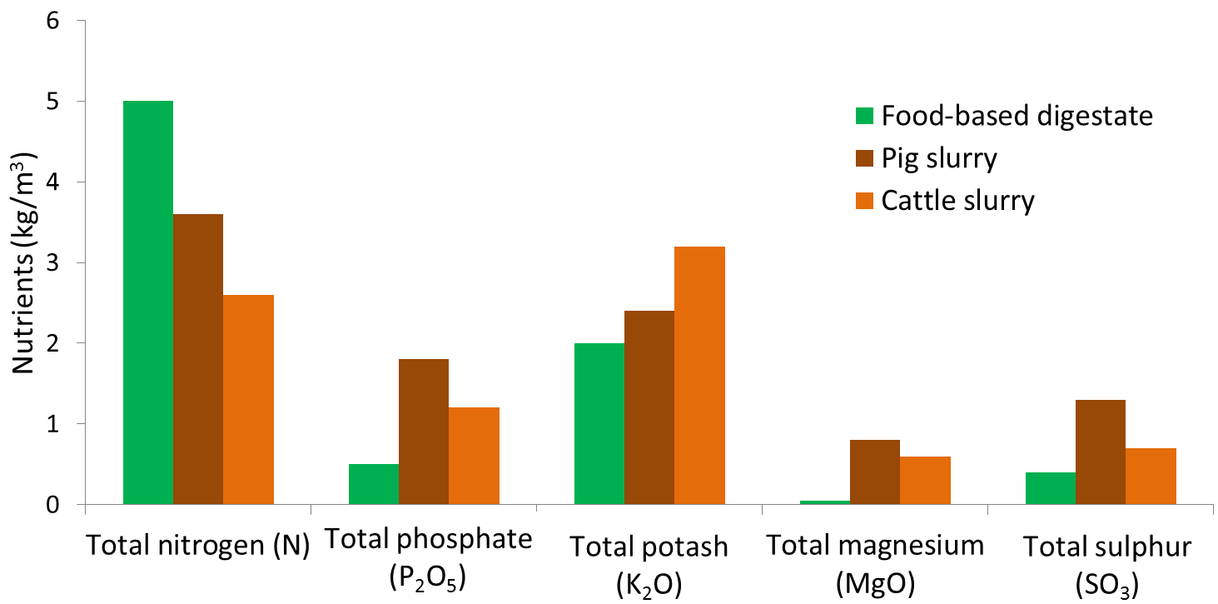
Figure 1. ‘Typical’ nutrient content of food-based digestate and livestock slurries (fresh weight basis)
Table 1. Typical nutrient contents of food-based and manure (cattle slurry)-based whole digestates
Determinand | Unit | Food-based digestate | Cattle slurry-based digestate
Dry matter content | % | 4.0 | 4.0
Total nutrients
Nitrogen (N) | kg/m³ | 5.0 | 2.6
Phosphate (as P₂O₅) | “ | 0.5 | 1.2
Potash (as K₂O) | “ | 2.0 | 3.2
Magnesium (as MgO) | “ | 0.1 | 0.6
Sulphur (as SO₃) | “ | 0.4 | 0.7

As the nutrient content of digestate will vary between AD plants and can change over the post-digestion storage period, it is recommended that an up to date pre-land spreading analysis is obtained. This can be done by:
- Asking for a copy of a recent laboratory analysis from the digestate supplier.
- Sending a sample for analysis at an accredited laboratory e.g. a member of the Professional Agricultural Analysis User Group.
- Undertaking on-site ‘rapid’ analysis to quantify the readily available nitrogen content, using a nitrogen meter e.g. Agros, Quantofix (Plate 1).
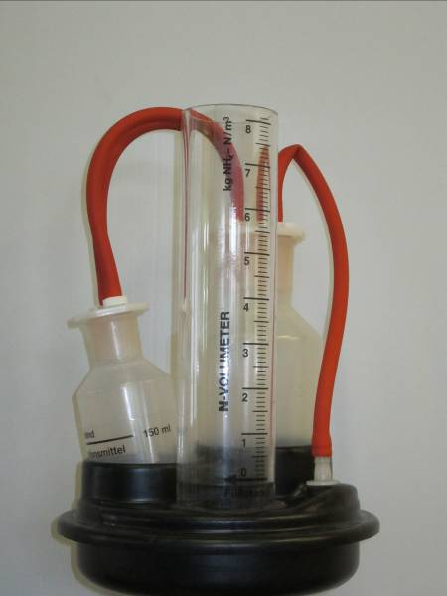
Plate 1. Example of a Quantofix for ‘rapid’ on-site analysis of readily available nitrogen

Nitrogen availability
Digestate is an excellent source of readily available nitrogen (RAN) i.e. ammonium-N, which is potentially available for immediate crop uptake. Food-based digestate typically contains around 80% of its total N content as RAN, compared with around 70% for pig slurry and 45% for cattle slurry (Figure 2).

Food-based digestate | Pig slurry |  | Cattle slurry
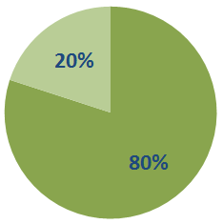 | 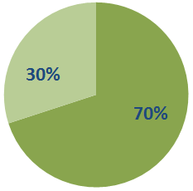 |  | 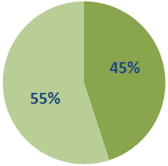
%Organic N |  | % RAN

Figure 2. Readily available nitrogen content of food-based digestate in comparison with ‘typical’ values for pig and cattle slurry
Most of the nitrogen in digestate will become available to the crop in the year of application, as it is mainly present as RAN. However, it is important not to confuse RAN with crop available nitrogen. Whilst digestate is rich in RAN, just like livestock slurries, this can decrease during storage and be lost to the wider environment following land spreading by two main routes: (a) ammonia emissions to air; and (b) nitrate leaching to surface and ground waters. The proportion of RAN which can be used by the crop, taking into account these losses, is called crop available nitrogen.
Freely available software can be used to help calculate the amount of crop available nitrogen that can be expected from digestate and to help integrate its use into farm nutrient management plans (see Section 6).
Maximising crop available nitrogen
Managing digestate to increase the amount of crop available nitrogen supplied will increase the fertiliser replacement value of the digestate, the financial value to farmers and reduce emissions to the environment. There are two key steps that can be taken to reduce emissions and increase the amount of crop available nitrogen:
- Use precision application equipment such as band spreaders or shallow injectors or, where appropriate, rapid soil incorporation, to reduce the amount of nitrogen lost as ammonia. Broadcasting digestate with a splash-plate or similar will result in higher ammonia losses and greater amounts of crop contamination.
- Apply digestate at times of active crop growth, which would normally be in early spring or summer; except where crops have a nitrogen requirement in late summer or autumn, e.g. oilseed rape and grassland.
Availability of phosphate and potash
As a general rule, around 50% of the phosphate and around 80% of potash in digestate will be available to the crop in the year of application. These values should be used in calculating crop nutrient requirements where a response to phosphate/potash is expected (e.g. ADAS soil P/K Index 0/1; SRUC very low/low status) or where responsive crops (e.g. potatoes, vegetables) are grown. Where the soil is at or above the target soil P/K status and a crop response to phosphate and potash additions is not expected (i.e. ADAS Index 2 or above; SRUC moderate status or above), the total phosphate/potash content of the digestate should be used in nutrient planning.
Digestate also supplies useful quantities of sulphur and magnesium. As there are no data on availability to the next crop grown, sulphur and magnesium inputs should largely be regarded as contributing to the maintenance of soil reserves.
Organic matter content
Based on an application rate of 250 kg total N/ha, which is the maximum field N rate permitted in Nitrate Vulnerable Zones (NVZs), the organic matter loading from a typical whole food-based digestate is around 1 t/ha.
Benefits of digestate use
The use of digestate can help reduce a farm’s carbon footprint by replacing the need to apply manufactured fertilisers, Table 2. Replacing the use of manufactured fertiliser with food-based digestate could reduce a farm’s carbon footprint by around 20 kg CO₂e/tonne of digestate applied, or around 1 tonne CO₂e/hectare (if applied at the maximum permitted field limit in NVZs of 250 kg total N/ha).
Table 2. Carbon savings from (whole) food-based digestate use
Nutrient | CO₂e (kg CO₂e /kg nutrient)ª | Food-based digestate nutrient content (kg/m³) | CO₂e (kg/t) saving
Crop available N | 6.2 | 3.0 | 18.6
Total phosphate-P₂O₅ | 0.7 | 0.5 | 0.4
Total potash-K₂O | 0.5 | 2.0 | 1.0
Total |  |  | 20.0
ª Taken from Brentrup and Paliére (2008)
^{b} Assuming crop available N = 60% of total N applied
Note: emissions of nitrous oxide (a greenhouse gas) from digestate applications will reduce the carbon savings from lower amounts of manufactured fertiliser use.

Compost
Typical nutrient contents
Compost contains valuable quantities of major plant nutrients, most notably phosphate and potash, plus nitrogen, sulphur and magnesium, Table 3. Compost can also have a liming value.
Table 3. Typical compost total and crop available nutrient contents (kilograms/tonne fresh weight)
Determinand | Unit | Green compost | Green/food compost
Dry matter content | % | 60 | 60
Total nutrients
Nitrogen (N) | kg/t | 7.5 | 11
Phosphate (as P₂O₅) | “ | 3.0 | 3.8
Potash (as K₂O) | “ | 5.5 | 8.0
Magnesium (as MgO) | “ | 3.4 | 3.4
Sulphur (as SO₃) | “ | 2.6 | 3.4
Crop available nutrient
Nitrogen (N) | kg/t | Nil | 0.6 (5%)
Phosphate (as P₂O₅) | “ | 1.5 (50%) | 1.9 (50%)
Potash (as K₂O) | “ | 4.4 (80%) | 6.4 (80%)
Magnesium (as MgO) | “ | n.d. | n.d.
Sulphur (as SO₃) | “ | n.d. | n.d.
n.d. = no data
Source: Defra Fertiliser Manual (RB209) and SRUC Technical Note 650
The typical values in Table 3 can be used as a guide for nutrient planning, however, the nutrient content and liming value of compost will vary between composting plants. It is recommended that an up to date analysis is obtained, this can be done by:
- Asking for a copy of a recent laboratory analysis from the compost supplier.
- Sending a sample of compost to be analysed at an accredited laboratory e.g. a member of the Professional Agricultural Analysis User Group.
Availability of nitrogen
Field experimental data have indicated that green compost supplies only very small amounts of crop available nitrogen, and that green/food compost supplies around 5% of the total nitrogen applied to the next crop grown (irrespective of application timing). However, following the repeated use of green and green/food compost long-term soil nitrogen supply will be increased.
Phosphate, potash & other major nutrients
As a general rule, around 50% of the phosphate and around 80% of the potash in compost will be available to the crop in the year of application.
Compost also supplies useful quantities of sulphur and magnesium. As there are no data on availability to the next crop grown, sulphur and magnesium inputs should largely be regarded as contributing to the maintenance of soil reserves.
Liming value
Compost also has a small liming value (around 3% on a dry matter basis) that can balance the acidifying effects of fertiliser nitrogen additions to soils.
Improving soil organic matter
Increasing soil organic matter levels has many benefits, including:
- improved soil structure and workability;
- increased soil biological activity and nutrient retention; and
- increased water holding capacity.
Organic matter is a vital component of fertile soils; quite simply “soil just isn’t soil without organic matter”. Crops often grow and yield better where compost has been used in reasonable amounts over several years. Compost is a valuable source of stable organic matter that can form part of a long-term strategy to maintain and enhance soil organic matter levels, and thereby help to maintain soils in good agricultural and environmental condition (GAEC). A ‘typical’ application of 30t/ha of green compost supplies around 5t/ha of organic matter, and 20t/ha of green/food compost around 4t/ha of organic matter. Compared to other organic materials that are commonly applied to agricultural land, compost supplies organic matter in a much more stable form, as indicated by its relatively high lignin content (Figure 3).
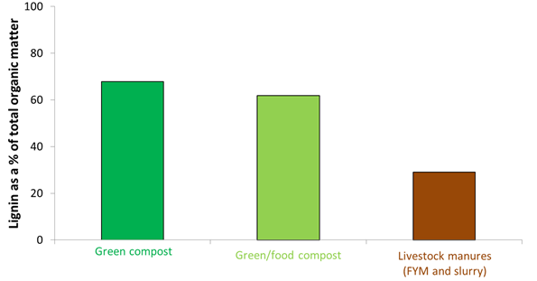
Figure 3. Lignin content of a range of organic materials applied to agricultural land
Field experiments have shown that following repeated compost additions over a period of 2 to 10 years soil organic matter levels had significantly increased by a mean of 12% (compared with untreated control soils), Figure 4a.
Notably, organic matter can hold up to 20 times its weight in water and will directly improve the ability of soils to retain water for longer, as well as improving soil structure and therefore indirectly improving the ability of the soil to retain more water. The same field experiments showed that compost application significantly increased the plant available water capacity of the soil by a mean of 5%, Figure 4b, improving the ability of crops to withstand periods of drought and decreasing the need for irrigation.
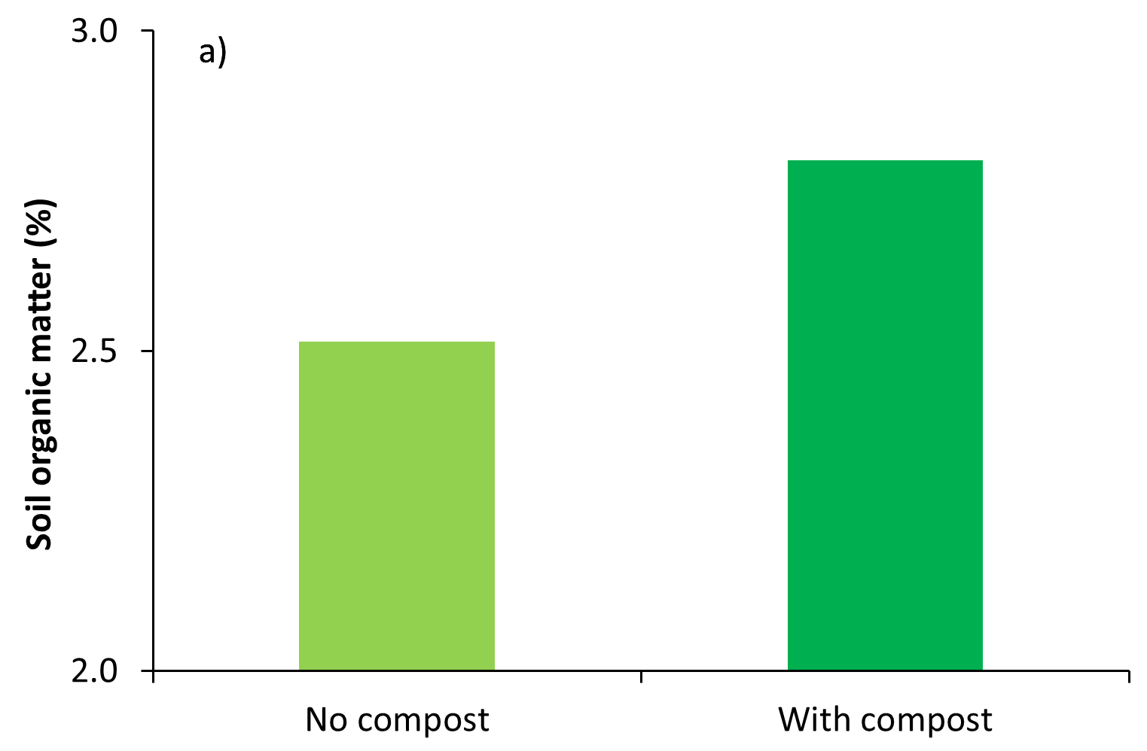 | 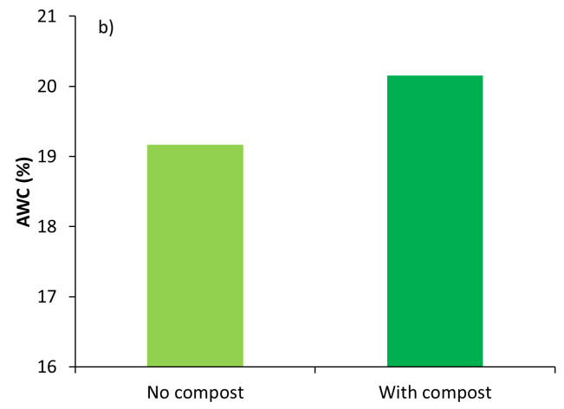
Figure 4. Effects of repeated compost additions on topsoil (a) organic matter levels, and (b) plant available water capacity (AWC).

3. Financial value of digestate & compost
Digestate and compost are valuable sources of major plant nutrients that can be used to replace manufactured fertiliser additions. At the time of publication, a typical food-based digestate application at a rate of 30 m³/ha has a value of around £130/hectare (Table 4), and green compost application at a rate of 30 t/ha has a value of around £170/hectare (Table 5).
Two worked examples are shown below of the financial benefits of major nutrients in renewable fertilisers.
Table 4. Digestate
 | Nitrogen (N) | Phosphate (P₂O₅) | Potash (K₂O)
1st cut grass silage requirement (kg/ha)ª | 120 | 40 | 80
Total nutrients supplied by 30 m³/ha food-based digestate application (kg/ha) | 150 | 15 | 60
Crop available nitrogen (kg/ha) | 90 | ~ | ~
Manufactured fertiliser required | 30 | 25 | 20
Digestate value in year 1^{b} | £81 | £6 | £29
Digestate value to next crop^{b} | - | £6 | £7
Total digestate value (per hectare) |  |  | £129
ª Based on first cut grass silage grown in P Index 2 and K Index 2- soils / SRUC moderate status
^{b} Assuming N = 90 p/kg, P₂O₅ = 80 p/kg, K₂O = 60 p/kg

Table 5. Green compost
 | Nitrogen (N) | Phosphate (P₂O₅) | Potash (K₂O)
Winter wheat requirement (kg/ha)ª | 190 | 65 | 85
Total nutrients supplied by 30t/ha green compost application (kg/ha) | 225 | 90 | 165
Crop available nitrogen | 0 | ~ | ~
Manufactured fertiliser required | 190 | nil | nil
Total compost value in year 1^{b} | - | £52 | £51
Compost value to next crop^{b} | - | £20 | £48
Total compost value (per hectare) |  |  | £171
a Based on winter wheat sown in autumn on medium soil with a soil nitrogen supply of Index of 2, P Index 2, K Index 2- (SRUC moderate status) and straw removed
^{b} Assuming N = 90 p/kg, P₂O₅ = 80 p/kg, K₂O = 60 p/kg
The financial values calculated above are based on the crop available nitrogen and total phosphate and potash supplied by the renewable fertiliser. Additionally, other major nutrients (e.g. sulphur and magnesium) and trace elements (e.g. copper) are applied, along with valuable amounts of stable organic matter.
Recent research has shown that the application of renewable fertilisers has provided savings in nitrogen fertiliser use and increased yields of between 0.20-1.56 t/ha, worth £60-380/ha. These yield increases (and fertiliser nitrogen savings) were achieved through careful nutrient planning and the enhanced supply of major nutrients delivered by renewable fertilisers.
The costs of transporting and applying digestate and compost will be an important consideration to decide whether or not their use will be worthwhile on individual farms. These costs can be high, due to the high water content of digestate and the bulky nature of compost (and fibre digestate). Some operators may be willing to share the costs of transporting digestate and compost, particularly if it is possible to develop a longer term working relationship; it is recommended that farmers discuss with their supplier the logistics and costs of using renewable fertilisers.

4. Safety and acceptability of digestate & compost use

Health and Safety
As with all organic materials, users should wear gloves when handling digestate and compost. If digestate or compost should come into direct contact with the skin, wash the affected area. Avoid eating any of the organic material, or inhaling any airborne dust, water vapour or microscopic particles that may arise when handling; you may wish to wear a facemask and work in a well-ventilated area.

The Renewable Fertiliser Matrix
The Renewable Fertiliser Matrix and associated cropping categories detail where renewable fertilisers should and should not be used on agricultural land.
The Matrix is based on a detailed scientific research programme which comprehensively evaluated the risks to human and animal health and the environment from recycling digestate and compost to land, and discussions with key industry representatives and crop assurance schemes.
Many perceived and actual aspects of digestate and compost quality were considered in the research programme, including flavour and odour taints, allergens and heavy metals. The research identified that only the microbiological aspects of quality needed to be managed further, and the necessary controls have been incorporated into the Matrix.
Although the Matrix builds on the baseline regulatory requirements for applying renewable fertilisers to agricultural land, it does not replace them – and following the Matrix does not exempt users of digestate or compost from compliance with regulatory requirements or good agricultural practice, which are outlined in Section 5.

The Renewable Fertiliser Matrix
 |  | BSI PAS 110 digestate |  |  |  | BSI PAS 100 compost
Cropping category |  | Pasteurised¹ |  | Non-pasteurised |  | Green |  | Green/food¹
Fresh produce | Group 1 |  | Before drilling/ planting² |  | NOT within 12 months of harvest and also at least 6 months before drilling/planting² |  | Any time before drilling/planting² |  | Before drilling/ planting²
 | Group 2 |  | Before drilling/ planting² |  | NOT within 12 months of harvest and also at least 6 months before drilling/planting² |  | Any time before drilling/planting^{2,3} |  | Before drilling/ planting^{2,3}
 | Group 3 |  | Before drilling/ planting² |  | NOT within 12 months of harvest and also at least 6 months before drilling/planting² |  | Any time before drilling/planting² |  | Before drilling/ planting²
Combinable and animal feed crops |  |  | ⁵ |  | ⁵ |  | ⁵ |  | ⁵
Grassland and forage – grazed |  |  | Statutory no-graze intervals apply⁴ |  | 4 week no grazing period applies |  | 4 week no grazing period applies |  | Statutory no-graze intervals apply⁴
Grassland and forage – harvested |  |  | Statutory no-harvest intervals apply⁴ |  | 4 week no harvest period applies |  | 4 week no harvest period applies |  | Statutory no-harvest intervals apply⁴

Notes
- Derived from feedstocks that include Animal By-Products (ABPs), according to the requirements of the European Animal By-Products Regulations (Regulation (EC) No. 1069/2009 and Commission Regulation (EU) No. 142/2011, as implemented by the nations of the UK and Northern Ireland).
- Target of zero and absolute limit of <0.1% (m/m dry weight) glass must be achieved.
- May be applied as mulch.
- In accordance with the Animal By-Products Regulations (see above). These currently stipulate intervals of two months for pigs and three weeks for other livestock.
- No specific additional risk-management approaches are required for this cropping category, as regulatory and good practice requirements apply to this (and all other) categories.

Cropping Categories
Fresh produce | Group 1 | Wholehead Lettuce, Leafy Salads (including any vegetable leaf you can eat raw), Celery, Salad Onions, Radish, Fresh and Frozen Herbs, Etc.
 | Group 2 | Apple, Beetroot, Blackcurrant, Blueberry, Broad Bean, Broccoli, Cabbage, Carrot, Capsicum, Cauliflower, Celeriac, Cherry, Courgette, Cucumber, Garlic, Green Beans (other than runner beans), Melon, Mushroom, Onion (red and white), Pea, Pear, Peach, Plum, Raspberry, Strawberry, Sugar Snap Peas, Sweet Corn, Tomato and Tree Nuts, Etc.
 | Group 3 | Artichoke, Runner Bean, Leek, Marrow, Parsnip, Potato, Pumpkin, Squash, Swede, Turnip, Etc.
Combinable and animal feed crops |  | Wheat, Barley, Oats, Rye, Triticale, Field peas, Field beans, Linseed/flax, Oilseed rape, Sugar beet, Sunflower, Borage
Grassland and forage – grazed |  | Grass, Forage swedes & turnips, Fodder mangolds, Fodder beet, Fodder kale, Forage rye and triticale, Turf
Grassland and forage – harvested |  | Grass silage, Silage maize, Haylage, Hay, Herbage seeds

Notes
- Group 1 crops are those you can eat raw and which do not have a protective skin that is removed before eating; they may also have a significant risk or history of pathogen contamination;
- Group 2 crops are those you can eat raw and which either have a protective skin or grow clear of the ground, or that have no history of pathogen contamination;
- Group 3 crops are those that the customer always cooks.

5. Managing renewable fertilisers

Good agricultural practice
A risk map showing where organic material applications should not be made or spread under certain conditions should be created, based on the guidance below.
To minimise water pollution risks, renewable fertiliser (and other organic material) applications should not be made when:
- the soil is waterlogged; or
- the soil is frozen hard; or
- the field is snow covered; or
- the soil is cracked down to field drains or backfill; or
- the field has been pipe or mole drained or subsoiled over drains in the last 12 months; or
- heavy rain is forecast within the next 48 hours.
Also, applications should not be made:
- within 10 metres of any ditch, pond or surface water (or within 6 meters if digestate is applied using precision application equipment e.g. a bandspreader or shallow injector); or
- within 50 metres of any spring, well, borehole or reservoir that supplies water for human consumption or for farm dairies; or
- on very steep slopes where run-off is a high risk throughout the year.
Liquid digestates typically have biochemical oxygen demand (BOD) levels of around 9,000 mg/l, which is similar to livestock slurries (10,000-30,000 mg/l) and dirty water (1,000-5,000 mg/l), and hence their application to land needs to be carefully managed to minimise water pollution risks.
For further information on the management of organic material applications to minimise environmental pollution risks, please refer to the “Code of Good Agricultural Practice” in England, “The Code of Good Agricultural Practice for Wales” or the “Prevention of Environmental Pollution from Agricultural Activity” in Scotland. Notably, it is important to apply renewable fertilisers when soil conditions are appropriate, as the weight of spreading equipment can cause compaction when soils are ‘wet’.

Animal By-Product (ABP) Regulations
Applications of digestate or compost that are derived from food waste or other animal by-products to agricultural land must also comply with the Animal By-Products Regulations (Regulation (EC) No. 1069/2009 and Commission Regulation (EU) No. 142/2011, as implemented by the nations of the UK). This applies regardless of whether they are certified as products (see Section 1 and Section 4) or classified as wastes.
Digestate or compost that is derived from food waste or other animal by-products, which is destined for use in agriculture must be clearly labelled as such during transport and prior to land spreading. The regulations impose strict ‘lay-off' periods, whereby pasture land cannot be used for livestock grazing, or harvested for forage, within 3 weeks (or 2 months for pigs) of applying digestate or compost that is derived from animal by-products. The regulations require compliance with these restrictions to be demonstrated through record keeping.

Nitrate Vulnerable Zones (NVZs)
Field N limit
In NVZs in Britain, the amount of N applied to a field in ‘organic manures’, including digestate and compost, must not exceed 250 kg N/ha in any 12 month period (i.e. the field N limit). This limit is based on the total N content of the organic manures applied.
In some situations, lower application rates may be appropriate, for example, where the amount of crop available N supplied would exceed the crop requirement. However, PAS100 certified compost (either green or green/food which does not include livestock manure as an input) can be applied as a soil conditioner/mulch at up to 500 kg total N/ha, provided no other organic manure applications are made in any two year period. Where PAS100 certified compost is used as a mulch in an orchard, up to 1,000 kg total N/ha can be applied provided no other organic manure applications are made in any four year period.
N max
The N max limit means that the average amount of crop available N supplied to specified crop types must not exceed the limit value. Changes to the regulations mean that from 1 January 2014 all organic manures including digestate and compost, must be included in the N max calculations.
Soil incorporation
Ammonia emissions (and odour nuisance) can be reduced by rapidly incorporating digestate into the soil, which as well as decreasing environmental pollution, will increase the crop available N supply. Applications of liquid digestate (i.e. where >30% of the total N content is present as RAN) to un-cropped land in NVZs must be incorporated into the soil within 24 hours, unless digestate has been applied with a bandspreader or shallow injector.

Temporary field heaps
The location of solid organic manure field heaps (including compost and fibre digestate) should be carefully managed to minimise the risks of water pollution. Like livestock manure field heaps, they should be constructed to occupy as small an area as possible and their position marked on the farm risk map (as well as other features).
Field heaps must not be located:
- within 10m of a surface water or (effective) land drain;
- within 30m of a surface water if the slope is >12°;
- within 50m of a spring, well or borehole;
- on land likely to become waterlogged;
- on land likely to flood; or
- in any single position for more than 12 successive months (and there must be a two year gap before returning to the same site).

Closed spreading periods for digestate
As the RAN content of liquid digestate (and some fibre digestates) exceeds 30% of its total N content, applications, like cattle and pig slurry and poultry manure, are subject to mandatory closed spreading periods in NVZs during autumn/winter.
To ensure that digestates are not applied in closed spreading periods, digestate suppliers need to ensure that they have adequate storage available (either on the site of the AD plant or via satellite storage on farms) and that the stores are constructed to meet the requirements of “SSAFO Regulations”. Ideally, the stores should be covered to prevent water ingress and to minimise ammonia emissions and odour nuisance.

Liquid digestate application techniques
To make best use of the RAN contained in digestate, the ADQP recommends that ‘low emission application equipment’ is used, i.e. precision application equipment such as a bandspreader (trailing hose/trailing shoe, Figure 5) or shallow injector (Figure 6), to minimise ammonia emissions (and odour nuisance) and increase crop available N supply.
Bandspreading and shallow injection application techniques have low coefficients of variation at spreading (<25%), increase the number of spreading days and causes less sward contamination than surface broadcast application. Bandspreading equipment is also available that enables accurate topdressing of arable crops across full tramline widths, without causing crop damage and contamination.
As digestates are bulky organic materials, there are considerable logistical advantages in having an available agricultural market close to the AD plant. In the case of liquid digestates, access to this agricultural land using umbilical (i.e. no tanker) spreading equipment can increase spreading opportunities and reduce soil compaction risks.
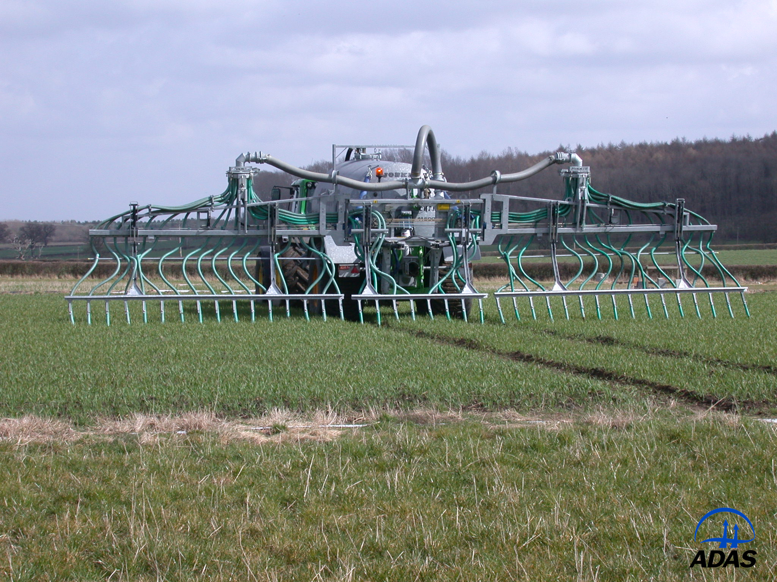 | 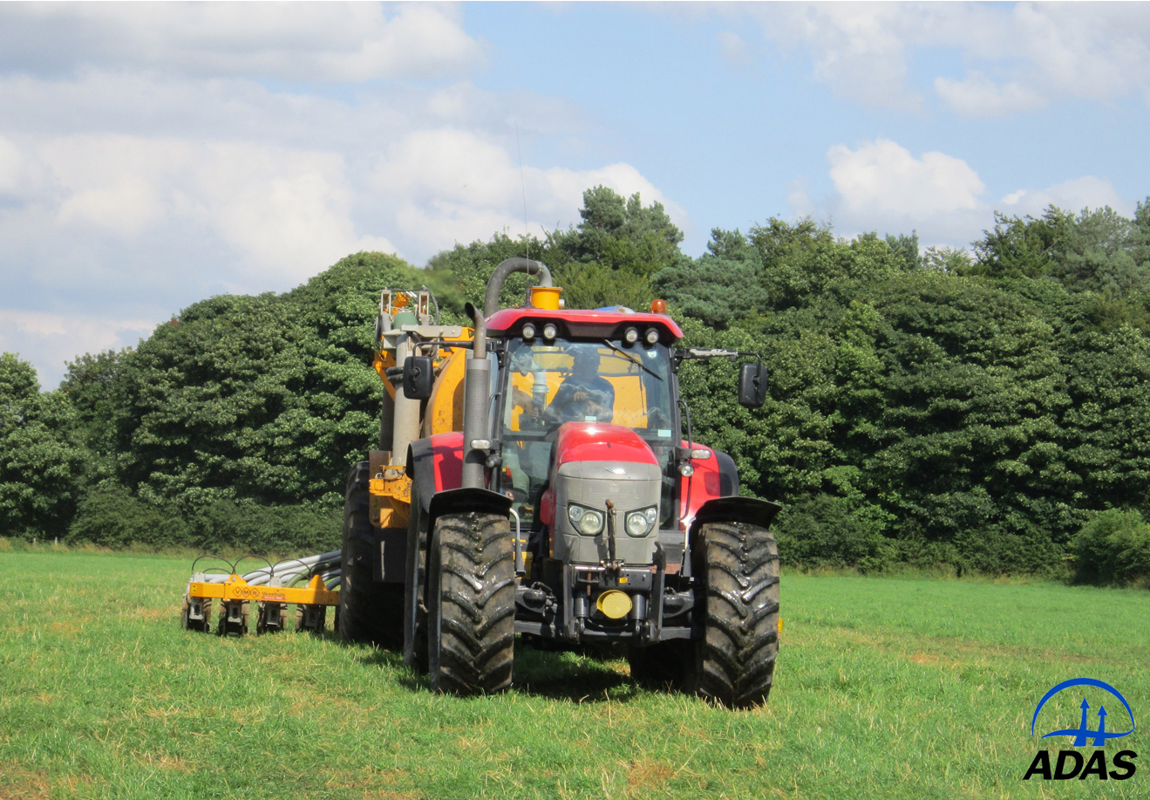
Figure 5. Bandspread application to arable land | Figure 6. Shallow injection application to grassland

6. Integrating renewable fertilisers and manufactured fertiliser use

Making optimum use of nutrient content
To make optimum use of the N content of renewable fertilisers (and in particular liquid digestate), they should be applied at times of active crop growth, which normally occurs during the early spring to summer period, although this can be extended through to autumn on grassland where there is a crop demand for nitrogen.

Tools to help
Freely available software can be used to integrate the nutrient supply from organic materials into nutrient management plans e.g. MANNER-NPK and PLANET/PLANET Scotland.
MANNER-NPK / PLANET predict the fertiliser N replacement value of field applied organic materials, and simplify their integration into farm nutrient management plans. | 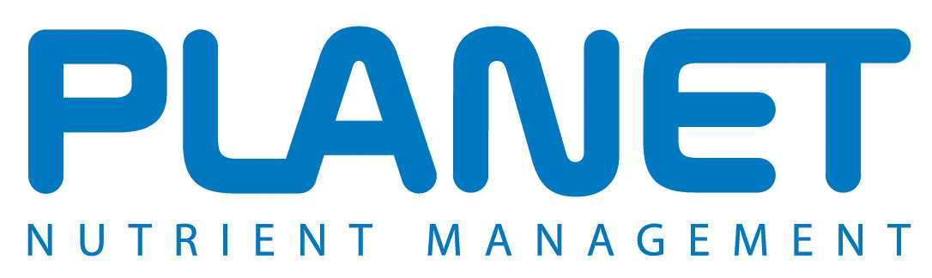

Nutrient planning
Integrating digestate and compost into a farm’s nutrient management plan should aim to maximise the nutrients supplied. Failure to adequately allow for the nutrients supplied by renewable fertilisers will waste money and potentially reduce crop performance, as well as causing environmental pollution. The key steps are:
- Identify the fields and crops that are available and will benefit most from renewable fertiliser application. Take into account accessibility and likely soil conditions at the time of application, and the application equipment available. Digestate is best suited to crops with a high nitrogen demand, and compost is best suited to soils requiring organic matter and/or phosphate and potash.
- Apply digestate in the early spring to summer period, as this will make best use of the readily available nitrogen applied.
- Use a nutrient management recommendation system (e.g. “The Fertiliser Manual (RB209)”, SRUC Technical Note 650 or the MANNER-NPK/PLANET software) to calculate the amount of crop available nitrogen, phosphate, potash and other nutrients supplied from each application in each field.
- Calculate the nutrients supplied by the renewable fertiliser and deduct this from the requirement of the crop. This will give the balance (if any) that needs to be supplied by manufactured fertiliser; see examples in Tables 4 and 5.
- Aim for digestate to supply no more that 50-60% of the total N requirement of the crop, and use manufactured fertiliser N to supply the remainder. Relying on digestate to supply the entire crop nitrogen requirement may compromise crop yields and quality.
- Make sure that application equipment is well maintained and suitable for applying digestate or compost evenly and at the target rate. All equipment should be well maintained and calibrated for the type of material being applied (please refer to the manufacturer’s guidance). For liquid digestate, use precision application equipment (e.g. trailing hose, trailing shoe or shallow injector).
Additional guidance on the use of organic materials (including compost) is contained within “The Fertiliser Manual (RB209)” or “SRUC Technical Note 650”. As digestate is a new organic material, it does not yet feature in “The Fertiliser Manual (RB209)”. Research to understand the nutrient supply properties of liquid digestate is being undertaken through the DC-Agri programme of field experiments; until this work is complete, the advice is to use pig slurry as a proxy.

7. Checklist for sourcing digestate and compost

If you are thinking of using digestate or compost – or are approached by a supplier of these materials, there are a number of key questions that you should ask to ensure that the materials meet your requirements and expectations.
- What is the potential agronomic benefit to you?
Get to know your supplier and their product; you may want to visit their site to understand the quality control processes used to ensure that the product is suitable for use on your farm. Ask for an up to date analysis of the material. Ideally this should be an analysis of the material that will be supplied for your use. Useful analyses include pH, dry matter, total nitrogen, phosphate, potash, magnesium and sulphur, as well as readily available nitrogen and liming value. Useful guidance on interpreting laboratory data can be found in Appendix 6 of the “Fertiliser Manual RB209”, as well as SRUC Technical Note TN650 and MANNER-NPK (which contains a laboratory analysis converter).
- Is it certified under the Biofertiliser Certification Scheme or Compost Certification Scheme?
Ask to see a certificate and check that the date on the certificate is valid. Current members of the BCS and CCS are listed online.
It is not compulsory for waste-derived digestate or compost to be certified to one of the end of waste approaches (see Section 1). Non-certified materials can still be used to confer benefit to agricultural land under the appropriate regulatory regime (such as Standard Rules No4 (2010) in England and Wales or a Paragraph 7(1) exemption from Waste Management Licensing (Scotland) Regulations 2011 in Scotland).
- Are you happy with the quality of the material?
Try to make sure that you are present when the digestate or compost is being delivered. You should inspect it to see if the quality meets your requirements and be prepared to reject it, before it is applied, if it does not.
Digestate certified under the BCS and compost certified under the CCS must comply with identified thresholds for quality aspects, such as physical contaminants (e.g. plastic and glass) and potentially toxic elements (e.g. copper and zinc). These schemes also have thresholds for indicator pathogens such as Salmonella (for which there is zero tolerance) and E.coli. You may decide to ask for an up to date analysis of the material to check that it complies with these requirements. Ideally this should be an analysis of the material that will be supplied for your use.
The approach taken to regulating the use of non-certified digestate and compost is different. Standard thresholds for quality parameters are not usually applied, with each case considered by the regulators individually. You should therefore ask for an up to date analysis of the material to check that you are happy to use it. The analysis should cover quality aspects described above, for certified materials.
If a product certified under either the BCS or CCS does not meet your expectations, you can make a complaint to the certifying bodies, i.e. [weblink awaited from REAL] and REAL in the case of compost.

8. Glossary
Anaerobic digestion | The controlled biological decomposition of biodegradable materials in the absence of oxygen.
Animal by-products (ABPs) | Animal by-products (ABPs) are animal carcasses, parts of carcasses, or products of animal origin not intended for human consumption. There are controls on the use of animal by-products when used as feed (including pet food), as fertilisers, or as technical products, in composting or anaerobic digestion, and on disposal by rendering and incineration. The rules also prevent catering waste being fed to livestock.  For further information see Animal By-Products Regulations (Regulation (EC) No. 1069/2009 and Commission Regulation (EU) No. 142/2011, as implemented by the nations of the UK and Northern Ireland).
Bandspread application | See trailing hose and/or trailing shoe applicators.
Broadcast application | Liquid organic material is forced under pressure through a nozzle, often onto an inclined plate to increase the sideways spread (also known as a splash plate or nozzles). The organic material will cover all the ground/crop.
Compost | Organic material produced by the aerobic decomposition of biodegradable organic materials.
Crop available nitrogen | Crop available N is the amount of readily available nitrogen that remains for crop uptake, after accounting for any losses to the environment (e.g. via ammonia volatilisation, nitrate leaching etc.). This also includes N released from organic forms.
FACTS | Fertiliser Advisers Certification and Training Scheme, which is the UK national certification scheme for advisers on crop nutrition and nutrient management. Membership renewable annually. A FACTS Qualified Adviser has a certificate and is a member either of the FACTS Annual Scheme or of the BASIS Professional Register.
Leaching | Process by which soluble materials such as nitrate are removed from the soil by water passing through it.
Manufactured fertiliser | Any fertiliser that is manufactured by an industrial process. Includes conventional straight and NPK products (solid or fluid), organo-mineral fertilisers, rock phosphate, slag, ashed poultry manure, liming materials that contain nutrients etc.
Organic material | Any organic-based source of crop nutrients derived from livestock, humans or plants. Includes livestock manures, compost and digestate.
Pasteurisation | A process step during which the number of pathogenic bacteria, viruses and other harmful organisms in materials is significantly reduced or eliminated by heating the material to a critical temperature, and for at least a minimum specified period of time.
Precision application technique | Method of accurately applying liquid organic materials with a trailing hose, trailing shoe or shallow injection.
Readily available nitrogen (RAN) | The nitrogen (i.e. ammonium and nitrate-N) that is potentially available for rapid crop uptake, but which may be lost to the environment if it is not managed well (e.g. through ammonia volatilisation to air and nitrate leaching to water).
Run-off | Movement of water across the soil surface or via field drains, which can remove soil particles, nutrients and particulate matter from organic materials and manufactured fertilisers.
Shallow injection application | Technique using machinery to inject liquid organic materials into a shallow ‘v’ shaped slot (typically 5-7cm deep) which is cut into the soil surface.
Slurry | Excreta of livestock (other than poultry), including any bedding, rainwater and washings mixed with it, that can be pumped or discharged by gravity. The liquid fraction of separated slurry is also defined as slurry.
Soil improver/ conditioner | Organic material added to the soil to primarily maintain or improve its physical properties, and which can improve its chemical and/or biological properties.
Soil Index (P, K or Mg) | Concentration of extractable (plant available) P, K or Mg, determined by standard analytical methods, expressed in bands or Indices.
Soil organic matter | Often referred to as humus. Composed of organic compounds ranging from undecomposed plant and animal tissues to fairly stable brown or black material with no trace of structure.
Source segregated | A class of waste material that is not mixed with any other waste material, either during storage, collection or treatment. For example, food wastes collected from food waste caddies. Food wastes extracted from a mixed waste bin are not source segregated as they may have become contaminated with potentially polluting materials.
Trailing hose application | Equipment used to apply liquid organic materials to land, whereby the material is forced under pressure along a boom and distributed close to the ground through hoses in bands.
Trailing shoe application | Equipment used to apply liquid organic materials to land, whereby the material is forced under pressure along a boom and distributed under the crop canopy onto the soil surface through ‘metal shoes’ in bands.
Volatilisation | In this context, volatilisation refers to the release of ammonia gas from organic materials to the atmosphere.
Waste regulatory controls | Legislative controls that govern the transfer, transportation, storage, handling, treatment, recycling, recovery and disposal of waste.

9. Links to other documents/information sources
- Biofertiliser Certification Scheme
http://www.biofertiliser.org.uk/
- British Standards Institute Publicly Available Specification 110
http://www.wrap.org.uk/content/bsi-pas-110-specification-digestate
- Anaerobic Digestate Quality Protocol
http://a0768b4a8a31e106d8b0-50dc802554eb38a24458b98ff72d550b.r19.cf3.rackcdn.com/geho0610bsvd-e-e.pdf
- SEPA position on ‘Classification of outputs from anaerobic digestion processes’
http://www.sepa.org.uk/waste/waste_regulation/guidance__position_statements.aspx
- British Standards Institution PAS 100
http://www.wrap.org.uk/content/bsi-pas-100-compost-specification
- Compost Quality Protocol
http://a0768b4a8a31e106d8b0-50dc802554eb38a24458b98ff72d550b.r19.cf3.rackcdn.com/geho0812bwpl-e-e.pdf
- Professional Agricultural Analysis User Group
http://www.nutrientmanagement.org/library/soil-testing-find-a-laboratory/
- Code of Good Agricultural Practice for England
https://www.gov.uk/government/uploads/system/uploads/attachment_data/file/69344/pb13558-cogap-090202.pdf
- The Code of Good Agricultural Practice for Wales
http://wales.gov.uk/docs/drah/publications/110420cogapwales2011introen.pdf
- Prevention of Environmental Pollution from Agricultural Activity
http://www.scotland.gov.uk/Resource/Doc/37428/0014235.pdf
- Regulation (EC) No. 1069/2009
http://eurl.craw.eu/img/page/Legislation/1069_2009_EN.pdf
- Commission Regulation (EU) No. 142/2011
http://eur-lex.europa.eu/LexUriServ/LexUriServ.do?uri=OJ:L:2011:054:0001:0254:EN:PDF
- MANNER-NPK
http://www.planet4farmers.co.uk/manner
- PLANET/PLANET Scotland
http://www.planet4farmers.co.uk/
- Membership of Biofertiliser Certification Scheme (BCS)
http://www.biofertiliser.org.uk/members
- Membership of Compost Certification Scheme (CCS)
http://www.organics-recycling.org.uk/page.php?article=1797&name=Composters+on+REAL%27s+Compost+Certification+Scheme
- SRUC technical notes
http://www.sruc.ac.uk/downloads/120202/technical_notes
- “SSAFO” Regulations
http://www.legislation.gov.uk/uksi/2010/639/pdfs/uksi_20100639_en.pdf

[1] All inputs to certified anaerobic digestion plants must be source separated, biodegradable materials. Food wastes from households (but not black-bag waste), food processers and caterers are treated by many facilities, although sewage sludge is not allowed. Any feedstocks that have, or might have been in contact with meat and other permitted but low risk animal by-products, are controlled by regulations which require a pasteurisation step, e.g. 1 hour at 70ºC, with a particle size no greater than 12mm.

