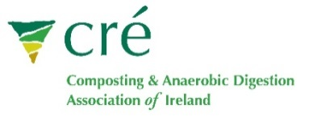  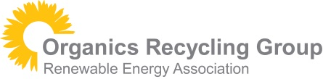 | Italian Study Tour  Booking Form

Applicant Information
Company
Contact Name:
 | Last | First
Mobile: |  | Email

Company Address:

Address

Tour Options
Tour Option |  | Price Euros  ex vat (23%) | Please state which option you want
A | Departs Dublin on 14th and returns on 16th | €1500
B | Departs Dublin on 14th and returns on 17th | €2000
C | Departs Stansted on 14th and returns on 17th | €2000
D | Organise Own Flights | Tour price minus €200

If UK delegates want to organise their own flights for a two day trip; they will have to organise their own travel to/from the airport if it is a different airport than Malpensa, Milan.

If you cancel your booking before 1st Oct, you will be refunded minus the cost of the flight and administration charges. After 1st Oct 50% of the fee will be refunded.

